Effect of microencapsulated essential oil from Chamaecyparis obtusa on monocyte-derived dendritic cell activation and CD4⁺ T cell polarization
Seung-Heon Shin*, Mi-Kyung Ye, Dong-Won Lee, Mi-Hyun Che
Department of Otolaryngology-Head and Neck Surgery, School of Medicine,
Catholic University of Daegu, Daegu, South Korea

Abstract

The essential oil of Chamaecyparis obtusa (C. obtusa), which is used in soap, toothpaste, and aromatic agents, has been known to have anti-inflammatory properties. In this study, we investigated the effects of microencapsulated C. obtusa essential oil on airborne fungus-induced dendritic cell (DC) activation and Th immune responses. We stimulated monocyte-derived DCs with Alternaria alternate and lipopolysaccharide (LPS). To determine the anti-inflammatory effects, we pre-treated DCs with various concentrations of microencapsulated C. obtusa essential oil and collected the supernatants to measure interleukin-6 (IL-6) and tumor necrosis factor-alpha (TNF-α), and we determined the expression of cell surface molecules. The effects of the essential oil on CD4⁺ T cells polarization was determine by culturing stimulated DCs and autologous CD4⁺ T cells. Alternaria enhanced the production of IL-6 and TNF-α from DCs, and pretreating DCs with 0.001, 0.01, and 0.05 % of the essential oil significantly inhibited their production. Increased CD80 and CD86 expression by Alternaria was significantly inhibited with 0.05% of the essential oil. Alternaria-induced IL-5, IL-10, and interferon-gamma from CD4⁺ T cells were significantly inhibited with C. obtusa essential oil in a dose dependent manner. C. obtusa influenced both Alternaria- and LPS-induced Th1 and Th2 polarization of CD4⁺ T cells. These results suggest a novel pharmacological use for C. obtusa essential oil to treat inflammatory airway diseases.

Image
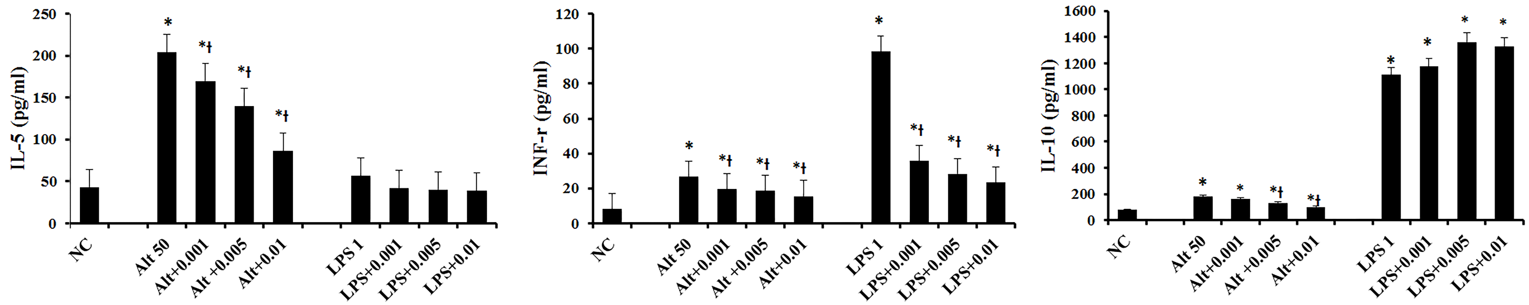
Fig 1. Effects of Chamaecyparis obtusa (C. obtusa) essential oil on dendritic cells (DCs) stimulated with Alternaria 50 ug/ml (Alt 50) and lipopolysaccharide 1 ug/ml (LPS 1) induced distinctive cytokines from autologous CD4⁺ T cells. Alternaria-induced interleukin-5 (IL-5), interferon gamma (INFγ), and IL-10 production and LPS-induced INF-γ production were significantly inhibited with various concentrations (0.001–0.01%) of C. obtusa. NC: negative control, * p < 0.05 vs. NC, Ɨ: p < 0.05 vs. Alt 50 or LPS 1.

Recent Publications

- Shin SH, Ye MK, Choi SY, Park KK (2018) Anti-inflammatory effect of bee venom in an allergic chronic rhinosinusitis mouse model. Mol Med Rep. 17:6632-6638.
- Shin SH, Ye MK, Choi SY, Park KK (2017) The effects of melittin and apamin on airborne fungi-induced chemical mediator and extracellular matrix production from nasal polyp fibroblasts. Toxins, 27:E348
- Shin SH, Kim YH, Ye MK, Choi SY (2017) Immunopathologic characteristics of nasal polyps in adult Koreans: a single-center study. Am J Rhinology Allergy 31:168-173
- Shin SH, Ye MK, Choi SY, Kim YH (2016) Effect of eosinophils activated with Alternaria on the production of extracellular matrix from nasal fibroblasts. Ann Allergy Asthma Immunol 116:559-564
- Shin SH, Kim YH, Jin HS, Kang SH(2016) Alternaria induces production of Thymic stromal lymphopoietin in nasal fibroblasts through toll-like receptor. 2 Allergy Asthma Immunol Res 8:63-68

Biography
Name : Seung Heon Shin, M.D., PhD, Graduated from Kyung Pook National University, School of Medicine, Daegu, South Korea. Working as Professor of Otorhinolaryngology, Catholic University of Daegu, School of Medicine, Daegu, Korea. Member Korean Society of Otorhinolaryngology Head & Neck Surgery, Korean Rhinology Society, International Rhinologic society, Korean Society of Allergy & Asthma.
.
Email: hsseung@cu.ac.kr
Notes/Comments:

