Noura Zidan, DDs, MSc, Damascus University, Faculty of Dentistry.
Comparative study of Co-Cr alloy specimens prepared by conventional casting or selective laser melting technique
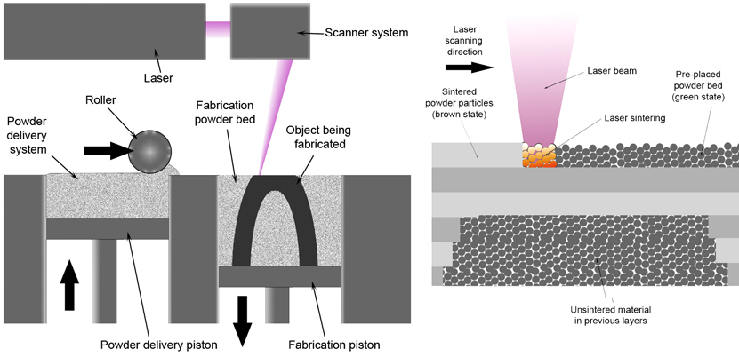
Statement of the Problem: there are different methods to make the dentistry metal framework structure. Such as, the classical casting method and the selective laser melting method. This encourages the researchers to study the properties of the metal framework structures, especially, the mechanical and bio-chemical properties. Which affect the clinical efficiency in the mouth.
Methodology & Theoretical Orientation: In this work, we have used commercial Co-Cr alloy to make new samples using the two methods, casting and SLM. Then, the investigations of mechanical properties were performed such as the microscopic hardness and Chemical likes the electrochemical corrosion as well as the surface morphology and the Chemical structure. 34 pieces were made from Co-Cr alloy to be used as samples to perform the present work. 17 pieces were made using the SLM method and the other 17 pieces were made using the Classical casting method. 8 pieces with rectangular shape from each group were taken to do the micro-hardness test, Vickers type, and the 9 pieces with cylindrical shape to perform the electrochemical corrosion test. It should be mentioned that 6 pieces from the last 9 group were taken and they located the Chemical test cell with three poles to perform the corrosion test and finally to make comparison study between the two methods. Then, the surface morphology characterization was done using the SEM, at the same time, the EDX technique was employed to know the element Chemical analysis. The 3 pieces were left without any Chemical treatment and used as references samples. The left 3 pieces will be used in comparison study of the surface morphology characterization as well as element Chemical analysis with Chemical treated samples. However, the results were analysis by T-student test at level of %95 and α =0.05.
- AL JABBARI, Y. S., BARMPAGADAKI, X., PSARRIS, I. & ZINELIS, S. 2019. Microstructural, mechanical, ionic release and tarnish resistance characterization of porcelain fused to metal Co–Cr alloys manufactured via casting and three different CAD/CAM techniques. Journal of prosthodontic research, 63, 150-156.
- CHEN, H., LI, H., ZHAO, Y., ZHANG, X., WANG, Y. & LYU, P. 2019. Adaptation of removable partial denture frameworks fabricated by selective laser melting. The Journal of prosthetic dentistry, 122, 316-324.
- DONG, X., SUN, Q., ZHOU, Y., QU, Y., SHI, H., ZHANG, B., XU, S., LIU, W., LI, N. & YAN, J. 2020. Influence of microstructure on corrosion behavior of biomedical Co-Cr-Mo-W alloy fabricated by selective laser melting. Corrosion Science, 108688.
- HAN, X., SAWADA, T., SCHILLE, C., SCHWEIZER, E., SCHEIDELER, L., GEIS-GERSTORFER, J., RUPP, F. & SPINTZYK, S. 2018. Comparative analysis of mechanical properties and metal-ceramic bond strength of Co-Cr dental alloy fabricated by different manufacturing processes. Materials, 11, 1801.
- NI, J., LING, H., ZHANG, S., WANG, Z., PENG, Z., BENYSHEK, C., ZAN, R., MIRI, A., LI, Z. & ZHANG, X. 2019. Three-dimensional printing of metals for biomedical applications. Materials Today Bio, 3, 100024.

Findings: Our results show that there are some important valuable differences during the characterization of the studied samples, which made by both preparing methods, Casting and SLM. Regarding, the micro-hardness test it was found that the casting method is better than the SLM method. But, the corrosion test and Chemical element characterizations, we found no important differences relating to the two preparing methods. We have found the similar surface morphology for the entire tested sample.
Conclusion & Significance: We have concluded from this study that the prepared SLM method of Co-Cr alloy samples have better mechanical properties than the Casting method. While all the samples have similar results regarding the micro-hardness and surface morphology as well as the Chemical element analysis.

Keywords— C0-Cr alloy, Casting method, selective laser melting, dentistry metal framework structure.

N. Zidan is with the Department of Removable prosthodontics, Faculty of Dentistry, Damascus University, Syria (nourazidan195@gmail.com ) Phone: +963992240341.

