Role of 3D printing in the management of complex acetabular fractures: a comparative study
Sajid Ansari· Sitanshu Barik · Sanny Kumar Singh · Bhaskar Sarkar · Roop Bhushan Kalia
AIIMS Rishikesh, India
Tarun Goyal, AIIMS Bhatinda, India

Abstract
Purpose: The aim of this study is to assess the role of 3D printing of actual size pelvis in the management and outcome of acetabular fractures.

Methods: Retrospective study with inclusion of acetabular fractures which were divided into two groups (traditional and 3D printing) was done over a 1-year period. The indices for comparison of both groups in this study were (a) operative time (from skin incision to suture), (b) intraoperative blood loss (noted from the anaesthetist notes), (c) times of intraoperative fluoroscopy, (d) postoperative complications, (e) quality of fracture reduction (good = < 2 mm displacement, fair = > 2 mm displacement) and (f) Harris hip score at final follow-up.

Results: 27 cases (traditional group = 15, 3D printing group = 12) meeting the study criteria were included in the study with a mean follow-up of 26.3 ± 11.2 months. There was a significant difference in the operative time, intraoperative blood loss and number of intraoperative fluoroscopy images. The mean operative time was shorter in the 3D printing group by 62 min. No difference was noted in the quality of reduction in either of the groups (p > 0.05).

Conclusion: 3D imaging and printing helps in better understanding of the anatomy of acetabular fractures. It leads to reduced operative time, blood loss as well as exposure to radiation intraoperatively. There is no difference in functional outcome at final follow-up between 3D printing and traditional groups.

Image

A B
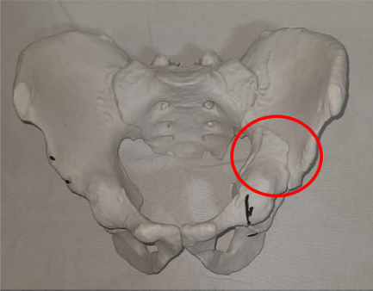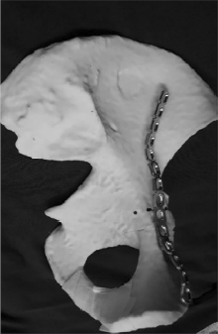
Figure 1: A. 3D model of the acetabulum and pelvis with fracture
marked on the injured side B. Contouring of the plate as done on the uninjured side

Recent Publications
1. Pascarella R, Cerbasi S, Politano R, Balato G, Fantasia R, Orabona G, et al. Surgical results and factors influencing outcomein patients with posterior wall acetabular fracture. Injury. 2017;48:1819–24.
2. Sahu RL. Outcome of surgical treatment for displaced acetabular fractures: a prospective study. Revista Brasileira de Ortopedia (English Edition). 2018;53:482–8.
3. Lou Y, Cai L, Wang C, Tang Q, Pan T, Guo X, et al. Comparison of traditional surgery and surgery assisted by three dimensional printing technology in the treatment of tibial plateau fractures. Int Orthop. 2017;41:1875–80.-17.
4. Wan L, Zhang X, Zhang S, et al. Clinical feasibility and application value of computer virtual reduction combined with 3D printing technique in complex acetabular fractures. Exp Ther Med. 2019;17(5):3630–6.
5. Li Y-T, Hung C-C, Chou Y-C, Chen J-E, Wu C-C, Shen H-C, et al. Surgical treatment for posterior dislocation of hip combined with acetabular fractures using preoperative virtual simulation and three-dimensional printing model-assisted precontoured plate fixation techniques. Biomed Res Int. 2019;2019:1–9.

Biography
Dr Roop Bhushan Kalia has his expertise in joint replacement and complex trauma surgeries. Practicing in a tertiary care hospital of North India, he is actively involved in post graduate and Mch teaching in the department of Orthopedics at AIIMS Rishikesh Hospital. The application of 3D printing in the management of complex trauma has been one of his keen interest and has been doing it with quite some perfection.
Email: roopkalia2003@yahoo.com

