
Corrosion behavior of metallic alloys obtained by Additive Manufacturing
Marina Cabrini, Sergio Lorenzi, Tommaso Pastore, Cristian Testa
University of Bergamo, Department of Engineering and Applied Science, Dalmine (BG) Italy, Europe
Abstract
Among the alloys, the most used in additive manufacturing (AM) technologies are surely Co-Cr, Ti-, Al- and Ni-alloys. Such alloys cover the most widespread industrial applications form automotive/aerospace, to medical, energy and Oil&Gas. The material qualification process of the alloys in the specific environment is nowadays gaining lot of importance, as the corrosion behavior of traditional casting and wrought alloys is well known, but it significantly modifies due to macro and microstructure modifications induced by additive manufacturing process (Fig. 1). The results of several reserches emphasize strict correlation between the corrosion behavior and the unique microstructure of these alloys, thus giving rise to new opportunities for increasing the knowlwge in corrosion science. Corrosion mechanisms are also affected by both the production processes and heat treatments (Fig.2). Additive technologies have several and undubtful advantages compared to subtractive ones, mainly due to the possibility to produce components with very complex and non-dense geometries (micro and macro porous, trabecular, etc.). The unique microstructure, the widening of the solubility field of the alloy elements due to rapid cooling, the precipitation of non-equilibrium phases, the different surface conditions and heat treatments are only some of the elements affecting both the mechanical behaviour and the corrosion resistance. In fact, for applications in particularly aggressive environments, the qualification of these materials must be completely re-discussed, as well as the definition of new production standards and post-processing heat treatments specifically designed to enhance their peculiarities.
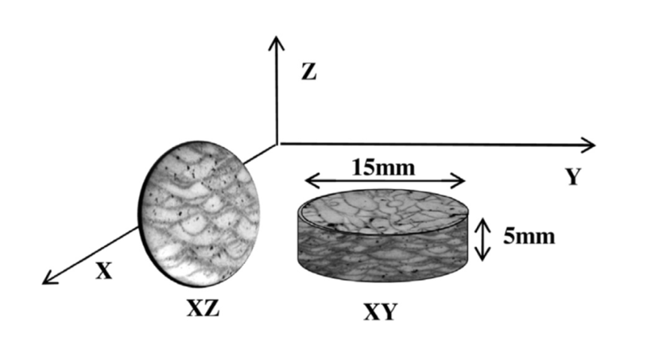
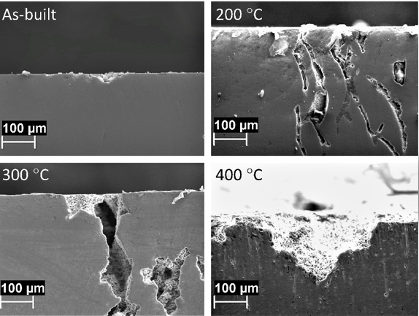

Fig.1: Schematic representation of the microstrucutre of the alloy AlSi10Mg obtained by means laser powder bed fusion as a function of the directions of the production (Cabrini et al., J. Mat. Proc. Tech. 231 (2016) 326–335 | Fig. 2: effect of the temperature of post processing heat treatments on the corrosion behavior of the AlSi10Mg alloy (Cabrini et al., Materials 2018, 11, 1051

Recent Publications (minimum 5)

- Cabrini, Marina, Lorenzi, Sergio, Pastore, Tommaso (2018). Effects of thiosulphates and sulphite ions on steel corrosion. CORROSION SCIENCE, vol. 135, p. 158-166, ISSN: 0010-938X, doi: 10.1016/j.corsci.2018.02.046
- Cabrini, Marina, Calignano, Flaviana, Fino, Paolo, Lorenzi, Sergio, Lorusso, Massimo, Manfredi, Diego, Testa, Cristian, Pastore, Tommaso (2018). Corrosion behavior of heat-treated AlSi10Mg manufactured by laser powder bed fusion. MATERIALS, vol. 11, p. 1-14, ISSN: 1996-1944, doi: 10.3390/ma11071051
- Cabrini, Marina, Lorenzi, Sergio, Pastore, Tommaso, Testa, Cristian, Manfredi, Diego, Cattano, Giulio, Calignano, Flaviana (2018). Corrosion resistance in chloride solution of the AlSi10Mg alloy obtained by means of LPBF. SURFACE AND INTERFACE ANALYSIS, p. 1-6, ISSN: 0142-2421, doi: 10.1002/sia.6601
- Cabrini, M., Lorenzi, S., Pastore, T., Pesenti Bucella, D., Pellegrini, G., Paggi, A., Paravicini Bagliani, E., Darcis, P. (2018). Development of new tests to assess sulfide stress corrosion cracking of line pipes. LA METALLURGIA ITALIANA, vol. 110, p. 11-21, ISSN: 0026-0843
- Cabrini, Marina, Lorenzi, Sergio, Pastore, Tommaso, Pesenti Bucella, Diego (2018). Effect of hot mill scale on hydrogen embrittlement of high strength steels for pre-stressed concrete structures. METALS, vol. 8, p. 1-12, ISSN: 2075-4701, doi: 10.3390/met8030158
- Bocchi, Sara, Cabrini, Marina, D'Urso, Gianluca, Giardini, Claudio, Lorenzi, Sergio, Pastore, Tommaso (2018). The influence of process parameters on mechanical properties and corrosion behavior of friction stir welded aluminum joints. JOURNAL OF MANUFACTURING PROCESSES, vol. 35, p. 1-15, ISSN: 1526-6125, doi: 10.1016/j.jmapro.2018.07.012
- Ferri, Michele, Trueba, Monica, Trasatti, Stefano P., Cabrini, Marina, Lo Conte, Antonietta (2017). Electrochemical investigation of corrosion and repassivation of structural aluminum alloys under permanent load in bending. CORROSION REVIEWS, vol. 35, p. 225-240, ISSN: 2191-0316, doi: 10.1515/corrrev-2017-0068
- Cabrini, Marina, Lorenzi, Sergio, Pastore, Tommaso, Bolzoni, Fabio Maria (2017). Environmentally assisted cracking of pipeline steels in CO₂ containing environment at near-neutral pH. CORROSION REVIEWS, vol. 35, p. 309-324, ISSN: 2191-0316, doi: 10.1515/corrrev-2017-0053
- Cabrini, Marina, Lorenzi, Sergio, Pastore, Tommaso, Favilla, M., Perini, R., Tarquini, Bruno (2017). Materials selection for dew-point corrosion in geothermal fluids containing acid chloride. GEOTHERMICS, vol. 69, p. 139-144, ISSN: 0375-6505, doi: 10.1016/j.geothermics.2017.05.010
- Cabrini Marina, Lorenzi Sergio, Pastore Tommaso, Pellegrini Simone, Burattini Mauro, Miglio Roberta (2017). Study of the corrosion resistance of austenitic stainless steels during conversion of waste to biofuel. MATERIALS, vol. 10, ISSN: 1996-1944, doi: 10.3390/ma10030325
- Cabrini Marina, Lorenzi Sergio, Pastore Tommaso, Pellegrini Simone, Pavese Matteo, Fino Paolo, Ambrosio Elisa Paola, Calignano Flaviana, Manfredi Diego (2016). Corrosion resistance of direct metal laser sintering AlSiMg alloy. SURFACE AND INTERFACE ANALYSIS, vol. 48, p. 818-826, ISSN: 0142-2421, doi: 10.1002/sia.5981
- Cabrini Marina, Lorenzi Sergio, Pastore Tommaso, Pellegrini Simone, Ambrosio Elisa Paola, Calignano Flaviana, Manfredi Diego, Pavese Matteo, Fino Paolo (2016). Effect of heat treatment on corrosion resistance of DMLS AlSi10Mg alloy. ELECTROCHIMICA ACTA, vol. 206, p. 346-355, ISSN: 0013-4686, doi: 10.1016/j.electacta.2016.04.157
- Cabrini Marina, Lorenzi Sergio, Pastore Tommaso, Pellegrini Simone, Manfredi Diego, Fino Paolo, Biamino Sara, Badini Claudio (2016). Evaluation of corrosion resistance of Al–10Si–Mg alloy obtained by means of Direct Metal Laser Sintering. JOURNAL OF MATERIALS PROCESSING TECHNOLOGY, vol. 231, p. 326-335, ISSN: 0924-0136, doi: 10.1016/j.jmatprotec.2015.12.033

Biography

Marina Cabrini is associate professor of “Metallic materials”, “Polymer, composites and ceramics”, “Biomaterials” at the University of Bergamo and of PhD course “Electrochemistry and Electrochemical Technologies”. Italian delegate in the Board of International Corrosion Council (ICC), member of European Federation of Corrosion and International Electrochemical Society. Her research activity is on electrochemistry and corrosion, primary focused on the environmental assisted cracking of traditional and innovative alloys, biomaterials, and corrosion of alloys produced by means of additive manufacturing. She has published more than 40 papers in reputed journals and has been serving as review and editorial board member of repute journals.
Presenting author details
Full name: Marina Cabrini
Contact number: 0039 035 2052318
Email id: marina.cabrini@unibg.it
Category: (Oral presentation/ Poster presentation) oral
Session name:
Research interest: corrosion and electrochemistry

