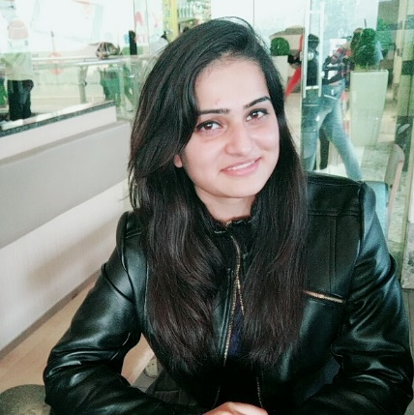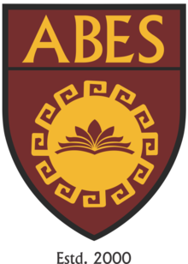

Title: Can I 3D Print ?
Author Name: Krati Taneja
ABES Engineering College , India

Abstract
In modern world scenario, the demand of 3D designs is increasing progressively. In this research paper the focus is on recent researches and the current trends going on in 3D Printing technology. This paper initiates from defining basics of 3D Printing technology and ends with its wide range applications, scope, emerging trends and finally the growth cycle of 3D Printing technology in household applications by figuring out various questions such as “Will 3D Printing technology reach our Homes i.e will it be used by common or less technically sound people, will we people be able to utilize our creativity to design and print what we actually want?” If yes then how is it useful to ordinary people. The grown use and decreased cost of these printers has brought a revolution in the field of manufacturing.

Presenting Author Details:
Full Name: Krati Taneja
Contact Number: 8800102454
Email-Id: kratitaneja3@gmail.com
Category: Oral presentation
Research Interest: Application of 3D Printing

