KNUCKLE FINGER IMAGER FOR IDENTIFICATION USING ACCURATE PERSON MATCHING SCORE

Anchana.G.V.
Department of ECE
anchanagv@gmail.com
PSVP Engineering College, Chennai

Ajima.R.
Department of ECE
Ajima091997@gmail.com
PSVP Engineering College, Chennai

Mrs.J. Gayathri
Assistant Professor
Department of ECE gayathrijayakumar13@gmail.com
PSVP Engineering College, Chennai

ABSTRACT
A biometric system using finger knuckle patterns has recently grown interest of researchers worldwide. Compared with its hand counterparts, palm and knuckle parts has several unique merits. Knuckle print based biometric system is highly acceptable because these patterns do not disturb with injury and wound the on finger surface. However, geometrical and textural features have been used widely in most of the existing knuckle print recognition methods where an individual is verified by extraction of size, length, position and shape features. This paper presents a matching score scheme for personal recognition using novel inner knuckle print based features i.e., knuckle distance based geometrical features, and texture features. The proposed method is tested on our in-house Hand database (720 images) collected over a span of 3 months. Finally, the test and training images are compared in terms of using fusion and decision algorithm.

Keywords:-Geometrical and Texture features, Matching score, in-house Hand database, Fusion and Decision Algorithm

1.INTRODUCTION
Digital image processing is the use algorithms to perform image processing on digital images. As a subcategory or field of digital signal processing, digital image processing has many advantages over analog image processing. It allows wider range of algorithms to be applied. It avoids problems such as the build-up of noise and signal distortion during processing. Since images are defined over two dimensions (perhaps more) digital image processing may be modelled in the form of multidimensional systems.
Digital Processing techniques help in manipulation of the digital images in image processing. Personal recognition based on hand biometric traits has been widely used in most of the modern security applications due to its low cost in acquiring data, its reliability in Aof acceptance by the user. Most of the research works proposed in hand based biometric authentication used different modalities viz., fingerprint, palm print, hand geometry, hand vein patterns, finger knuckle print and palm side finger knuckle print. Among these biometric traits, fingerprint is considered to be the very old trait and known as the first modality used for personal identification. Apart from the various beneficial aspects, fingerprint also possesses some limitations such as its vulnerability toward intrusion of acquired image and its features such as minutiae, singular points, and delta points, are highly distracted by means of wounds and injuries created on the finger surfaces.
A biometric system based on hand characteristics has been playing a substantial role in instituting human identity in most access control applications. The numerous features on palm or dorsal surface of the hand are very informative and have very unique anatomical structure as. These features can be captured with low cost and small size imaging devices without mounting extra hardware needs, provide smaller size templates and appropriate for large population practices.
The most commonly used hand based biometrics are hand geometry or shape, fingerprint, finger geometry, nail bed, palm print, dorsal hand vein, finger dorsal knuckle print, finger vein, finger inner knuckle print, and palm vein. Fingerprint is the oldest and provided basis for initial identification systems. Apart from its extensive usages, fingerprint has few drawbacks which limit its role in certain applications. It has been observed that fingerprint features like singular points, minutiae, and delta points can be easily disturbed with injury and wound on the finger surface. It is seen that the quality of fingerprint get faded for cultivators and laborers. No single biometric technique can meet all requirements in circumstances. To overcome the limitation of the uni modal biometric technique and to improve the performance of the biometric system, multimodal biometric methods are designed by using multiple biometrics or using multiple modals of the same biometric trait, which can be fused at four levels: image (sensor) level, feature level, matching score level and decision level. The rest of this paper is organized as follows. Section 2 discusses the extraction of proposed system. Section 3 describes the extraction and the matching of global features using Tophat filter. Section 4 presents the matching score of two fingers. Section 5 presents the fusion and decision based FKP recognition algorithm. Section 6 reports the experimental results. Finally, conclusions are made in Section 7.

1.1. KNUCKLE PRINT RECOGNITION
The proposed system is a novel framework of combining the knuckle print at the matching score level. IKP recognition method suffered from finger pose variations, as this lead to false rejections in the matching process involved. In order to handle the issues occurred during the process, a peg based imaging setup is developed to acquire the fixed position fingers. Otherwise matching accuracy may fall massively due to flexibility in finger.
The input images are colour images. The colour images are converted to grey scale images using grey scale conversion. In binary conversion, grey scale images are converted to binary images 0’s and 1’s.In image complement of a binary image, 0’s become 1’s and 0’s become 1’sHistogram equalization is a technique for adjusting image intensities to enhance contrast. Histogram equalisation is a technique for adjusting image intensities to enhance contrast. The method is useful in images with backgrounds and foregrounds that are both bright or both dark. Histogram equalization. methods seek to adjust the image to make it easier to analyse. It improves visual quality.
Top-hat filtering computes the opening of the image and then subtracts the result from the original image. The output image BW replaces all pixels in the input image with luminance greater than level with the value 1 (white) and replaces all other pixels with the value 0 (black). then Tophat filter is used to remove the noise. Finally, the line images are obtained. the principal line based method is able to provide stable performance for verification.
To define and extract the local orientation of the image, we make use of the competitive coding scheme which has been used for FKP recognition. Thus, better recognition performance could be expected by combining these three local features together in some way.

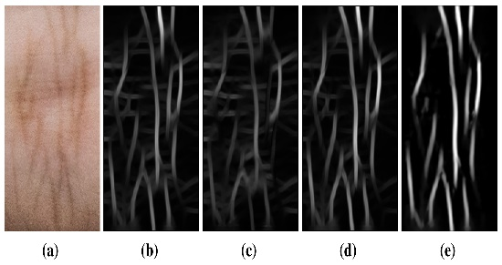
Fig .1. Pre-processing
The flowchart given above explains the process undertaken. Below fig(a) represents the input image, fig(b) represents greyscale image, fig(c) represents contrast image, and also fig(d) represents complement of the image, fig(e) represents binary image.
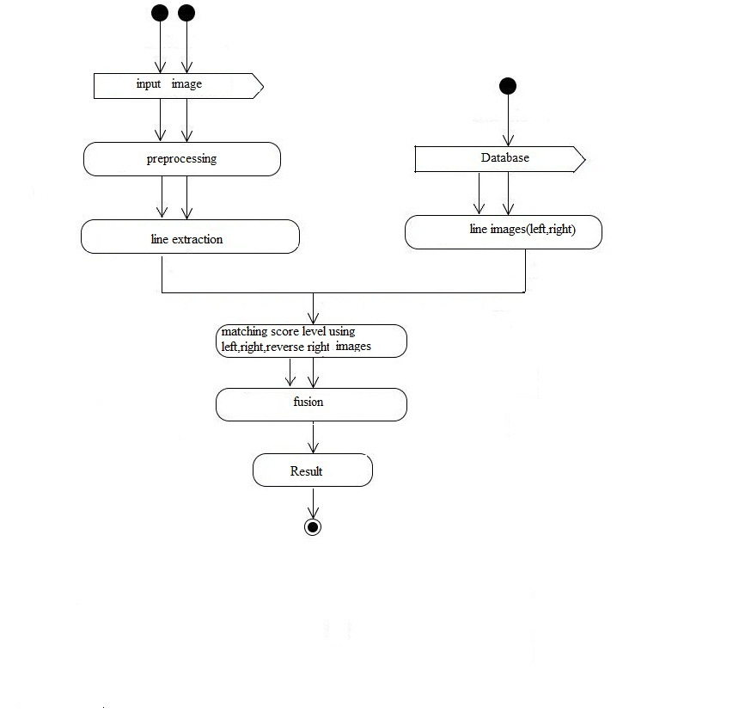 Fig 2. Flowchart
1.3. TOPHAT FILTER

The Top-hat filter refers to several real-space and Fourier space filtering techniques which is different from the top-hat transform. The top-hat name originates from the shape of the filter. This filter is a rectangle function. The Tophat filter performs nearest-neighbour filtering and incorporates components from neighbouring function values. The practical use of Tophat filter is limited as the real-space representation used in sin function. It has the undesirable effect on non-local frequencies. Top-hat filtering is the process of subtracting the result that performs a morphological opening operation from the input image itself.
IM2=imtophat (IM, SE)
The above equation performs the morphological top-hat filtering on the grayscale or binary images. Imtophat uses the structuring element SE, where SE is returned by strel. SE must be a single structuring element object and not an array containing multiple structuring element object.
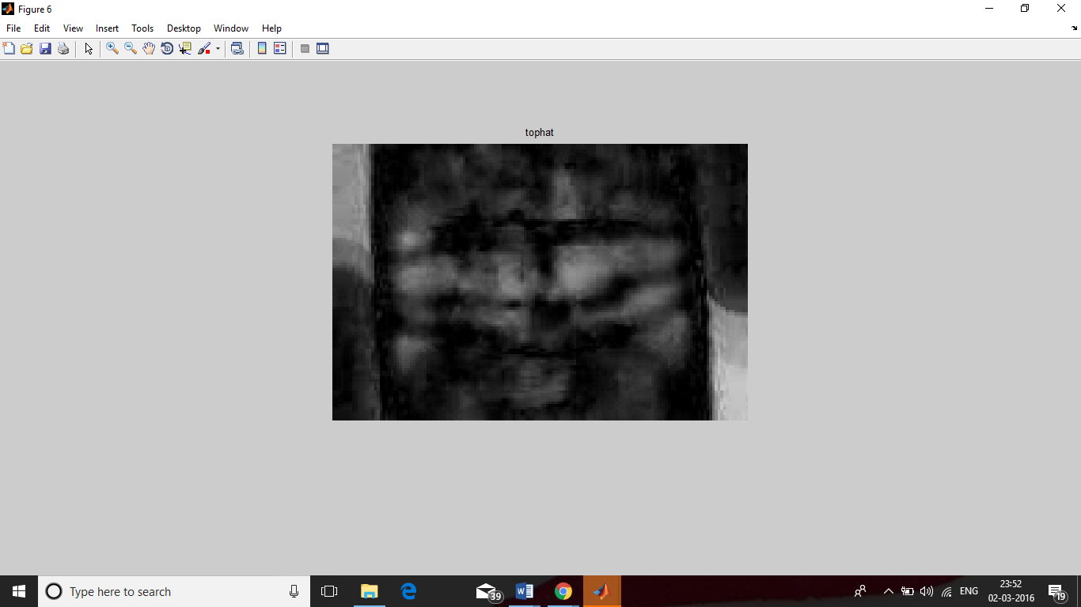
Fig 3. Tophat Image

After filtering, the image is dilated and elated in order to obtain the principal lines that are found in knuckles. These lines are used in next level of processing the image i.e. matching score. an approximate top-hat filter can be constructed in analogue hardware using approximate low-band and high-band filters. The top hat filter is based on neighbourhood ranking, but it uses the ranked value from two different size regions. Tophat filters are mainly used in order to level both the features present in knuckles. So Tophat filter is the main method used in this knuckle print recognition.

1.4. MATCHING SCORE
Matching score is a technique in digital image processing for finding small parts of an image which match a template image. It can be used in manufacturing as a part of quality control, as a way to detect edges in images. If the template image present in the database has effective knuckle features, a feature-based approach may be considered as one of the technique to improve this recognition process; the approach may prove further useful if the match in the search image might be transformed in few fashion.
The match score is a measure of similarity between the input and template biometric feature vectors. When match scores output by different biometric matchers are consolidated in order to arrive at a final recognition decision. The match scores contain the richest information about the input patterns.
S (A, B) = sum (sum (A (i, j) & ¯B (i, j))/NA.
Where A and B are two lines images, “&” represents the logical “AND” operation, NA is the number of pixel points of A, and B¯(i, j ) represents a neighbor area of B(i, j ).For example, B¯(i, j ) can be defined as a set of five pixel points, B(i −1, j ), B(i +1, j ), B(i, j ), B(i, j −1), and B(i, j +1). The value of A(i, j ) & B¯(i, j ) will be 1 if A(i, j ) and at least one of B¯(i, j ) are simultaneously principal lines points, otherwise, the value of A(i, j ) & B¯(i, j ) is 0. S(A, B) is between 0 and 1. Thus, the query image can be classified into the class that produces the maximum matching score. Sometimes matching score may produce fake recognition such as unauthorized person is shown as authorized one. In order to overcome this drawback fusion and decision algorithm is carried out.

1.5. FUSION AND DECISION ALGORITHM
Fusion process can be defined as the process of combining matching scores obtained from each finger knuckle regions using different fusion rules in order to obtain better performance in terms of accuracy. The goal of this fusion process is to integrate the matching scores obtained through geometric and texture analysis methods from different finger knuckle regions. It is to investigate the integrated performance of the proposed personal authentication system. All the four finger knuckle regions exhibit different dermal patterns which can be treated as different modality. Hence, it is meaningful to combine the formation obtained from different finger knuckle regions using fusion process Fusion process can be defined as the process of combining matching scores obtained from each finger back knuckle regions using different fusion rules in order to obtain better performance in terms of accuracy.
The data concerning a certain phenomenon in the recognition are often summarized in a few bits. When inferring on a binary event, in the extreme case only binary decisions are sent to a Decision Fusion Centre (DFC) and combined in order to obtain improved classification performance. From this recognition process the output is obtained.
Decision level fusion was chosen against data fusion and feature fusion in the fusion hierarchy. Because of its feasibility, lower computational complexity and robustness to the removal, it has been used in many processes. It has the power to automatically generate a solution given a library of features, data-mining algorithms and fusion techniques. This process are comparable.

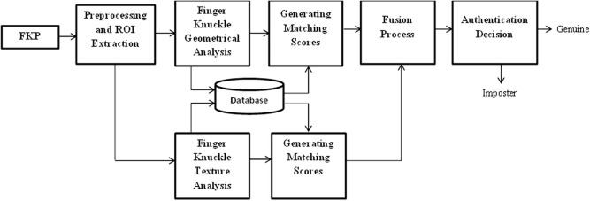
Fig 3. Block diagram for Fusion and Decision Algorithm
2.EXPERIMENTAL ANALYSIS
From the input image the RGB is converted in to gray scale image. Then it is converted into binary images. Histogram Equalisation is used to enhance the image. Decision-level fusion is most convenient for such data, but it is suboptimal in principle, since targets not detected by all sensors will not obtain the full benefits of fusion.

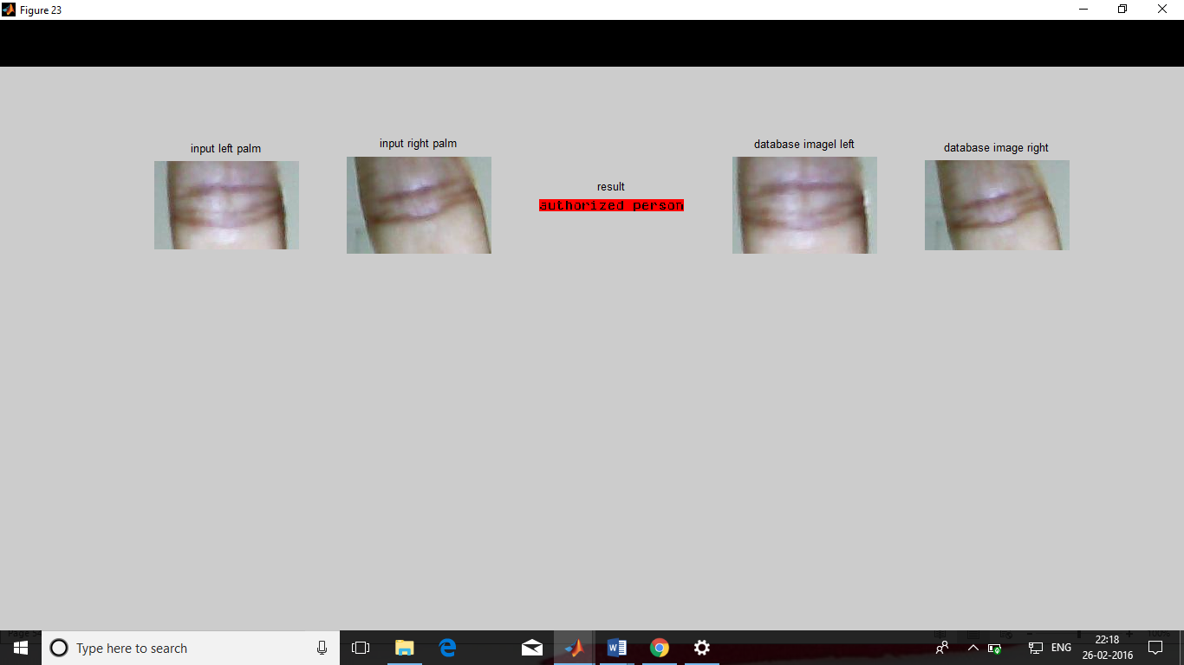

Fig 4. Output Image

3.CONCLUSION AND DISCUSSION
The proposed results are also compared with some well-known existing systems which reveal the significance of proposed multi-feature fusion strategy. In addition to this, there is no standard benchmark dataset is available for IKP feature analysis. Our dataset lacks uniform results due to uncontrolled illuminations using contactless acquisition sensor. It has been observed that measuring interfinger cross knuckle distance for IKP recognition is a novel and unique mechanism, but it needs further amendments. Finally, we get a line images. the principal line based method is able to provide stable performance for verification.

REFERENCES

[1] A. Jain, A. Ross, and S. Prabhakar, “An introduction to biometric recognition,” IEEE Transactions on Circuits and Systems for Video Technology, pp. 4-20, 2004.J. Clerk Maxwell, A Treatise on Electricity and Magnetism, 3rd ed., vol. 2. Oxford: Clarendon, 1892, pp.68-73.
[2] Gaurav Jaswal, Amit Kaul, and Ravinder Nath. "Knuckle Print Biometrics and Fusion Schemes--Overview, Challenges, and Solutions." ACM Computing Surveys (CSUR) 49.2, 2016.
[3] Domenico Ciuonzo, and Pierluigi Salvo Rossi. "Decision fusion with unknown sensor detection probability." arXiv preprint arXiv:1312.2227, 2013.
[4] Ajay Kumar, and K. Venkata Prathyusha, “Personal authentication using hand vein triangulation and knuckle shape”, IEEE Transactions on Image processing 18, no. 9, pp. 2127-2136, 2009.
[5] Adams Kong, David Zhang, and Mohamed Kamel, “A survey of palm print recognition Pattern Recognition,” 42.7, pp. 1408-1418, 2009.
[6] Charles Colbert, "Knuckle profile identity verification system", U.S. Patent No. 5,594,806, 1997.
[7] Lin Zhang, Lei Zhang and David Zhang and H. Zhu, “Online Finger Knuckle Print Verification for Personal Authentication”, Pattern Recognition7, 43, pp. 2560–2571, 2010.

.

