


Title: Fabrication of composite filaments with high dielectric permittivity for fused deposition 3D printing
Author (s) Name: Yingwei Wu, Dmitry Isakov, Patrick S. Grant
University of Oxford, UK

Additive manufacturing of complex structures with spatially varying electromagnetic properties can enable new applications in high-technology sectors such as communications and sensors. This work presents the fabrication method as well as microstructural and dielectric characterization of bespoke composite filaments for fused deposition modeling (FDM) 3D printing of microwave devices with a high relative dielectric permittivity of 11 in the GHz frequency range. The filament is composed of 32 vol%of ferroelectric barium titanate (BaTiO3) micro-particles in a polymeric acrylonitrile butadiene styrene (ABS) matrix. An ionic organic ester surfactant was added during formulation to enhance the compatibility between the polymer and the BaTiO3. To promote reproducible and robust printability of the fabricated filament, and to promote plasticity, dibutyl phthalate was additionally used. The combined effect of 1 wt % surfactant and 5 wt % plasticizer resulted in a uniform, many hundreds of meters, continuous filament of commercial quality capable of many hours of uninterrupted 3D printing. We demonstrate the feasibility of using the high dielectric constant filament for 3D printing through the fabrication of a range of optical devices. The approach herein may be used as a guide for the successful fabrication of many types of composite filament with varying functions for a broad range of applications.

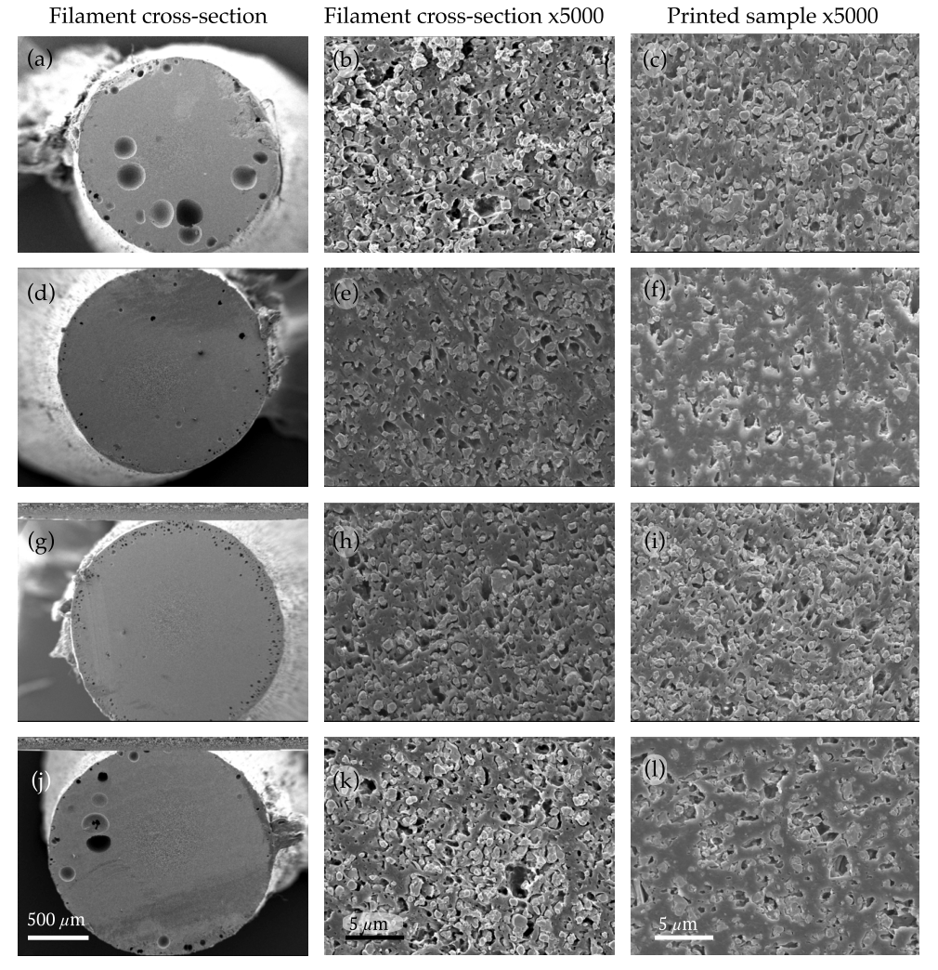
Figures if any (BW/Color):

Figure 1. Electron micrographs of the cross-section of 30 vol% BaTiO3/acrylonitrile butadiene styrene (ABS) filament (left and middle columns) and 3D-printed coupons (right column). (a-c) BaTiO3/ABS with 0 wt% surfactant; (d-f) 0.5wt% surfactant; (g-i) 1.0wt% surfactant; (j-l) 1.5wt% surfactant.
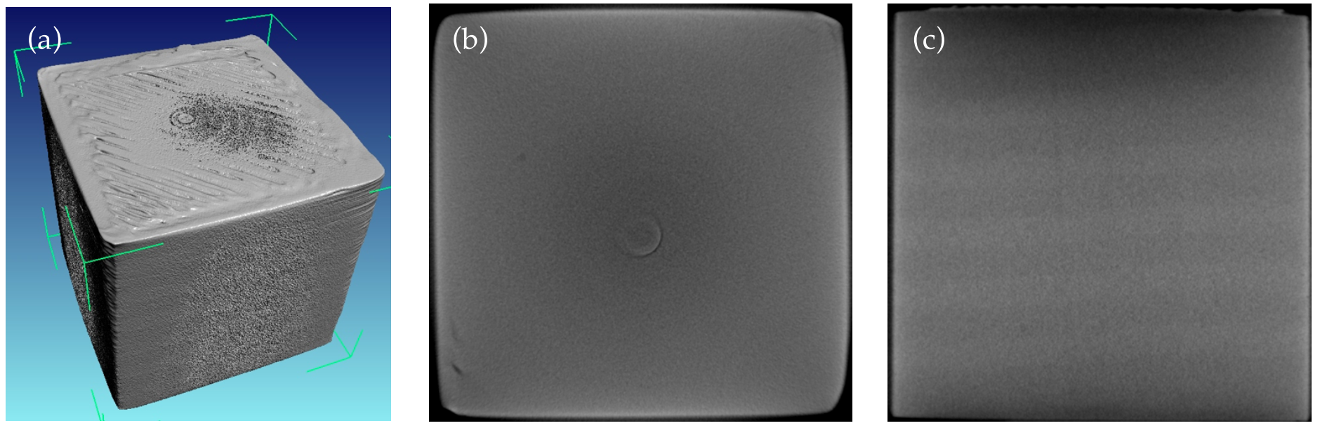
Figure 2. X-tay tomography image of the 3D-printed 15 by 15 by 15 mm^3 cube using optimized composite filament. (a) Full 3D reconstruction; (b) xy-plane cute; (c) xz-plane cut. The images show the absence of voids or interlayer/interfilament porosity.

Biography

Yingwei Wu is a second year PhD student from University of Oxford. Her research topic is on using additive manufacturing (3D printing) to print devices with novel functionality working at microwave frequency range with anisotropic and graded materials to achieve spatial control of electromagnetic waves.

Presenting author details
Full name: Yingwei Wu
Contact number: 7494 314567
Email id: yingwei.wu@materials.ox.ac.uk
Category: (Oral presentation)
Session name: (Track 1-9 or Track 10-4) Fabrication of composite filaments with high dielectric permittivity for fused deposition 3D printing
Research interest: dielectric composite materials, fused deposition modeling, 3D printing

