

Title: Use of Biomaterials for Large-Scale Additive Manufacturing
Author (s) Name: Timothy J. Theiss, Halil Tekinalp, Erin G. Webb, Soyan Ozcan
Oak Ridge National Laboratory, Oak Ridge, TN USA

Oak Ridge National Laboratory (ORNL) is pioneering the use of bio-derived polymer materials for large-scale additive manufacturing. Large-scale polymer additive manufacturing is enabled through the use of blending fibers with a resin matrix. The fibers provide dimensional stability for the resin and constitute anywhere between 10% and 40% by weight of the composite. Polylactic acid (PLA) is currently used as the bio-resin with a variety of bio-derived fibers, such as flax, bamboo and poplar. Several large-scale components and structures have been successfully printed with these materials leading to interest in the use of additional feedstocks. For example, bamboo/PLA was used successfuly to print a large pavilion for an architectural display in December 2016. The use of poplar is of keen interest as this feedstock is a suitable energy crop is the USA. Poplar was milled and fracionated by particle size. Larger fibers were compounded with PLA and used for large-scale additive manufacturing while smaller sizes are attractive for biofuel production. An integrated process capable of supplying fiber for 3D printing and feedstock for biofuel production would be ecomically attractive. ORNL is currently evaluating the use of poplar for its suitability as a 3D printing material for large scale additive manufacturing and biofuel production.
(Up to 250 words)

Figures if any (BW/Color):

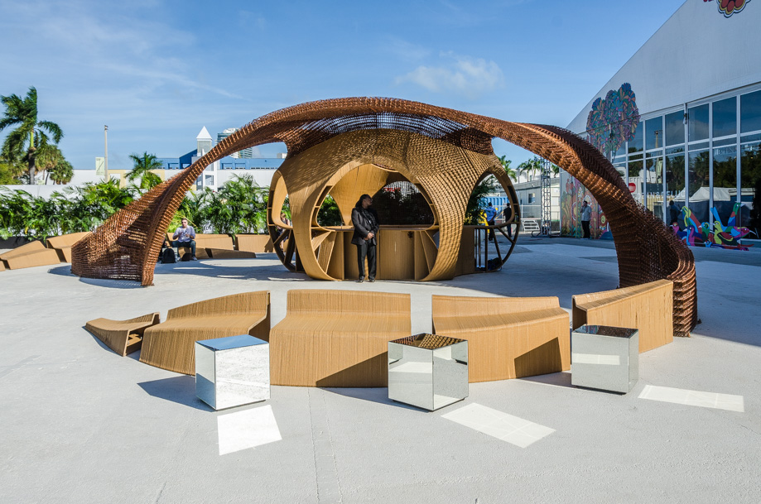
A large pavilion was printed from a formulation of bamboo/PLA for the Design Miami Show in Dec. 2016

Biography
Mr. Theiss has been a staff member at the US Department of Energy’s Oak Ridge National Laboratory (ORNL) since 1987, as a research development staff member, a group leader and a program manager. Tim has been serving as the ORNL Program Manager for the DOE Bioenergy Technologies Program for the past 6 years. He has published over 75 papers or reports in a broad range of topics. He has a BS degree from Tennessee Technologica University and a Master’s degree in Engineering Mechanics from Virginia Polytechnic Institute (Virginia Tech).
(Up to 100 words)
Presenting author details
Full name: Timothy J. Theiss
Contact number: +1 (865) 946-1348
Email id: theisstj@ornl.gov
Category: Oral presentation
Session name:
Research interest:

