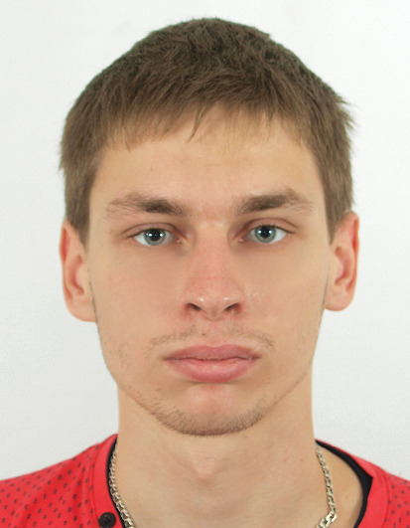
Title: Metasurfaces with graphene lattice fabricated by direct laser writing.
Name: Artem Sinelnik
ITMO University, St. Petersburg 197101, Russia

Metasurfaces are two-dimensional periodical structures that consist of nano- and microscale particles with the lattice spacing less than a wavelength of incident light. The fabrication of metasurfaces is novel area of materials science with many promising applications. Metasurfaces make is possible to tune the wavefront and phase of incident electromagnetic radiation according to arbitrary law.
The aim of our work is to fabricate metasurfaces with graphene-type lattice ('honey-comb' structure) and to study it’s by means of optical methods. We fabricate over 300 samples with different parameters by exploiting two-photon polymerization direct laser writing technique. The side of the hexagonal comb is varied from 0.3 µm to 2 µm, and the number of hexagons forming the structure is changed from a few to several hundreds.
To control the quality of the synthesized samples we use scanning electron microscopy. Also the fabricated structures are studies by optical methods. We investigate diffraction patterns of our structures in the visible range. A Nd-laser with 0.532 µm wavelength is used as light source. Although some samples have small sizes, the diffraction patterns on a 40 by 40 cm screen are bright and can be clearly analyzed by a naked eye. We investigate an evolution of the diffraction patterns of structure being transformed from metasurface to photonic crystal regime. This transition can be detected by appearance of the Laue diffraction.

Biography

Artem Sinelnik received his Bachelor degree in optical techniques from Kharkiv National University of Radio Electronics. He is currently doing his Master in the field of Nanophotonics and Metamaterials at ITMO University in Russia. His research activity is focused on fabrication of nanostructures by the direct laser writing technique and studying the fabricated samples by means of optical diffraction.
Presenting author details
Full name: Artem Sinelnik
Contact number: +7 (966) 7593225
Session name/ number: 3D Printing Materials
Category: Poster presentation

