Effect of restricting ice cream intake at night on insulin sensitivity and cardiac function
Hitoshi Adachi, MD, Gunma Prefectural Cardiovascular Center, JAPAN

Abstract
Statement of the Problem: Free fatty acid production from triglyceride is well known to induce insulin resistance, which is reported to be one of the causes of cardiac dysfunction in patients with dyslipidemia. Nocturnal monosaccharide overtaking causes hypertriglyceridemia, and withholding it is supposed to reduce fasting triglyceride levels. And as a result, there is a possibility that cardiac dysfunction would improve. Hereby, we investigated the effect of restriction of night-time ice cream intake on insulin resistance and cardiac function.
Method: Thirteen patients with cardiac dysfunction who routinely take ice-cream at night were enrolled. We instructed them not to eat ice cream after 21 o’clock for 3 months, and compared the HOMA-IR, blood triglyceride level, exercise tolerance (peak VO2 and anaerobic threshold) and diastolic cardiac functions before and after the examination.
Findings: Triglyceride level and HOMA-IR significantly improved from 217.2+-63.1 to 150.2+-37.7 mg/dL(p<0.01), and 4.5+2.0 to 2.4+-2.3(p<0.05) respectively. Although, E/A failed to improve, E/E’ and DcT improved significantly from 10.1+-3.0 to 8.1+-2.3(p<0.01) and 241+-65 to 231+-50(p<0.05), respectively. Peak oxygen uptake and anaerobic threshold improved significantly.
Conclusion & Significance: It is concluded that restriction of nocturnal ice-cream improves cardiac function by ameliorates insulin resistance.

Image
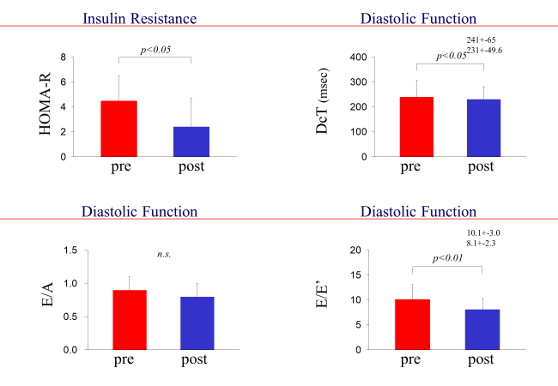

Recent Publications (minimum 5)
- Adachi H, Ohno T, Oguri M Oshima S, Taniguchi k (2007) Effect of insulin sensitivity on severity of heart failure. Diabetes Res Clin Pract 77 Suppl 1:S258-62.
- Jayasinghe SU, Tankeu AT, Amati F. (2019) Reassessing the Role of Diacylglycerols in Insulin Resistance. Trends Endocrinol Metab 30:S1043-2760(19)30123-7855-876.
- Novo G, Manno G, Russo R, et al. (2016) Impact of insulin resistance on cardiac and vascular function. Int J Cardiol 15:1095-9.
- Liu Y, Neumann D, Glatz JFC, Luiken JFP (2018) Molecular mechanism of lipid-induced cardiac insulin resistance and contractile dysfunction. Prostaglandins Leukot Essent Fatty Acids 136: 131-41.
5. Adachi H (2017) Cardiopulmonary exercise test. Int Heart J 58:654-65.



Biography
Dr. Adachi has completed his MD at the age of 32 years from Gunma University and worked as an exchange resercher at Harbor-UCLA medical center. He is the director of Cardiac Rehabilitation division of the Gunma Prefectural Cardiovascular Center. He has published more than 25 papers in the field of cardiac rehabilitation and has been serving as one of the directors of Japanese Association of Cardiac Rehabilitation.

Email: h-adachi@ops.dti.ne.jp

