A review on Robotic surgery in dentistery

In recent years, robot-assisted surgery (RAS) has become one of the hot topics in clinical dentistry research. Recent advances in technology has triggered the introduction of surgical robotics in the field of head and neck surgery and changed the landscape indefinitely. The advent of transoral robotic surgery and robotic techniques has urged the extended applications of the robot to other neck surgeries including remote access and implant surgeries.

A robotic system provides an easy-to-use platform offering increased maneuverability for a surgeon and an improved working environment for the entire surgical team. However, Operation times using a robotic system were prolonged and the costs of robotic surgery were more expensive.

Compared with traditional surgery, RAS has advantages in terms of minimal invasiveness, aesthetics, and functional preservation, and has been gradually applied in clinical practice such as head and neck surgery. In the treatment of head and neck tumors, RAS can effectively minimize the surgical injury and accelerate postoperative recovery.This article provides an overview of robotic surgery applications in oral and maxillofacial surgery.

Major applications of robotics in head and neck surgery were transoral robotic surgery (TORS) but we can use this technology in different fields. TORS was first described by Weinstein et al in 2005 and has gained increasing popularity with head and neck surgical oncologists during the past 15 years. Transoral Robotic Surgery (TORS) has been described for treatment of benign and malignant lesions of the oropharynx, hypopharynx, supraglottis, glottis, skull base, and parapharyngeal space

In implant dentistry, the cost-benefit and cost-effectiveness of robotic surgery, is significant and awaits validation. Use of a surgical guide template is considered a reliable strategy to assist in diagnosis and facilitate proper position of implant placement according to the prosthesis design.

We 2 KEY POINTS about Robotics in Dental Implantology :
1_ the current status of robot-assisted dental implant surgery is evaluated and illustrated with worldwide examples.
2_ the advantages and limitations of the robot-assisted dental implant surgery are discussed. The latest development in autonomous robot is explored.

Early experience with robotic surgery accuracy for the use in maxillofacial surgeries is beginning to gain traction with only a few clinical studies at present.

Despite limitations and early development difficulties, the future of robotic use in this field seems certain to flourish as systems improve and costs go down.

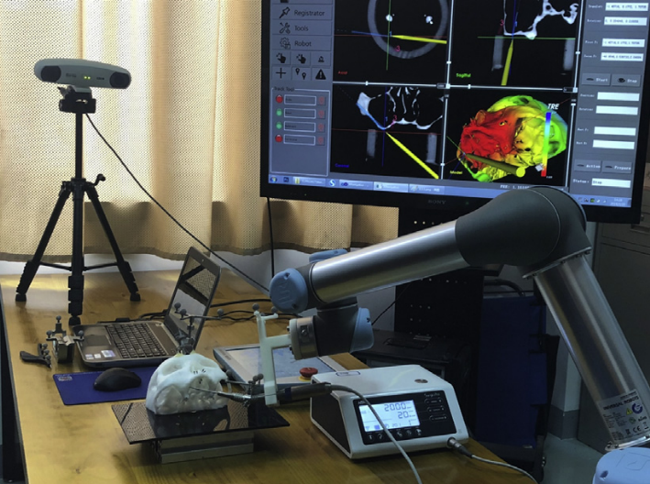

Fig. 1. The surgical robotic system includes thefollowing elements: robot arm, surgical navigation system, optical tracking device, and preoperative planning software.

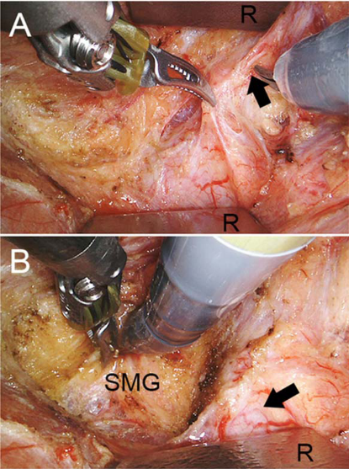
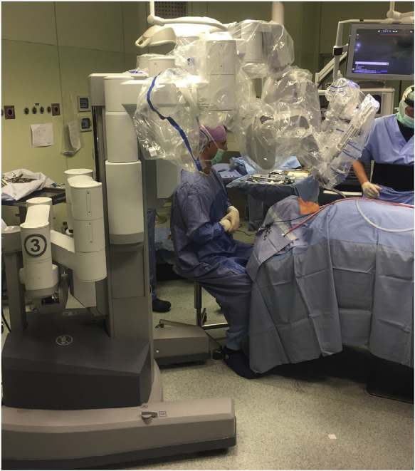

Transoral robotic surgery for hilo-parenchymal submandibular stones

Robotic surgery for submandibular gland resection through a trans-hairline approach
The Universal Application of the Retroauricular Approach

