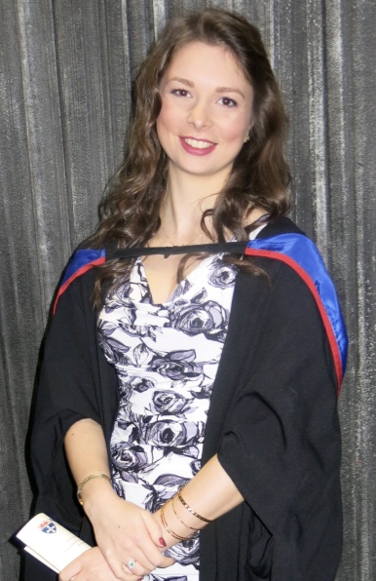
Title: Slowing Down: Dehydration in Desert Drivers
Name: Dr. Isobel Morley

Guy’s and St Thomas’ NHS Foundation Trust &
Automobile Touring Club of the United Arab Emirates

Introduction:
Desert endurance racing risks dehydration but little is known about effects dehydration has in extreme racing conditions. We aimed to study the correlation between dehydration, assessed by urine concentration, and reaction times in desert endurance drivers.

Methods:
We collected urine samples, observations and medical history from drivers and immediately tested reaction times using an application. GraphPad was used to assess for correlation, and its significance.

Results:
We found a statistically significant correlation between urine colour and reaction time (p < 0.0001) and urine colour with heart rate (p = 0.0042). There was no correlation between blood pressure and reaction time or urine colour.
Solo riders had more concentrated urine and longer reaction times than drivers and co-drivers.

Conclusion:
This is the first study to use urine colour as a proxy of hydration status in desert endurance drivers.

We conclude the greater the degree of dehydration, the slower the reaction time. Urine colour can be used as a proxy for dehydration in extreme environments, allowing self-assessment of hydration and ensure adequate hydration when racing in order to maximise performance. This result shows adequate hydration may enhance performance; reducing race times and reducing the risk of dehydration in desert endurance driving.

Biography

Isobel has completed her primary medical degree at Newcastle University, followed by a Masters in Research for which she successfully achieved a Distinction. She has worked in the NHS for over three years and is starting surgical training. She also dedicates her time and skills to the Abu Dhabi Formula 1 and the Abu Dhabi Desert Challenge each year, during which time the extreme conditions provide both questions and answers for interesting research topics.

