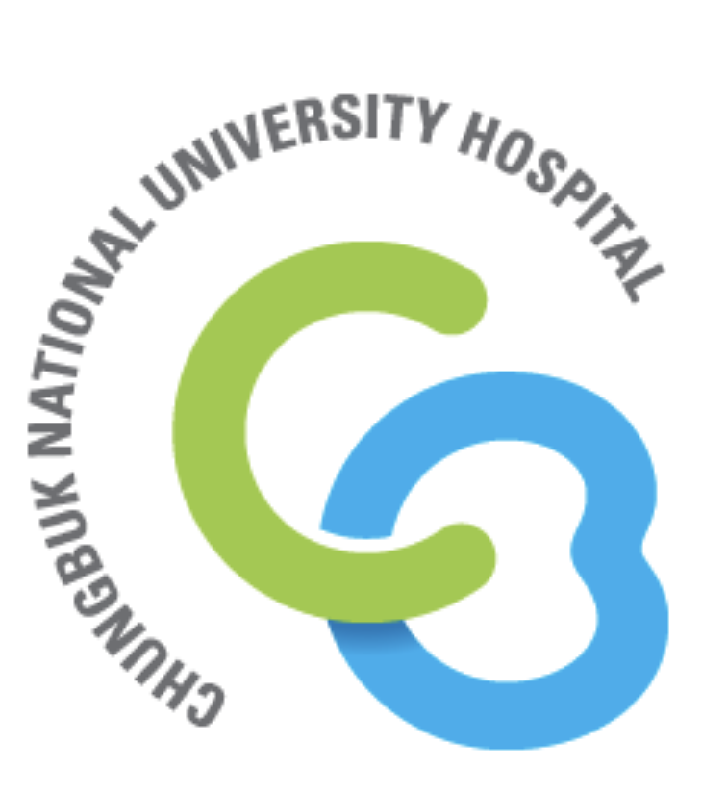

Title: A neural network-based approach for predicting outcomes after hypofractionated gamma-knife radiosurgery for large brain metastases

Name: Hyeong Cheol Moon^{1,2}, Jae Hoon Woo¹, Kyoung-Ha So^{3,4}, Daae Lee², Young Seok Park^{1,2} , Hong Rae Kim¹

¹Department of Neurosurgery, Gamma-knife Icon Center, Chungbuk National University Hospital, Cheongju, South of Korea, ²Department of Medical Neuroscience, Chungbuk National University, Cheongju, South of Korea, ³Institute for Stem Cell & Regenerative Medicine (ISCRM), College of Veterinary Medicine, Chungbuk National University, South of Korea, ⁴Laboratory of Veterinary Embryology and Biotechnology, College of Veterinary Medicine, Chungbuk National University, South of Korea

Gamma knife radiosurgery (GKRS) is commonly employed in patients with brain metastases, but the predictions of patient outcomes after hypofractionated treatment for large brain tumors (diameter >3 cm) are inaccurate. The purpose of this study was to predict the outcomes after hypofractionated GKRS (hfGKRS) for mask-based treatment of large brain metastases using an artificial neural network (ANN). ANN approaches feature engineering and model optimization to find the most accurate prediction of large brain tumor outcomes. From the 28 patients treated with magnetic resonance imaging (MRI) before hfGKRS, 40 large brain lesions with 15 features were included for analysis in the randomized training sets, and 18 brain lesions were included in the test sets. We used to follow up MRI for label data to visualize the data 3 months after hfGKRS treatment. The highest accuracy was 80% and 75% each of multi-layer perceptron (MLP) and single-layer perceptron (SLP), respectively. This MLP could provide the best possible prediction of hfGKRS outcomes and could be applied to protocol for further development for medical care. These results suggest that ANNs are useful models for predicting hfGKRS outcomes in large brain metastasis. We also demonstrated that daily hfGKRS showed highly local control rates in brain metastasis.

Biography

Mr. Moon is a medical physicist from Chungbuk National University Hospital, and a PhD course student. He has publised more than 10 papers in reputed journals. He works in Gamma-knife Icon Center from 2018. He is interested in ultra-high field 7T MRI, quality assurance for gammaknife radiosurgery, and artificial neural network.

Presenting author details
Full name: Hyeong Cheol Moon
Contact number: 82-10-4536-5434
E-mail : jimmun@cbnuh.or.kr,
Category: Poster presentation

