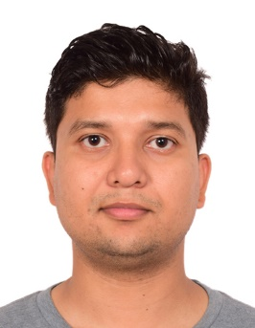


Title: Massive MIMO Technology for 5G Communication
Author (s) Name: Robin Chataut
University of North Texas, Denton, Texas, USA
Abstract
With globalization, present-day networks are facing high traffic demands, the cellular networks are deployed within a few hundred-meter distances, and wireless local area networks are available almost everywhere. To meet this increasing demand, we need to achieve much higher area throughput, which is the product of spectral efficiency, cell density, and bandwidth. With the current technology and designs, either bandwidth or cell density is increased to fulfill the demands. However, these resources are certainly reaching their saturation point. Furthermore, the increase in bandwidth and cell densification makes the system more expensive, increases latency, and decreases the signal to noise ratio. Because cellular network frequencies below 5GHz are suitable for cellular network coverage, bandwidth has also become a scarce resource. However, with these other improvements, the third factor affecting area throughput, spectral efficiency, has remained mostly untouched and unchaned.
To achieve the goals of the fifth generation ‘5G’ network, it is highly desirable to improve the area throughput. This area throughput should be increased by increasing the spectral efficiency rather than by increasing bandwidth or cell density. Massive MIMO (Multiple Input Multiple Output) is a technique which increases the spectral efficiency of cellular networks by deploying hundreds or thousands of antennas at base stations and performing coherent transceiver processing. The challenge now is to improve spectral efficiency to accommodate more wireless traffic with higher reliability and accuracy. In massive MIMO orthogonal, pilots are reused in many cells as there is limited channel coherent time due to mobility. This reuse of pilot causes pilot contamination, which limits throughput. To achieve higher spectral efficiency, which is required for future generation networks, efficient and robust pilot reuse methods are required. Existing precoding, decoding, and channel estimation designs for massive MIMO have higher computational complexity and lower spectral efficiency. We are currently developing new algorithms that will decrease the complexity associated with currently existing designs and will improve spectral efficiency. To meet the anticipated demand of 5G networks, it will require about 1000-fold improvement in spectral efficiency when compared to IMT advanced requirement for 4G (3 bits/s/Hz). We have achieved around 60 bits/s/Hz, which is 20 times more than the current requirement for 5G by developing robust decoding, precoding, channel estimation, and new scheduling algorithms.
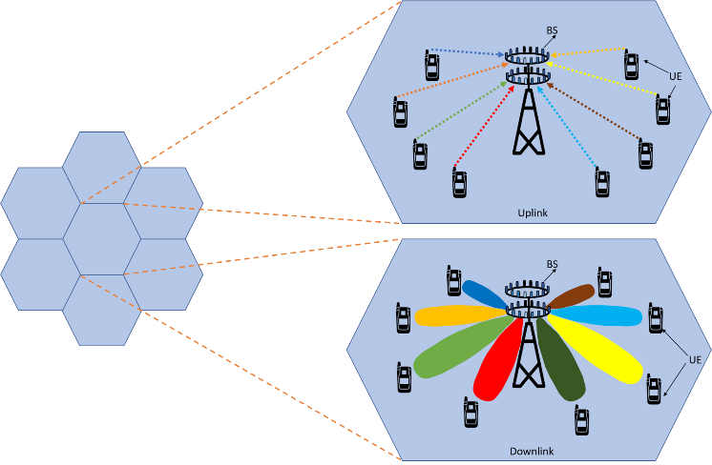

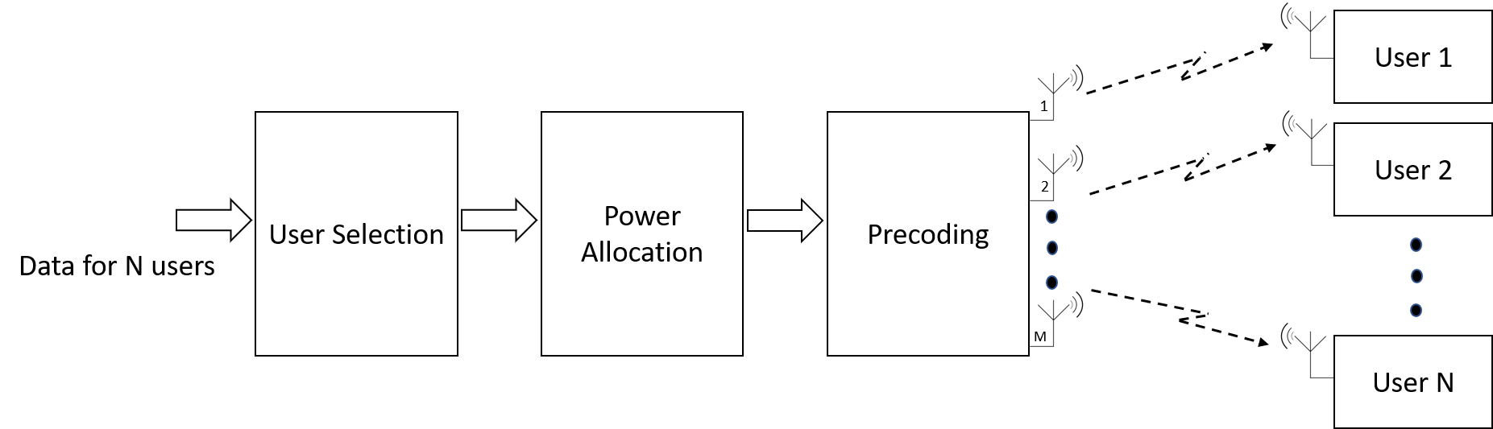
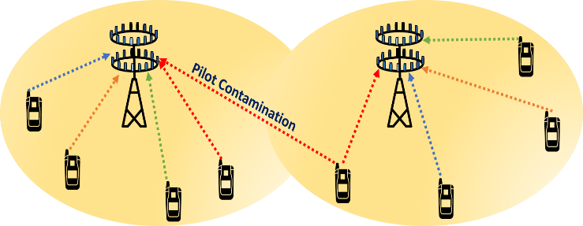
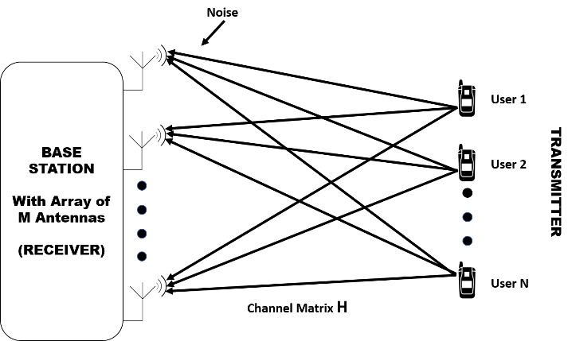

Recent Publications

- R. Chataut., R. Akl, U.K. Dey ."Least Square Regressor Selection Based Detection for Uplink 5G Massive MIMO Systems,".April 2019 The 20th Annual Wireless and Microwave Technology Conference (IEEE WAMICON 2019).

- R. Chataut., R. Akl ."Huber Fitting Based ADMM Detection for Uplink 5G Massive MIMO Systems,".November 2018. The 9th Annual Ubiquitous Computing, Electronics & Mobile Communications Conference (IEEE UEMCON 2018).

- R. Chataut., R. Akl ."Efficient and Low Complex Uplink Detection for 5G Massive MIMO Systems,".April 2018. The 19th Annual Wireless and Microwave Technology Conference (IEEE WAMICON 2018).

- R. Chataut., R. Akl ."Optimal Pilot Reuse Factor Based on User Environments in 5G Massive MIMO,,".January 2018. The 8th Annual Computing and Communication Workshop Conference (IEEE CCWC 2018).

- R. Chataut., R. Akl."Channel Gain Based User Scheduling for 5G Massive MIMO Systems,,".Submitted to “2019 IEEE 16th International Conference on Smart Cities: Improving Quality of Life Using ICT & IoT and AI (HONET-ICT)”

Biography

Robin Chataut is a Ph.D. candidate in Computer Science and Engineering program at the University of North Texas. He is currently working as a research assistant at Wireless Sensor Lab, University of North Texas. His research interests are in 5G networks, mainly focused on Massive MIMO systems and has published several research papers on this domain. He holds a Bachelor degree in Electronics and Communication Engineering from Tribhuvan University, Nepal.

Presenting author details
Full name: Robin Chataut
Contact number:+19402200158
Email id: robinchataut@my.unt.edu
Website: robinchataut.com
Category: Poster presentation
Research interest: 5G, 4G

