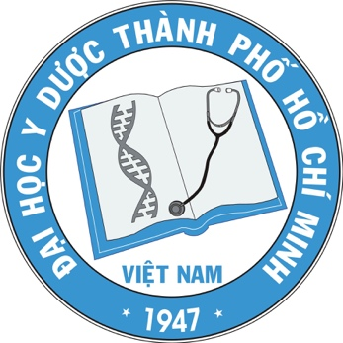
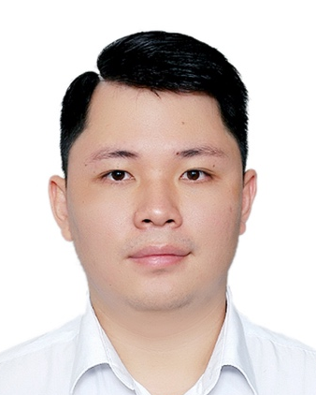

Title: Evaluation of efficacy of tissue autofluorescence imaging in the diagnosis of oral cancer
Name: TRAN MINH CUONG¹, TRAN NGOC LIEN¹, NGUYEN PHAN THE HUY¹, NGUYEN DUC TUAN¹, DANG HUY QUOC THINH², NGUYEN THI HONG¹

¹: University of Medicine and Pharmacy at Ho Chi Minh City; ²: Ho Chi Minh City Oncology Hospital, Vietnam

Background: Normal oral mucosa emits a pale green autofluorescence while abnormal tissue may show loss of autofluorescence and appears dark in contrast. Loss of autofluorescence as an early phenomenon associated with tissue degeneration seems to be promising for the diagnosis of oral cancer.
Objective: To assess the value of tissue autofluorescence imaging in the diagnosis of oral cancer.
Materials and methods: The cross-sectional study was conducted on 133 patients with non-healing oral mucosal lesions. After oral examination under white light, the tissue autofluorescence imaging using VELscope® was applied. All the lesions were biopsied for definitive diagnosis. The diagnostic values were calculated for the autofluorescence imaging compared to histopathological diagnosis.
Results: In total there were 133 oral mucosal lesions, among them 107 malignant ones (80.5%) and 26 benign ones (19.5%). The autofluorescence imaging displayed high sensitivity of 90.7% and average specificity of 46.2%. The accuracy of this test was 82.0%. The positive predictive value was 87.4% and the negative predictive value 54.5%. The area under the curve (AUC) was 0.68. The Kappa coefficient was 0.4, which showed a moderate agreement between autofluorescence imaging and histopathology.
Conclusion: As a simple and non-invasive technique, with high sensitivity, the tissue autofluorescence test could be a useful diagnostic adjunct to visual inspection for the detection and localization of oral cancer lesions. However, autofluorescence results must be interpreted with caution and cannot replace conventional histopathological examination.

Biography

Tran Minh Cuong has completed DDS degree at the age of 24 years from University of Medicine and Pharmacy at Ho Chi Minh City, Vietnam. Now he is PhD graduate student at Department of Oral and Maxillofacial Surgery of Tokyo Medical and Dental University, Japan. His main reseach theme is about clinocopathology of oral cancer.

