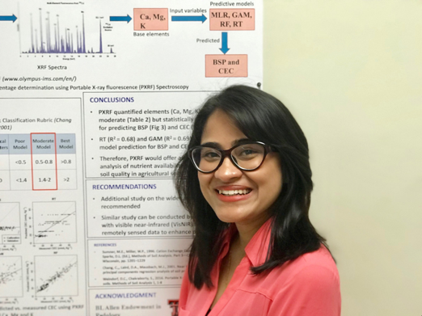

Title: Determination of base saturation percentage in agricultural soils via portable X-ray fluorescence spectrometer
Name: Ashmita Rawal
Texas Tech University, Department of Plant and Soil Science, TX 79409, USA

Soil base saturation percentage (BSP) plays an important role in the assessment of soil taxonomic classification and soil fertility. Conventionally, soil BSP measurement methods are fraught with many drawbacks such as being time consuming, laborious, and cannot be performed directly in the field. Recently, proximal sensors such as portable X-ray fluorescence (PXRF) spectrometry have proven to be effective for rapid physicochemical analysis of soils. In this study, we proposed and examined a PXRF-based method to predict BSP using 300 soil samples from agricultural lands across six states in the USA; Colorado, California, Minnesota, Nebraska, Oklahoma, and Texas. An Olympus Vanta series PXRF analyzer was employed to measure Mg, Ca, and K for BSP prediction. Predicted BSP was validated against measured BSP using four different multivariate models [generalized additive model (GAM), multiple linear regression (MLR), random forest (RF), and regression tree (RT)] via R 3.5.1. Predictive model performance was assessed via root mean squared error (RMSE), coefficient of determination (R² ), residual prediction deviation (RPD), and the ratio of performance to interquartile (RPIQ) range. While predicting BSP, models exhibited validation R² and RPDs as follows: GAM = 0.58, 1.6; MLR = 0.45, 1.4; RF = 0.62, 1.6; RT = 0.68, 1.8, respectively. This study demonstrated that PXRF elements can be used to predict BSP with fair accuracy for the range of agricultural soils examined. Therefore, PXRF could offer advantages for faster, easy, and in-situ analysis of base elements and soil classification.

Biography

Ashmita Rawal did her undergraduate in Forestry science from Tribhuvan University in Nepal. She is pursuing her Masters degree in Soil Science from Texas Tech University and is planning to graduate in May 2019. She will start her PhD at the University of Wisconsin-Madison from September 2019. She has published a paper for her Masters work in Geoderma of Elsevier journal and had volunteered in different national and international non-governmental organization (INGO). After her undergraduate, she worked as a field officer in CARE Nepal, an INGO and a consultant in World Wide Fund for Nature (WWF).

Presenting author details
Full name: Ashmita Rawal
Contact number: +18062244680
Twitter account: https://twitter.com/ashmita_rawal
Linked In account: https://www.linkedin.com/in/ashmita-rawal-599860b5/
Session name/ number:
Category: (• Oral presentation/ Poster presentation)

