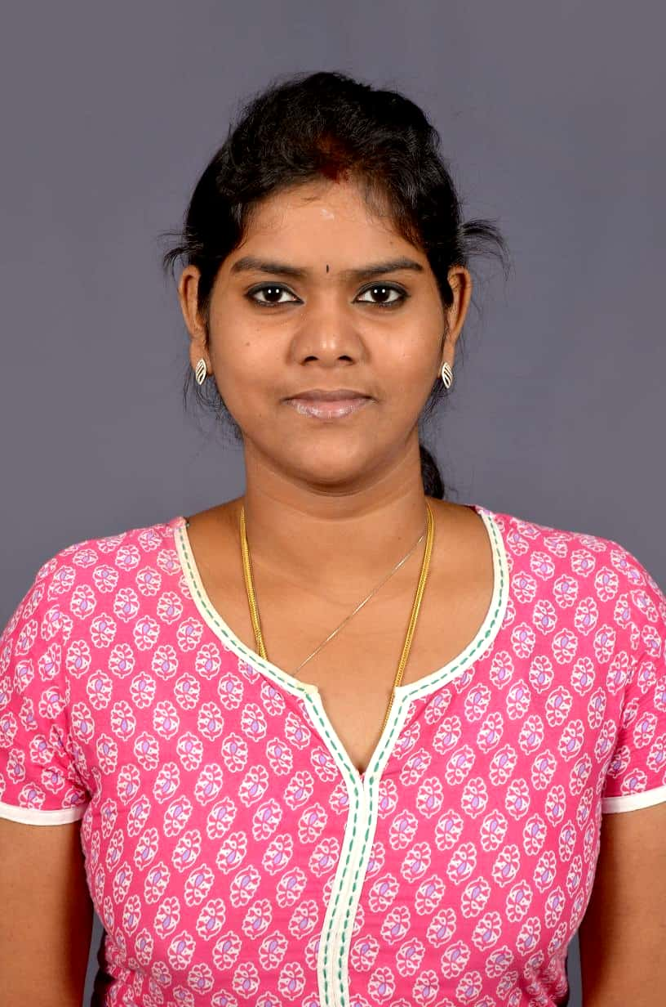 | 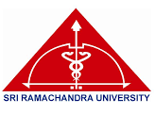
TITLE: EVALUATION OF ANTI-DIABETIC ACTIVITY OF METHANOLIC EXTRACT OF THE MARINE ALGAE Ulva paschima – IN VITRO & IN SILICO SCREENING
Dr. A. Latha Priya
M.D., Ph.D.,(Integrated) Post-Graduate, Department of Pharmacology,
Sri Ramachandra Institute of Higher Education and Research,
Porur, Chennai, Tamil Nadu, India.

Ulva paschima is a novel algae recently discovered in India after 40 years and it requires pharmacological evaluation to explore its therapeutic potential. The present study involves evaluation of this algae for its anti-diabetic potential through in vitro and in silico analysis. The methanolic extract of the algae was subjected to GCMS (Gas Chromatography and mass spectroscopy) analysis to identify the library of compounds present in the algae. Among these, a compound Phenol,2,4-bis (1,1-dimethylethyl) showed favourable binding with all the target proteins namely Alpha-amylase, alpha-glucosidase, Insulin receptor-3, GLUT-4 and SGLT-2 through in silico analysis. This compound showed good binding with all these targets notably GLUT-4 with the least binding energy of -8.2 kcal/mol. Invitro evaluation of antidiabetic activity was elucidated by alpha-amylase and alpha-glucosidase inhibition assay. The algal extract showed a significant enzyme inhibition in a dose-dependent manner which was comparable with the standard drug, Acarbose. The IC-50 value of alpha-amylase and alpha-glucosidase inhibitory activity of methanolic extract of the algae Ulva paschima was found to be 77.37±2.48 µg/ml and 58.33±2.23 µg/ml respectively. Thus, the study algae showed good anti-diabetic activity both in vitro and in silico analysis.

BIOGRAPHY:
Dr.A. Latha Priya, is currently a M.D.,Ph.D (ICMR -Integrated) post-graduate from the department of Pharmacology, Sri Ramachandra Institute of Higher Education and Research, Chennai, Tamil Nadu, India. She is pursuing her research in the field of Marine Pharmacology and is funded by ICMR (Indian Council of Medical Research). She also attended and resourced many workshops and conferences across the country and has good hands-on training in her field of research. She also has a keen interest over medical teaching.

