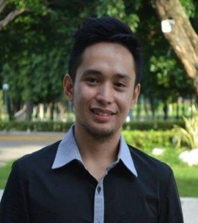Official Photo University/Organization Logo

Thermodynamic Potential in the Spin Polaron Formulation
Marcielow J. Callelero, Ph.D. student, University of San Carlos, Philippines
Danilo M. Yanga, Ph.D., University of San Carlos, Philippines

Abstract (300 word limit)
The thermodynamic potential is calculated in this work using the Linked Cluster expansion theory in the spin polaron formulation. We implement this in the finite temperature (Matsubara) Green’s function method in a representation, where holes are described as spinless fermions and spins as normal bosons. The spins are characterized by the hard-core bosonic operators in linear spin wave theory by way of the Holstein-Primakoff transformation. The hole-spin wave interaction in the spin polaron Hamiltonian resembles the classical polaron problem and is used as the interaction term in the S-matrix expansion. The cumulants in the expansion of the thermodynamic potential is obtained using the Feynman diagrammatic techniques and this is done for normal state cuprates without vertex corrections. This is expressed in terms of the first-order spin wave Green’s function and self-energy term.

Key words: spin polaron, thermodynamic potential, cumulants, Matsubara’s Green’s Function, spin wave

Image
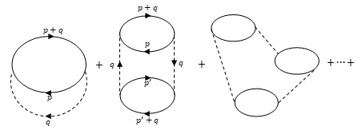
Fig.1 The cumulant diagrams with no vertex correction. The left, middle, and right figures are the first, second, and third cumulants respectively.

Biography
Marcielow J. Callelero has developed an interest in condensed matter physics, high-temperature superconductivity, and theoretical physics. His Ph.D. dissertation focuses on high-order term Feynman diagrams and calculation of vertex corrections in the spin polaron formulation.

Presenting author details
Full name (As per the passport): Marcielow Jocson Callelero
University/Industry/Organization name: University of San Carlos
Designation(Director/Prof/Assistant or Associate prof/Researcher/Student): Ph.D. Student
Country: Philippines
Mobile number (country code – number):+63-9985939392
Email:marcielow123@gmail.com
Track number: https://annualmeeting.conferenceseries.com/dentists/call-for-abstracts.php (For track number follow this link
Category (Oral presentation/ Poster presentation/Young researcher forum/E-poster): Poster presentation
Research interest: Condensed matter physics, superconductivity, and theoretical physics
Your profile page URL in your department: N/A
Year of birth: 11/21/1990
Linked In/Facebook/twitter account: N/A

Note: Please fill up the Red mark fields so that it would be easier for us to cite your details in the conference particulars. (Please do not forget to fix your photo and Logo above the title)

