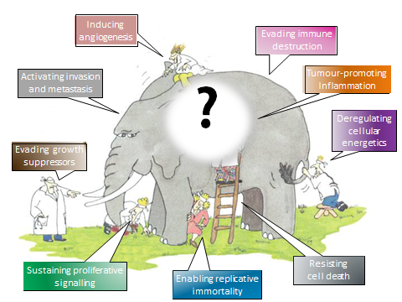
Instability and dynamic self-organization of the cancer cell system. The hypothesis of the cancerogenic hypercycle.
Vladimir N. Malzev
Read, listen and download (Power Point 2010 Congress 2018_ 2019_ENG.ppts)    https://cloud.mail.ru/public/7BoA/CoeGrekcP | Listen and download (Video  Congress 2018_ 2019_ENG.wmv)    https://youtu.be/3wK3Wz_oe0Y
Information on the author and his other publications –

http://orcid.org/0000-0003-3139-5183

