Novel synthetic approach to YbPO₄:Eu³⁺ and luminescence of light-emitting YbPO₄:Eu³⁺@SiO₂ hybrid nanostructure
Tamara Gavrilović¹, Ivita Bite¹, Jurgis Grube¹, Katrīna Laganovska¹, Krisjanis Smits¹, Dragana Jovanović² and Miroslav Dramićanin²
¹Institute of Solid State Physics, University of Latvia, Riga, LV-1063, Latvia
²Vinča Institute of Nuclear Sciences, University of Belgrade, Belgrade, 11000, Serbia

Statement of the Problem: YbPO₄:Eu³⁺ and YbPO₄:Eu³⁺@SiO₂ are developed to investigate Yb³⁺ sensitized up-/down-conversion luminescence of Eu³⁺ ions. New tetragonal light-emitting photonic materials YbPO₄:Eu³⁺ were synthesized for the first time via sol-gel route. Optical properties of as obtained YbPO₄:Eu³⁺ and YbPO₄:Eu³⁺@SiO₂ hybrid nanomaterials were investigated by varying the dopant concentration. The structural examination of YbPO₄ revealed single phase tetragonal, I41/amd, zircon type structure. XRD data showed uniform morphology and extremely high crystallinity of all synthesized samples with an average particle size around 21.5 nm. Emission spectra showed intense typical transitions of Eu³⁺ ions. Emission spectra recorded under 320 nm excitation demonstrated dominant ⁵D₀→⁷F₁, ⁵D₀→⁷F₂, ⁵D₀→⁷F₄ Eu³⁺ transitions, which indicates that Eu³⁺ is not at a site with a center of symmetry. With increasing of Eu³⁺ doping concentration emission intensity increased. Emission spectra recorded under 978 NM excitation exhibited an increase of dominant emissions with doping concentration and possibility of color tuning. These insights are highly important in emerging applications of YbPO₄:Eu³⁺ doped nanocrystals. All emission spectra displayed high energy transitions in the 450-570 nm region characteristic of Eu³⁺ ions which are rarely observed. This unusual result shows that the phonon energies are low enough to lead to the observation of high energy lines in this region, which are comparable with fluoride, germanate and tellurite glasses. The influence of SiO₂ shell on up-/down-conversion emission of YbPO₄:Eu³⁺ showed significant suppression of the UC/DC emission with SiO₂ protection due to light-scattering effect caused by the amorphous silica layer. The presence of free silanol groups on the surface not only results in high solubility in water, but also allows further conjugation with various biomolecules, which opens the possibility of distinct bio-applications. Conclusion & Significance: We obtained novel up-/down shifting material which, among distinct applications should enhance the rational design of rare-earth spectral converters.
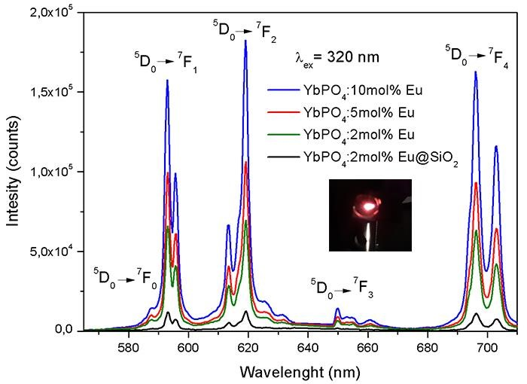

Figure 1. Down-conversion spectra of Eu³⁺ (2, 5,10 mol%)
doped YbPO₄ and YbPO₄:2mol%Eu³⁺@SiO₂ samples

- Tamara V. Gavrilović, Dragana Jovanović, Miroslav Dramićanin (2018) Chapter 2: SYNTHESIS OF MULTIFUNCTIONAL INORGANIC MATERIALS: FROM MICROMETER TO NANOMETER DIMENSIONS in Nanomaterials for Green Energy (Eds. Bharat A. Bhanvase, Vijay B. Pawade, Sanjay J. Dhoble, Shirish H. Sonawane, Muthupandian Ashokkumar). Elsevier ISBN: 978-012-813731-4.
- T. V. Gavrilović, D. J. Jovanović, V. Lojpur, M. D. Dramićanin (2014) Multifuctional Eu³⁺ and Er³⁺/Yb³⁺-doped GdVO₄ nanoparticles synthesized by reverse micelle method. Scientific Reports 4:4209-4217.
- Tamara V. Gavrilović, Dragana J. Jovanović, Krisjanis Smits, Miroslav D. Dramićanin (2016) Multicolor upconversion luminescence of GdVO₄:Ln³⁺/Yb³⁺ (Ln³⁺ = Ho³⁺, Er³⁺, Tm³⁺, Ho³⁺/Er³⁺/Tm³⁺) nanorods. Dyes and Pigments 126:1–7.
- Tamara Gavrilović, Jovana Periša, Jelena Papa, Katarina Vuković, Krisjanis Smits, Dragana J. Jovanović, Miroslav D. Dramićanin (2018) Particle size effects on the structure and emission of Eu³⁺:LaPO₄ and EuPO₄ phosphors. Journal of Luminescence 195:420–429.
- Tamara V. Gavrilović, Dragana J. Jovanović, Lidija V. Trandafilović, Miroslav D. Dramićanin (2015) Effects of Ho³⁺ and Yb³⁺ doping concentrations and Li⁺ co-doping on the luminescence of GdVO₄ powders. Optical Materials 45:76–81.
- Tamara Gavrilović, Katrīna Laganovska, Aleksejs Zolotarjovs, Krisjanis Smits, Dragana J. Jovanović, Miroslav D. Dramićanin (2018) High resolution luminescence spectroscopy and thermoluminescence of different size LaPO₄:Eu³⁺ nanoparticles. Optical Materials 82:39–46.


Tamara Gavrilović has completed her PhD from Belgrade University, Serbia. She is the Lead Researcher of the department of Institute of Solid State Physics, University of Latvia, a premier research organization. She has published more than 10 papers in reputed journals, book chapter and has been serving as an outstanding review member. The winner of Individual Marie Sklodowska-Curie postdoc fellowship. Has an expertise in synthetic chemistry of innovative optical materials, examination and enhancement of their properties.
Email: tashichica@gmail.com

Notes/Comments:
Category: (Poster presentation)
Session name: Materials Characterization and Applications
Research interest: Materials Science

