Prognostic importance of lactate level during transfusion
M.D. Ermira BIU
Faculty of Technical Medical Sciences, University of Medicine, Tirana, Albania

Abstract
Background: Elevated lactate is a good predictor parameter of tissue hypoperfusion and is well known as an universal risk factor for mortality.
Aim: Evaluation of 24-h variation of lactates values as prognostic indicator of patients admitted to ICU-care.
Methods: In this prospective observational study,105 patients were enrolled at ICU care unit of UHC “Mother Theresa”, Tirana during January–December 2015. All patients underwent 1 or more units of packed red blood cell transfusions in 24 hours based on monitored lactates level at admission time before transfusion, 2 hours and 24 hours after blood transfusions. Inclusion criteria: >18 years old,Hb< 9g/dl ,lactates> 2,5 mmol/l. Exclusion criteria: APACHE score II over 20, cardiac disease, and trauma patients. No protocols were used for hemotransfusion trigger, it was based on the clinical judgement.
Results: In the study, 60% were males and 40% females with mean age 49.83( ± 17.4) , transfused with 1.97( ±0.78) units of packed red blood cells.On admission time (before transfusion) 2 hours and 24 hours after transfusion, the obtained results showed these lactate values: pre-transfusion: 2.6±1.17, 2h post-transfusion:1.95±1.06(p=0.001) and
24-h post-transfusion :1.35±0.08 (p=0.001). So, lactate levels were significantly decreased at first 2 hours after transfusion, meanwhile this decrease remained significant (at p< 0,005)after 2 and till 24 hours after packed red blood cell transfusion.
Conclusions Lactates are a good prognostic indicator of tissue hypoxia, so that the evaluation and screening of them is very important for transfusion decision making also 24 hours after admission time.
Keywords:blood transfusion, lactates,prognostic indicator

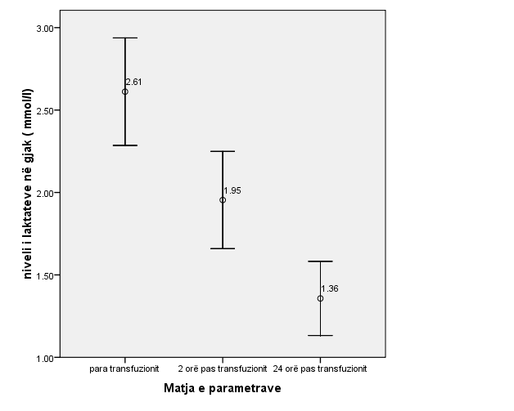

1. Vink EE , Bakker J (2018) Practical Use of Lactate Levels in the Intensive Care J Intensive Care Med.33(3):159-165

2. Jansen TC, van Bommel J, Mulder PG, Rommes JH, Schieveld SJ, Bakker J. (2008) The prognostic value of blood lactate levels relative to that of vital signs in the pre-hospital setting: a pilot studyCrit Care.12(6):R160

3. St John AE, McCoy AM, Moyes AG, Guyette FX, Bulger EM, Sayre MR (2018)Prehospital Lactate Predicts Need for Resuscitative Care in Non-hypotensive Trauma Patients West J Emerg Med. 19(2):224-231
4. Bou Chebl R , El Khuri C, Shami A, Rajha E, Faris N, Bachir R, Abou Dagher G. (2017)Serum lactate is an independent predictor of hospital mortality in critically ill patients in the emergency department: a retrospective study Scand J Trauma Resusc Emerg Med. 25(1):69.
5. Nake A(2018)Laboratory, society, trauma”vectors”(consequences), parts of non-euclidean triangles, ijees 8(4): 791-794.
6. Guyette F, Suffoletto B, Castillo JL, Quintero J, Callaway C, Puyana JC (2011)Prehospital Serum Lactate as a Predictor of Outcomes in Trauma Patients: A Retrospective Observational Study J Trauma. 70: 782–786



Biography
Ermira Biu is graduated as physician at Faculty of Medicine of Tirana, Albania in 2011.In 2012 she became a full-time lecturer of the Paraclinical Department of the Faculty of Technical Medical Sciences of Tirana. She has also developed her skills as an assistant of esthetic surgery. She is a PhD candidate and her research is based on blood and its products transfusion, data collected mostly on ICU-care, which most of her publications consist.
Email: dr.ermirabiu@gmail.com
Notes/Comments

