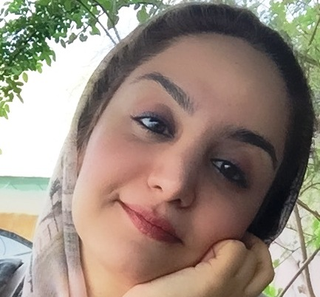


Title: Evaluation the etiology of anaphylaxis according to age: A survey of anaphylaxis in Iran
Name: Yalda Hassanpour

Mashhad University of Medical Sciences, Faculty of Medicine, Mashhad, Iran

Since avoidance of triggering agents is the most important step in the management and prevention of allergic reactions, identifying the causes of anaphylaxis which is an acute, potentially fatal systemic reaction is very important in every community. In this cross-sectional survey we evaluated all patients with a history of anaphylactic reaction, being referred to allergy clinics of 2 tertiary university hospitals of Iran between 15 April 2010 and 5 January 2017. We used a combination of the patient’s clinical history and allergy diagnostic testing including SPT and RAST to determine the etiology of anaphylaxis. We identified 172 anaphylactic reactions in 70 patients. Of the patients, 44.3% were adults and 55.7% were male. Median age was 15 years; range was from 6 months to 48 years. The triggers included: foods, 61.4%; drugs, 15.7%; Hymenoptera venom, 8.6%; idiopathic, 5.7%; immunotherapy, 4.3%; other, 5.7%. Atopy was present in 2/3rds of the patients and a positive family history of anaphylaxis in 2.9%. Nuts and seeds were the most important triggers of food induced anaphylaxis, especially in schoolchildren, adolescents and young adults, followed by fruits. However, cow's milk and hen's egg were the only triggers of anaphylaxis in children under 2 years of age. The most common symptoms were cutaneous (85.7%) and cardiovascular (77.1%). Corticosteroids (94.3%) and/or antihistamines (85.7%) were used most frequently for treatment followed by intravenous fluids (54.3%), whereas epinephrine was only used in 17.1% of the cases. Based on our findings in this study, food-related anaphylaxis and other typical triggers of anaphylaxis are age-dependent, and the risks and triggers change with age.

Biography

Yalda Hassanpour is a junior physician who has completed her medical degree at Mashhad University of Medical Sciences, Faculty of Medicine, Mashhad, Iran on 2 January 2018. Abstract above is a summary of her thesis research project.

