
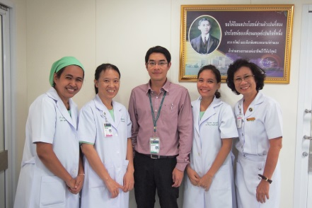

Effect of 72-Hour versus Weekly Changes of In-Line Suction Catheters on Rates of Ventilator-Associated Pneumonia
Yupin Poolkumlang

Siriraj Hospital, Mahidol University, Bangkok, Thailand

Objective: Various studies have demonstrated that these two suction systems were no significant difference in the incidence of VAP and mortality rate among the mechanically ventilated patients. Closed suction system provided some benefits over open suction system. The objective of the present study is to determine whether 3-day interval changes of in-line suction catheter affects the incidence of VAP compared to 7-day interval changes.
Materials and Methods: The present study is a randomized controlled study. Mechanically ventilated medical patients who admitted to intensive care unit were enrolled and randomized into 2 groups, group 1 (3-day interval changes of in-line suction catheter) and group 2 (7-day interval changes).
Results: 206 patients were randomized into group 1 (N=116) and group 2 (N=90). Demographic data were no significant difference except for APACHE II score (18 and 20 in group 1 and 2, respectively; p=0.013). The incidence of VAP was 18.9% which was no difference between two groups using non-inferiority test (15.5% and 23.3%, respectively; p<0.002). Patients in group 2 had significant higher all-cause mortality compared to patients in group 1. We estimated that 7-day interval change of suction catheter will result in a cost-savings of 1,195 baht per person per day.
Conclusion: In comparison with 3-day interval changes of in-line suction catheter, 7-day interval changes is not associated with higher incidence of VAP and results in cost savings without increase rate of early replacement of suction catheter. However, the effect on all-cause mortality cannot be concluded from the present study.

Biography
Yupin Poolkumlang, RN, BSN, earned her bachelor of nursing science degree from Mahidol University. She has 17 years of nursing experience and 7 years of expertise and is a member of Thai nursing council. After graduation, she has been a nurse specialist for 19 years at Respiratory care unit (RCU). She has overseen advanced nursing care and mentored novice nurses in Respiratory Care Unit at Siriraj Hospital, Bangkok, Thailand.

