Title: The contribution of interleukin-6 signaling to the development of T helper immune response in chronic obstructive pulmonary disease
Name: Karolina Sidletskaya, Tat'yana Vitkina, Tat'yana Novgorodtseva
Vladivostok branch of Federal State Budgetary Science Institution «Far Eastern Scientific Center of Physiology and Pathology of Respiration» - Institute of Medical Climatology and Rehabilitative Treatment, Russia

Abstract
Statement of the Problem: Interleukin-6 (IL-6) is a systemic inflammatory marker in chronic obstructive pulmonary disease (COPD). It has been shown that IL-6 acts on T-helper cells (CD4⁺) and, therefore, impact on the formation of the T helper (Th) immune response, which determines the progression of the pathology. However, the molecular basis of immunoregulatory action of IL-6 in COPD has not been sufficiently studied. The aim of this study is to assess expression level of the membrane receptor for IL-6 (IL-6R/CD126⁺) on CD4⁺ cells in patients with COPD of varying severity with different types of Th immune response. Methodology: The study included 98 patients with stable COPD (34 mild, 45 moderate, 19 severe) and 32 healthy volunteers. The type of Th immune response was determined by calculating the ratio of the concentrations of serum cytokines – TNF-α, IFN-γ, IL-4, -6, -10, -17A (BD, USA). Cytokine levels and the number of blood CD4⁺CD126⁺ cells were assessed by flow cytometry (cytometer «BD FACSCantoII», USA). Findings: Th1 and Th17 immune response were found in stable COPD. The number of CD4⁺CD126⁺ cells was increased by 111% (p<0.001) in patients with severe COPD with Th1 immune response relatively healthy persons. The levels of CD4⁺CD126⁺ cells was elevated by 47% (p<0.05), 117% (p<0.01) and 286% (p <0.01) in patients with mild-to-severe COPD with Th17 pathway respectively compared to the control group. Conclusions: Systemic inflammation in stable COPD develops predominantly according to Th1 or Th17 immune response. Increasing the expression level of IL-6R on blood CD4⁺ cells is a possible mechanism for enhancing the Th17 immune response as COPD progresses. Th1 immune response is characterized by the raised expression of IL-6R on blood CD4⁺ cells only in patients with severe COPD. It may be associated with the repolarization of this phenotype towards Th17 as the disease progresses.
Image
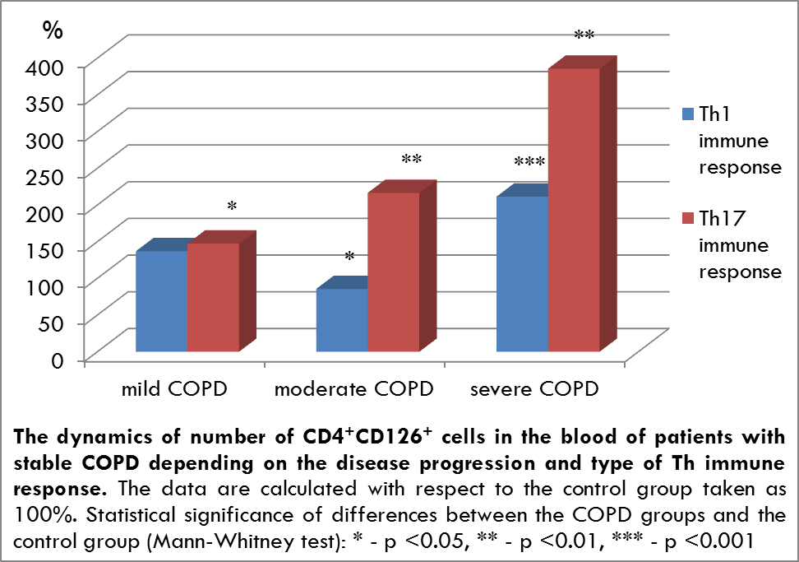
Recent Publications
- Cosmi L, Liotta F, Annunziato F (2016) Th17 regulating lower airway disease. Current Opinion Allergy Clinical Immunology 16(1):1-6.
- Ferrari R, Tanni SE, Caram LMO, Correa C, Correa CR, Godoy I (2013) Three-year follow-up of Interleukin 6 and C-reactive protein in chronic obstructive pulmonary disease. Respiratory Research 14(24).
- Rincon M, Irvin CG (2012) Role of IL-6 in asthma and other inflammatory pulmonary diseases. International Journal of Biological Sciences 8(9):1281-1290.
- Vitkina TI, Denisenko YK, Sidletskaya KA (2017) Changes in the surface IL-6 receptor expression of distinct immune cells in progression of chronic obstructive pulmonary disease. Medical immunology 19(2):191-196. (in Russian).
- Wolf J, Rose-John S, Garbers C (2014) Interleukin-6 and its receptors: a highly regulated and dynamic system. Cytokine 70(1):11-20.



Biography
Karolina Sidletskaya works as a junior researcher in the Laboratory of Biomedical Research of the Institute of Medical Climatology and Rehabilitative Treatment. In 2017 she graduated with honors in Cell Biology (master's degree) from Far Eastern Federal University. Now she is a PhD student in Pathological Physiology at the Institute of Medical Climatology and Rehabilitative Treatment. The area of her research work is the molecular mechanisms of the inflammatory response in chronic obstructive pulmonary diseases. She has published 7 papers in reputed journals and 14 abstracts in materials of conferences. She participated with report in 5 International conferences and 2 Russian conferences.
Email: d-karolina-a@mail.ru
Notes/Comments:

