
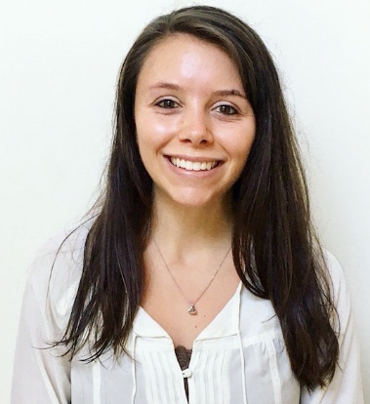



Antimicrobial Resistance Patterns and Seasonal Variation Among 2017 Isolates at the Mulago National Referral Hospital (MNRH) in Kampala, Uganda

Carlie Skellington, MPH Candidate

Columbia University Mailman School of Public Health, NY 10032, USA

From misunderstanding to misuse of antimicrobials, Uganda experiences high rates of resistance to antimicrobials that are heavily relied upon to treat prevalent infections, including pneumonias, bacterial meningitis, and respiratory infections. Prior literature suggests seasonal periodicity of bacterial infections, typically with increased prevalence when higher temperature and lower humidity. Unfortunately, Uganda has yet to implement a national, systematic AMR surveillance system. The aim of this retrospective cohort study was to identify AMR seasonality trends (rainy vs. dry season) among isolates collected by MNRH’s Microbiology Laboratory in Kampala, Uganda. Demographic variables and antibiotic sensitivity (S/I/R) for positive cultures were assessed via laboratory chart review of blood specimen (n=552), CSF isolates (n=742), and culture swabs (n=508) from patients treated between January and December, 2017. Controls were selected via systematic sampling of negative cultures. Two-tailed chi-square tests compared frequencies of antibiotic use and sensitivities. Average monthly rainfall and humidity were retrieved from IAMAT. The most commonly prescribed antibiotics included SXT, TE, CTX, AMP, and C. Blood isolates and culture swabs did not show differences in AMR according to season at the 5% significance level. Resistance within CSF cultures, however, differed significantly by season, showing a 22% greater risk of resistant strains identified during rainy months than during dry months (χ²=4.19, p=0.04, RR=1.22). Based on preliminary analysis, AMR trends within CSF cultures appear to mirror Kampala’s seasonal patterns. Multivariate regression analysis may account for potential selection bias and confounding. Results warrant additional AMR research in order to improve surveillance and better inform practitioner prescription habits.

Biography

Carlie Skellington is a MPH candidate at Columbia University Mailman School of Public Health studying epidemiology and humanitarian assistance. She graduated with honors from Lehigh University in 2015 with a B.S. in Biology, during which she worked in Dr. Jill Schneider’s neuroendocrinology laboratory and completed her independent thesis research project on asesssing environmentally-induced variability of morphological, ingestive, and reproductive traits in the male Syrian hamster based on living conditions (group-housed vs. singly-housed). Carlie has also worked within a sustainable development lab, during which she helped design and develop a phytopurifier that degrades common indoor home air pollutants within Pennsylvania, USA.

