Sugar and fat reduction strategies in Irish confectionery products: sensory evaluation and physical properties
Andrey A. Tyuftin, PhD, Postdoctoral researcher, Food and Nutrition Department, UCC, Cork, Ireland
Aislinn M. Richardson, Postgraduate student, Food and Nutrition Department, UCC, Cork, Ireland
Maurice G. O’Sullivan, PhD, Lecturer, Sensory group, Food and Nutrition Department, UCC, Cork, Ireland
Joseph P. Kerry, PhD, Professor, Lecturer, Food packaging group, Food and Nutrition Department, UCC, Cork, Ireland

Abstract
Statement of the Problem: One of the main causes for obesity in society today is the consumption of free and refined sugar (MacGregor & Hashem, 2014). In Ireland the Irish Universities Nutrition Alliance (IUNA, 2011) reported that free sugars account for 14.6% of the total energy intake of Irish adults who participated in the study. According to the Healthy Ireland survey (2015), 37% of adults that participated were overweight and a further 23% were obese (a strong risk factor for type 2 diabetes). The highest sugar content in day to day diet products in Ireland is in bakery products.
The aim of the work was to reduce sugar and fat content in brownies, cakes and biscuits. Methods for the sugar reduction contained sugar particle manipulation (grinding and fractioning), addition of sugar and fat organic replacing ingredients. Physical and sensory perception properties of sugar reduced sweet products were evaluated.
Sugar particle manipulation strategy (Richardson et al, 2018) was used in brownies containing black beans as a fat replacer. Brownie samples containing the smallest sugar particles size (SPS) with 25% butter replacement were most significantly associated with liking of appearance, texture, colour and overall acceptability (p<0.01).
In formulation of sponge cakes there was no significant difference between the control sample and the 25% sugar replaced with SPS sample and sucrose and stevia extract as a sugar replacer.
In the formulation of biscuits, a sample with SPS was more acceptable in sweetness perception.
In conclusion, sugar particle manipulation has a significant impact on properties of bakery products along with sugar and fat organic replacers and can be utilized by bakery companies for sugar reduction, economy and customers’ health impact.
The funding for this research was provided by the Food Institutional, Research Measure (FIRM, 14F 812), Department of Agriculture, Food and the Marine.

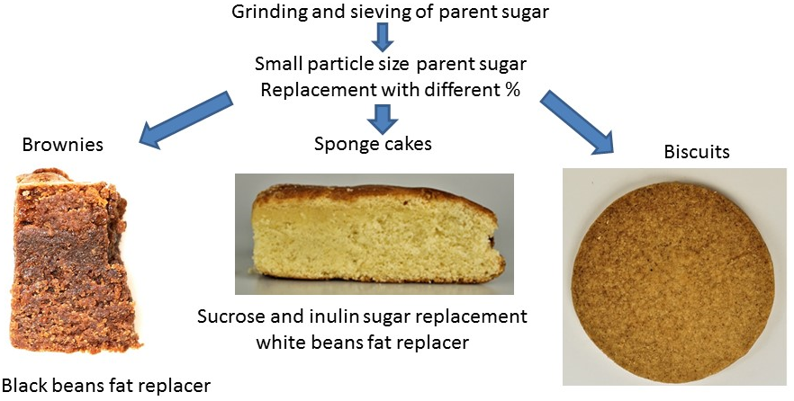
Figure1. Impact of sugar particle size manipulation and partial sugar and fat replacement by organic ingredients on the physical and sensory attributes is reported.
Recent Publications
- MacGregor, G. A., Hashem, K. M. (2014). Action on sugar-lessons from UK salt reduction programme. The Lancet, 383(9921), 929–931.
- Irish Universities Nutrition Alliance (IUNA) (2011). National adult nutrition survey (NANS) summary report., (March 2011), 37http://www.iuna.net/wp-content/uploads/2010/12/National-Adult-Nutrition-Survey-Summary-Report-March-2011.pdf, Accessed date: 5 April 2017.
- Healthy Ireland (2015). Healthy Ireland survey 2015: Summary of findings.
- Richardson A.M., Tyuftin A.A., Kilcawley K.N., Gallagher E., O’Sullivan M.G., Kerry J.P. (2018). The impact of sugar particle size manipulation on the physical and sensory properties of chocolate brownies. LWT - Food Science and Technology, 95, 51-57.

Photograph

Biography
Dr A. Tyuftin is a postdoctoral researcher at UCC, Ireland. He has expertise in (1) high barrier coatings for flexible packaging, (2) development of biodegradable edible active antimicrobial films and coatings based on food ingredients, (3) supramolecular systems for sensors application in smart packaging and particular (4) in new food products formulation. Dr. A. Tyuftin is participating in voucher funded R&D projects of funding contributions from individual food companies primarily for short-term client-commissioned research projects at UCC for testing and development of new food products. For example, he developed and validated super food smart beverage with sugar substitution. He received a PhD degree in Organic (Supramolecular) Chemistry in 2009. Before joining UCC he worked four years as R&D manager in flexible packaging industry on projects for famous brands and local companies. He is collaborating with several universities and small to large SME.
Email: Joe.Kerry@ucc.ie; a.tiuftin@ucc.ie
Notes/Comments:

