Spatiotemporal distribution of photosynthesis:
Evaluation in a strawberry greenhouse under CO₂ enrichment
Kensuke Kimura, PhD student, Kyushu University, Japan
Daisuke Yasutake, Associate professor, Kyushu University, Japan, & Masaharu Kitano, Professor, Kyushu University, Japan

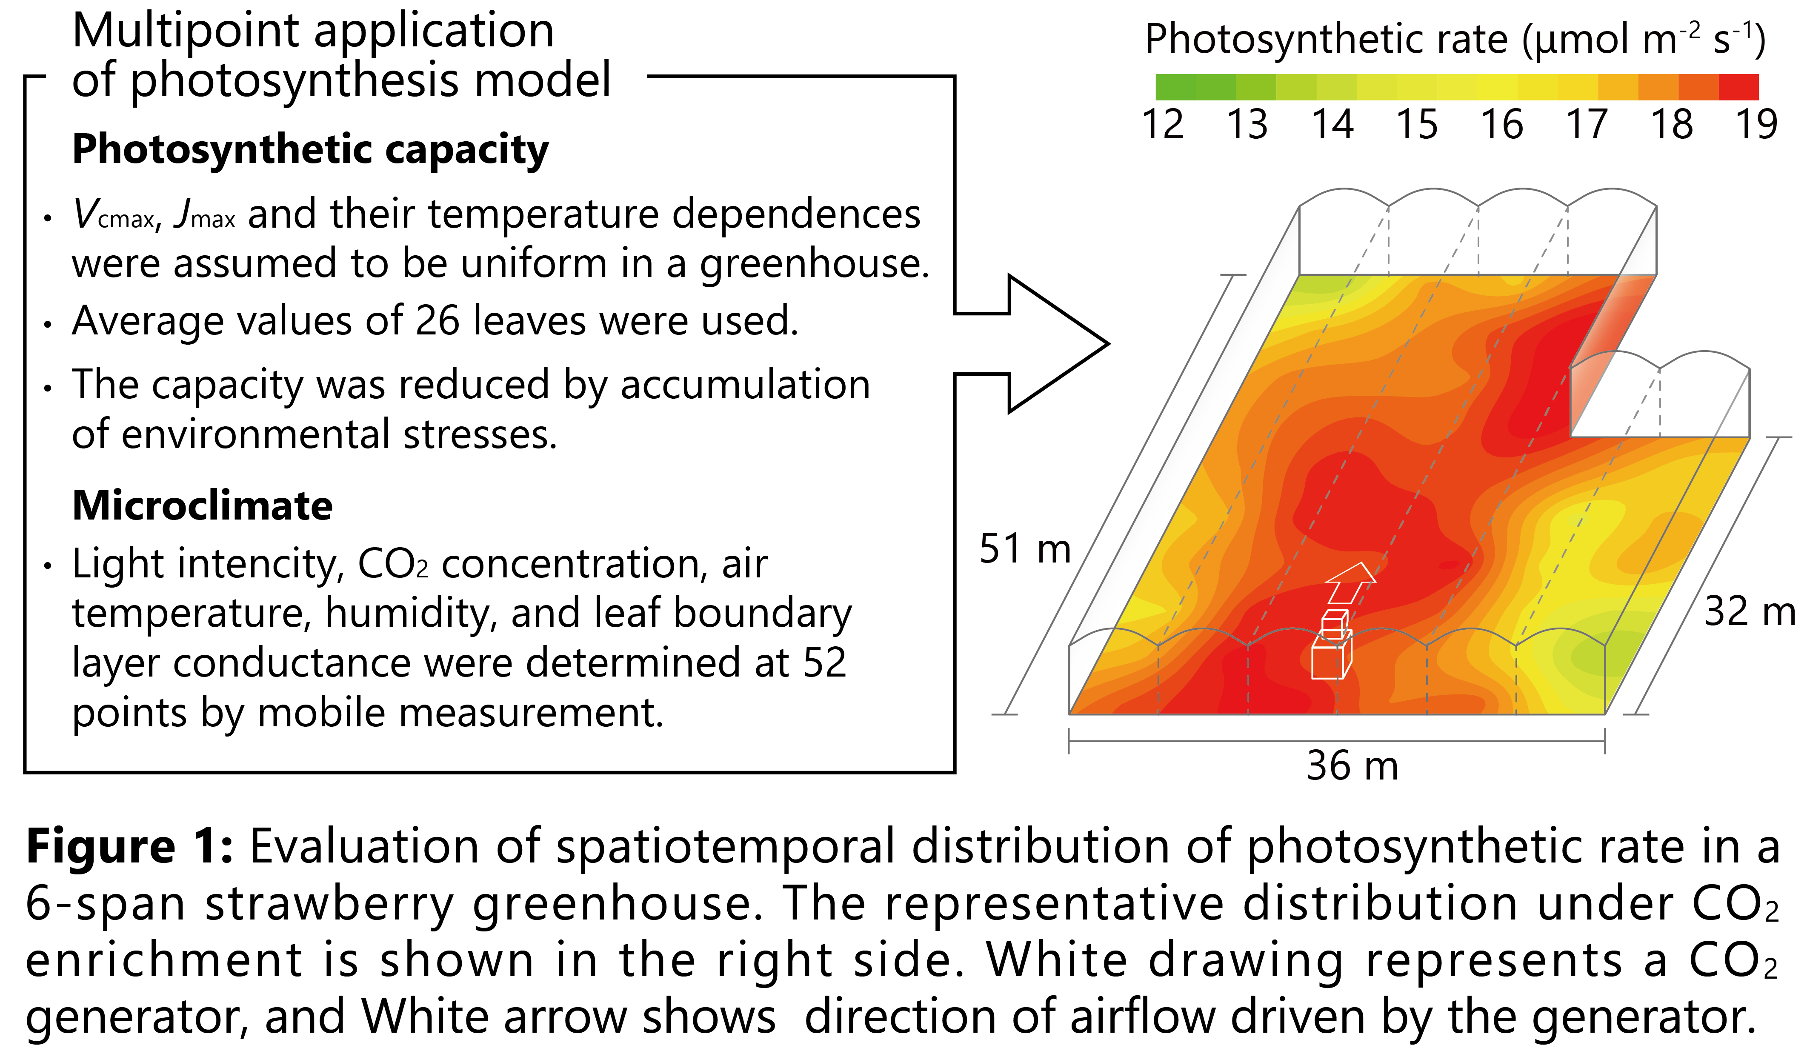
Abstract
Statement of the Problem: Achieving higher crop production in a greenhouse requires optimizing spatiotemporal variability of photosynthesis, which is the basic process underlying crop growth. However, there has been little research with a focus on spatiotemporal variations of photosynthesis in a greenhouse. Here, we conducted multipoint application of a photosynthesis model in a 6-span strawberry greenhouse under CO₂ enrichment, to reveal the spatiotemporal distribution of photosynthesis.
Methodology & Theoretical Orientation: Leaf photosynthetic rate (A) was evaluated by coupling the biochemical model for C3 photosynthesis (Farquhar et al., 1980) with gas diffusion theory of the Fick’s law. Moreover, a midday depression of photosynthesis was simply modeled using accumulated evaporative demand during a daytime, assuming that the depression arises from a reduction in photosynthetic capacity (V_{cmax} and J_{max} in the Farquhar model) induced by accumulation of midday environmental stresses (expressed by evaporative demand) to a leaf. Multipoint application of the model was performed as shown in Fig.1, thereby visualizing the spatiotemporal distribution of A in the greenhouse.
Findings: The model could well capture time courses of A including the midday depression influenced by some environmental stresses. This indicates that accumulated evaporative demand may be applicable to the evaluation of the midday depression during a day. The spatiotemporal distribution of A under CO₂ enrichment was strongly affected by the pattern of leaf boundary layer conductance (i.e., airflow) as well as that of CO₂ concentration, and consequently remarkable non-uniformity in A appeared across the greenhouse (Fig.1). This result confirms the importance of controlling airflow for optimizing spatiotemporal variability of A under light wind conditions in the greenhouse.
Conclusion & Significance: the multipoint application proposed herein contributes to spatiotemporal optimization of environmental controls in the greenhouse (e.g., CO₂ enrichment, ventilation, and heating), leading to optimization of spatiotemporal variability of photosynthesis.

Image
Recent Publications
- Cabrera-Bosquet L et al. (2016) High-throughput estimation of incident light, light interception and radiation-use efficiency of thousands of plants in a phenotyping platform. New Phytologist 212: 269-281.
- Kimura K et al. (2016) Leaf boundary layer conductance in a tomato canopy under the convective effect of circulating fans in a greenhouse heated by an air duct heater. Environmental Control in Biology 54: 171-176.
- Kimura K et al. (2017) Dynamic distribution of thermal effects of an oscillating frost protective fan in a tea field. Biosystems Engineering 164: 98-109.
- Li Y et al. (2018) Automatic carbon dioxide enrichment strategies in the greenhouse: A review. Biosystems Engineering 171: 101-119
- Xue W et al. (2017) A spatially hierarchical integration of close-range remote sensing, leaf structure and physiology assists in diagnosing spatiotemporal dimensions of field-scale ecosystem photosynthetic productivity. Agricultural and Forest Meteorology 247: 503-519.

 Biography
Kensuke Kimura is a PhD student at Kyushu University in Japan, specializing agricultural meteorology. He is also a research fellow of Japan Society for the Promotion Science. His research consistently focuses on spatiotemporal variabilities of plant-environment transport phenomena (e.g. energy balance, transpiration and photosynthesis). He has evaluated spatiotemporal distributions of such phenomena in several types of agricultural fields, with the aid of continuous-multipoint measurements of microclimate using his original sensor and many models of the transport phenomena including his original models. He is now interested in the integration of close-range remote sensing technique with his previous works, to elucidate higher-resolution patterns of the plant-environment transport phenomena.
Email: kensuke.kimura.352@s.kyushu-u.ac.jp

Notes/Comments: This study was partly supported by JSPS KAKENHI Grant Number JP17J05569.

