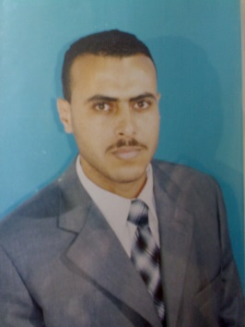


Title: E-BABE- The effectiveness of Mind Body Medicine Program on the Coping Styles and Quality of Life among people with Physical Disabilities in the Gaza Strip
Name: Mohammed Fat'hi Mohammed Naser

Al-Quds University- School of Public Health, Palestine- Gaza

General aim: was to identify the effectiveness of Mind-Body Medicine (MBM) group interventions on coping styles (CS) and quality of life (QoL) among people with physical disabilities (PwPD) in the Gaza strip (GS). The program included "autogenic and biofeedback, drawing, relaxation, guided imagery, visualization, meditation, genogram, and dialogue with symptoms".
Aims and methods: The study is a before and after, interventional study, the sample consisted of 380 (PwPD) living in Gaza Strip governorates by representative sample of 226 males and 154 females aged 18 years old and over. On arrival, before the program, the participants completed three questionnaires. The first was A COPE Inventory (Carver, 1989). The second was (WHOQoL BREF, 2001). The third was Socio-demographic Questionnaire. The experimental sample was 20 participants selected randomly who scored lowest numbers for (CS) & (QoL) questionnaires, ten as experimental group and ten others as controlled matched for sex and age. For ten weeks duration, two houses each week.
Results: The results indicated that there were a significant differences between the responses of the participant before and after the MBM application; which means that the MBM program have appositive effect in improving the QOL for the participant.

There were a moderate differences between the responses of the participant before and after the MBM application; which means that the MBM program have a moderate effect in improving the (CS) for the participant.
Conclusion: MBM group have a positive effect in improving QOL and moderate effect in improving the (CS) among (PwPD) in Gaza Strip.

Biography
Mohammed Naser; has completed his Master in community mental health from (Al-Quds University). Works as pert time academic lecture instructor at (Al Quds Open University), Educational psychology, disabilities care, and adaptation & mental health care supervised, member of evaluation team and facilitator at (Global Impact for Consultation), public relation officer at (Baitona For Community Development), researcher part time at (Al Quds Bank for Information) & (Society Voice Foundation), social worker volunteer at (Jabalia Rehabilitation Society), & psychological counselor volunteer at (Gaza Mental Health Program). This is the first paper send to published.

