Correction of a skeletally class III malocclusion in an adult with a combined orthodontic-orthognathic approach
Bader Hassosah, KFAFH, Saudi Arabia
Abstract

This case report describes a successful orthognathic treatment of a skeletal Class III malocclusion due to deficient maxilla and prognathic mandible in an adult individual. The patient with skeletal Class III malocclusion was treated with orthodontics and double jaws surgery. The surgical-orthodontic combination therapy has resulted in near-normal skeletal, dental and soft tissue relationship, with marked improvement in the facial esthetics in turn. The interdisciplinary approach is the treatment of choice in most of the skeletal malocclusions in an adult.

INTRODUCTION
The Skeletal Class III malocclusion is characterized by mandibular prognathism, maxillary deficiency or both. The effect of environmental factors and oral function on the etiological factors of a Class III malocclusion is not completely understood. However, there is a definite familial and racial tendency to mandibular prognathism. For moderate to severe class III malocclusions in adult, surgical treatment can be the best alternative. Depending on the amount of skeletal discrepancy, surgical correction may consist of mandibular setback, maxillary advancement or a combination of mandibular and maxillary procedures.

TREATMENT OBJECTIVES
The treatment objectives were to correct the skeletal class III relationship via orthognathic surgery to achieve class I buccal segment with normal overjet and overbite.

TREATMENT PLAN AND ALTERNATIVES
The plan was combined surgical and orthodontic treatment that will correct the anteroposterior discrepancy, the anterior and bilateral posterior crossbite and will achieve a balanced face.
The alternative plan was surgically assisted rapid palatal expansion aimed for correction of the bilateral crossbite and extraction of one lower incisor that will increase the compensation and correct the anteroposterior discrepancy. The drawbacks of this plan it will not target the chief complaint of the patient that is the large lower jaw. In addition, this treatment modality usually done in mild to moderate cases as the mandibular incisors were not suitable for much distal movement because of the thin symphysis bone that could damage the periodontal tissues and diagnostic wax up should be checked for tooth size discrepancy after lower incisor extraction. For these reasons discussed above this plan was ignored.

TREATMENT RESULT
A well-aligned dentition and a good facial balance were obtained. Class I relationships were achieved with normal overjet and overbite and correction of the relative crossbite.

CONCLUSION
This case report describes the surgical orthodontic treatment of an adult with severe skeletal and dental class III relationships. The orthognathic treatment was the best option for achieving an acceptable occlusion with good esthetic result. An experienced multidisciplinary team approach ensures a satisfactory outcome.

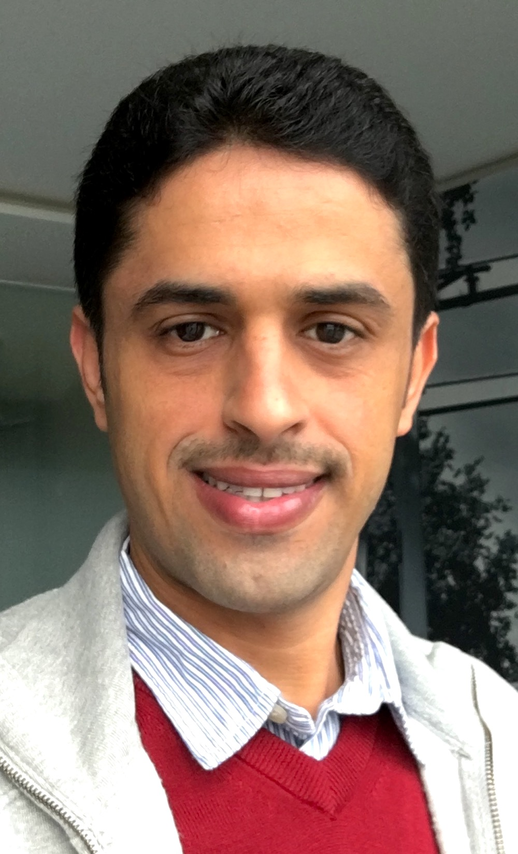 Biography

Dr. Bader Hassosah obtained his degree in Dentistry from the University of King Abdulaziz University, and postgraduate in Orthodontics at KAU (Board Certified). He is Head of orthodontic division and full time practice as Consultant in Orthodontics in KFAFH hospital, Jeddah, Saudi Arabia.

Email: dr.badrh@gmail.com
Phone: +966555558468

