Correction of a skeletally class III malocclusion in an adult with a combined orthodontic-orthognathic approach
Bader Hassosah, KFAFH, Saudi Arabia

Abstract

This case report describes a successful orthognathic treatment of a skeletal Class III malocclusion due to deficient maxilla and prognathic mandible in an adult individual. The patient with skeletal Class III malocclusion was treated with orthodontics and double jaws surgery. The surgical-orthodontic combination therapy has resulted in near-normal skeletal, dental and soft tissue relationship, with marked improvement in the facial esthetics in turn. The interdisciplinary approach is the treatment of choice in most of the skeletal malocclusions in an adult.

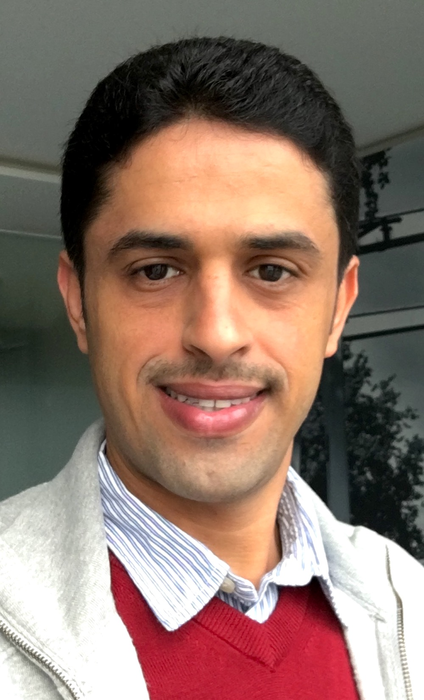 Biography

Dr. Bader Hassosah obtained his degree in Dentistry from the University of King Abdulaziz University, and postgraduate in Orthodontics at KAU (Board Certified). He is Head of orthodontic division and full time practice as Consultant in Orthodontics in KFAFH hospital, Jeddah, Saudi Arabia.

Email: dr.badrh@gmail.com
Phone: +966555558468

