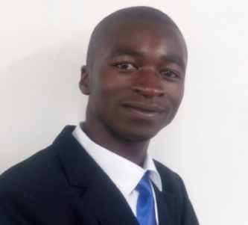
Title: MODELLING HEALTHCARE FINANCING IN KENYA
[THE GREEN PATH MODEL - GPM]
Author (s) Name: Odero Livingstone sichonjo, Dr. John Olukuru
Strathmore University, Africa

This study involves modelling healthcare financing in Kenya. The 2001 Abuja Declaration that requires governments to allocate at least fifteen percent (15%) of their total budgets to health and the universal $60 health per capita target are used as benchmarks in this study.
The proposed model that is used for modelling healthcare financing in Kenya is the Green Path Model (GPM). GPM consists of a six-staged path that involves identification of health financing gaps at both National and County level, issuing of a Social Impact Bond, SIB, a conceptual shift to the Circular Economy, CE framework and refocusing on repayment of the social investors. At the final stage, the surplus amount generated from the Circular Economy’s green initiatives is channelled to the Green Fund – pool of funds in a Green Bank thus filling up the health financing deficits. This study found out that as at now, Kenya has neither allocated at least 15% of its total budget to health nor met the universal $60 health per capita target both at National and County Level.
Key words: Abuja Declaration, health per capita, Circular Economy, Social Impact Bond and Green Bank

Figures if any (BW/Color):
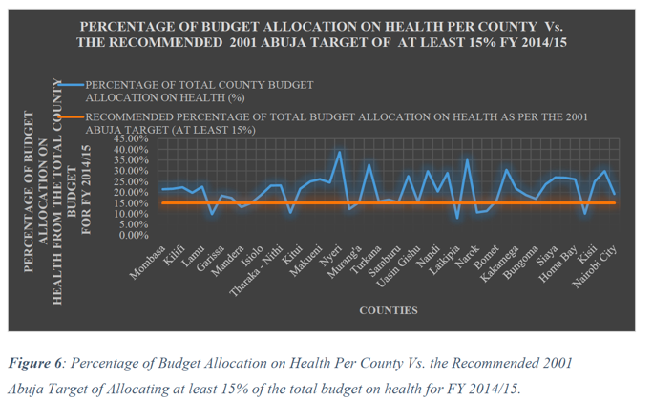
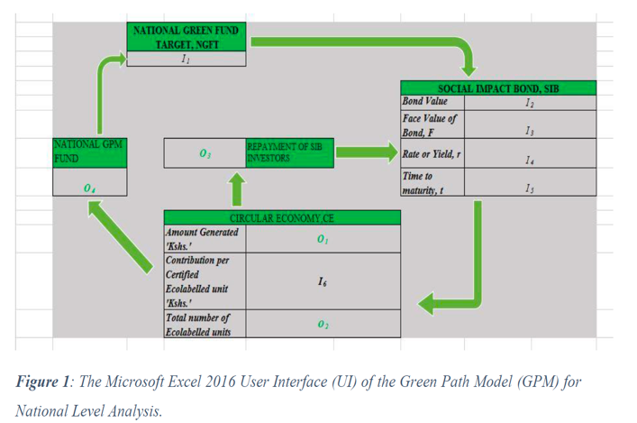

Biography
Livingstone is based in Nairobi with SunFunder's Lending team where he works as a Financial Analyst. He vets and analyzes borrowers' operations, particularly finances. Livingstone holds a Bachelor of Business Science in Actuarial Science from the Strathmore Institute of Mathematical Sciences (SIMS). Previously, Livingstone presented this Research Paper at the Strathmore International Mathematics Conference on June 23rd 2017 under the Mathematical Modelling session.

Presenting author details
Full name: Odero Livingstone Sichonjpo
Contact number: +254 725 382 917
Email id: oderolivingstone@gmail.com
Category: Poster presentation
Session name:
Research interest: Healthcare Financing in Developing Countries.

