Title: Cognitive Therapy vs. Anti-depressants in the treatment of depression: A Literature Review
Authors: Nair S, Fernandez A, MD
Objectives: Depression is one of the leading causes of disability in the United States and the primary treatment for this mental illness is currently cognitive behavioral therapy adjunctive with medications like Selective Serotonin Reuptake Inhibitors. We are comparing research articles that will analyze the efficacy of Cognitive monotherapy vs. medications alone and look to plot the correlation via mixed or indirect treatment comparison between these two therapy approaches. We look at the data established in each of the studies that comply with our inclusion criteria and discuss the any possible statistically significant relationship that can be determined from the studies.
Methods: This involves accessing research articles via credible sources like PubMed, JAMA Psychiatry, Taylor and Francis Online, Journal of Affective Disorders and Journal of Mental Health. By searching for articles via keywords like “cognitive monotherapy” and “antidepressants” and using the inclusion criteria to filter out the outlying studies, we hope to have a minimum of three or more articles that will provide enough data and statistics to determine a significant contrast between CBT vs medications in the treatment of MDD. This involves research on certain variables in each study including the lack of conflict of interest, the various scales of depression being used to analyze (i.e: HAM-D, MADRS, experience of the psychiatrists conducting the CBT, the trials being blinded and randomized to prevent any bias. Statistical analysis performed for each study will be analyzed and compared to each other. If the analysis involves CBT vs placebo or medications vs. placebo, this data is still valid to create an indirect contrast between CBT and medications.
Inclusion Criteria:
- Patients diagnosed with minor, moderate or major depressive disorder using Depression rating scales such as Hamilton Depression Rating Scale (HDRS), Beck’s Depression Inventory (BDI), Montgomery-Asberg Depression Rating Scale (MADRS) and Patient Health Questionnaire (PHQ-9).
- Patients underwent anti-depressant treatment or cognitive monotherapy.
- Patients had to undergo atleast 6 months each to receive substantial effect of each treatment

Results:
Gloaguena and her colleagues in 1998 performed a meta-analysis of cognitive therapy in mild or moderate depression: The results are listed in the table below:
Comparisons | n | d+ | Confidence | % | Z | P | Q
 |  |  | interval | benefit |  |  | (df)
 |  |  | 95%
 |  |  | d+
Waiting-list
or placebo | 20 | −0.82 | (−0.83; | 29 | −8.72 | <0.0001 | 137.1*
 |  |  | −0.81) |  |  |  | (19)
Antidepressants | 17 | −0.38 | (−0.39; | 15 | −5.16 | <0.0001 | 19.6
 |  |  | −0.37) |  |  |  | (16)
Behaviour therapy | 13 | −0.05 | (−0.08; | 2 | −0.07 | 0.95 | 2.5
 |  |  | −0.02) |  |  |  | (12)
Other therapies | 22 | −0.24 | (−0.25; | 10 | −2.93 | <0.01 | 73*
 |  |  | −0.23) |  |  |  | (21)
*, Between-trial heterogeneity (P<0.05).
Interpersonal therapy was identified as distinct from both cognitive therapy, behaviour therapy or cognitive-behaviour therapy as demonstrated in the works of De Rubeis et al. (1982), Weissman and Markowitz (1994).
We found a highly significant difference (P<0.0001) in favour of CT versus waiting-list or placebo. The average subject in CT is better of 29% than the average subject in the waiting-list or placebo. The hypothesis of between trial homogeneity was rejected (Q=137.1, df 19). This may suggest that in some trials non-specific factors were operating both in CT and control conditions. The trials of Neimeyer et al., 1983, Elkin et al., 1989, Beach and O'Leary, 1992)had a d=0. As the NIMH study had the largest number of patients, and its outcomes were related to therapeutic alliance in CT, interpersonal therapy, imipramine, and placebo (Krupnick et al., 1996), we suppressed it from the meta-analysis to evaluate its impact on the homogeneity. A Q of 134.1, df 18, P<0.001 was obtained, which was far from reaching the homogeneity criterion.
CT was superior to antidepressants (P<0.0001). The hypothesis of between-trial homogeneity was not rejected.
Driessen and his colleagues (Driessen, 2010) summarized that CBT has found to work better than its absence and may well work for specific reasons. CBT seems to be as efficacious as other active treatments, including medications. Adding CBT to ADM has resulted in a modest improvement of efficacy. The benefits of adding medication to CBT relative to CBT alone have been less apparent, although these effects might be larger in applied clinical practice than in the controlled setting of a treatment trial.

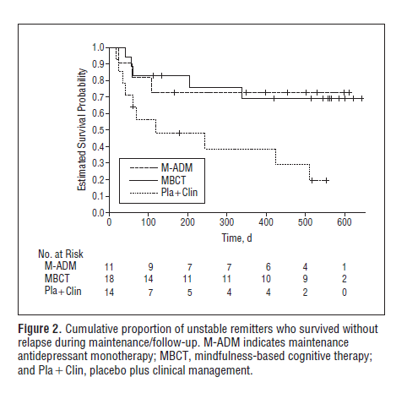
March and his colleagues performed an Intention-to-treat analyses on the Children's Depression Rating Scale–Revised and identified a significant time × treatment interaction (P < .001). Rates of response were 73% for combination therapy, 62% for fluoxetine therapy, and 48% for CBT at week 12; 85% for combination therapy, 69% for fluoxetine therapy, and 65% for CBT at week 18; and 86% for combination therapy, 81% for fluoxetine therapy, and 81% for CBT at week 36. Suicidal ideation decreased with treatment, but less so with fluoxetine therapy than with combination therapy or CBT. Suicidal events were more common in patients receiving fluoxetine therapy (14.7%) than combination therapy (8.4%) or CBT (6.3%).
In the figure below, Segal and his determined that in acute phase treatment, patients who received Cognitive therapy (CT) had lower chance of relapse than Anti-depressant (ADM) monotherapy. However, in long term phase, CT was shown to be equally as effective as ADM.
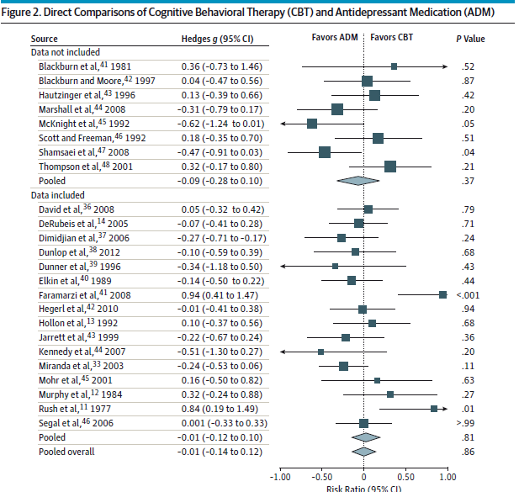
Weitz and her colleagues noticed there was a main effect of ADM over CBT on the HAM-D (β = −0.88; P = .03) and a nonsignificant trend on the BDI (β = −1.14; P = .08, statistical test for trend), but no significant differences in response (odds ratio [OR], 1.24; P = .12) or remission (OR, 1.18; P = .22). Mixed-effects models using the HAM-D indicated that baseline depression severity does not moderate reductions in depressive symptoms between CBT and ADM at outcome (β = 0.00; P = .96). Similar results were seen using the BDI. Baseline depression severity also did not moderate the likelihood of response (OR, 0.99; P = .77) or remission (OR, 1.00; P = .93) between CBT and ADM.
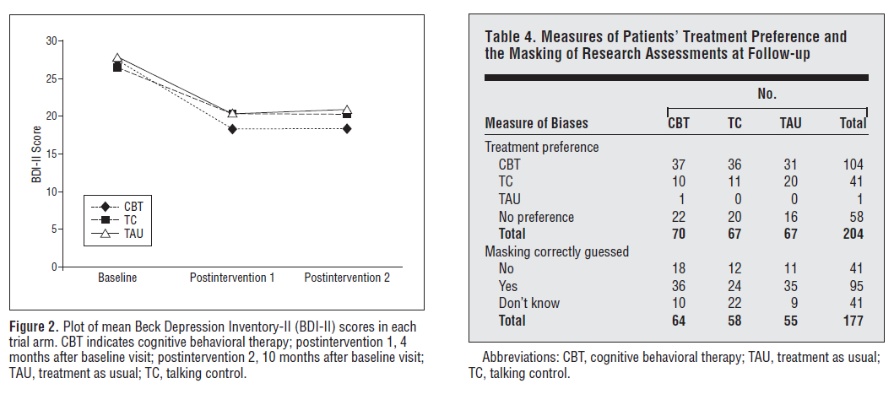
In a study done by Dr. Serfaty and his colleagues, according to the figure above, eighty percent of participants were followed up. The mean number of sessions of Talk Control (TC) or Cognitive Behavioral Therapy (CBT) was just greater than 7. Intent-to-treat analysis found improvements of −3.07 (95% confidence interval [CI], −5.73 to −0.42) and −3.65 (95% CI, −6.18 to −1.12) in BDI-II scores in favor of CBT vs Treatment As Usual (TAU) and TC, respectively. Compliance Average Causal Effect analysis compared CBT with TC. A significant benefit of CBT of 0.4 points (95% CI, 0.01 to 0.72) on the BDI-II per therapy session was observed. The cognitive therapy scale showed no difference for nonspecific, but significant differences for specific factors in therapy. Ratings for CBT were high (mean [SD], 54.2 [4.1])

Conclusions:
Out of the five articles researched, Weitz and her colleagues did not report any moderate differences between Cognitive Behavioral Therapy (CBT) and Anti-Depressant Medications (ADM). The other research articles suggest that CBT is a better alternative for mild and moderate depression with more enduring effects in comparison to anti-depressants. In terms of severe depression, there is no significant correlation for CBT being a more effective treatment than anti-depressants.

Reference:
Amick Halle R, Gartlehner Gerald, Gaynes Bradley N, Forneris Catherine, Asher Gary N, Morgan Laura C et al. Comparative benefits and harms of second generation antidepressants and cognitive behavioral therapies in initial treatment of major depressive disorder: systematic review and meta-analysis BMJ 2015; 351 :h6019
DeRubeis RJ, Siegle GJ, Hollon SD. Cognitive therapy vs. medications for depression: Treatment outcomes and neural mechanisms. Nature reviews Neuroscience. 2008;9(10):788-796. doi:10.1038/nrn2345.
Driessen E, Hollon SD. Cognitive Behavioral Therapy for Mood Disorders: Efficacy, Moderators and Mediators. The Psychiatric clinics of North America. 2010;33(3):537-555. doi:10.1016/j.psc.2010.04.005.

Gloaguen, Valérie, et al. "A meta-analysis of the effects of cognitive therapy in depressed patients." Journal of affective disorders 49.1 (1998): 59-72.
Isabelle Soucy, Martin D. Provencher, Michelle Fortier, Taylor McFadden. (2018) Secondary outcomes of the guided self-help behavioral activation and physical activity for depression trial. Journal of Mental Health 0:0, pages 1-9.
Judd LL, Akiskal HS, Zeller PJ, et al. Psychosocial Disability During the Long-term Course of Unipolar Major Depressive Disorder. Arch Gen Psychiatry. 2000;57(4):375–380. doi:10.1001/archpsyc.57.4.375
Michael A. Sugarman. (2016) Are antidepressants and psychotherapy equally effective in treating depression? A critical commentary Journal of Mental Health 25:6, pages 475-478.
Segal ZV, Bieling P, Young T, et al. Antidepressant Monotherapy vs Sequential Pharmacotherapy and Mindfulness-Based Cognitive Therapy, or Placebo, for Relapse Prophylaxis in Recurrent Depression. Arch Gen Psychiatry. 2010;67(12):1256–1264. doi:10.1001/archgenpsychiatry.2010.168
Serfaty MA, Haworth D, Blanchard M, Buszewicz M, Murad S, King M. Clinical Effectiveness of Individual Cognitive Behavioral Therapy for Depressed Older People in Primary CareA Randomized Controlled Trial. Arch Gen Psychiatry. 2009;66(12):1332–1340. doi:10.1001/archgenpsychiatry.2009.165
March J, MD, The Treatment for Adolescents With Depression Study (TADS)Long-term Effectiveness and Safety Outcomes. Arch Gen Psychiatry. 2007;64(10):1132–1143. doi:10.1001/archpsyc.64.10.1132
Weitz ES, Hollon SD, Twisk J, et al. Baseline Depression Severity as Moderator of Depression Outcomes Between Cognitive Behavioral Therapy vs PharmacotherapyAn Individual Patient Data Meta-analysis. JAMA Psychiatry. 2015;72(11):1102–1109. doi:10.1001/jamapsychiatry.2015.1516

