ZOLAR PHOTON PLUS
In today’s world where dentistry has become a part of one’s life,laser treatment has come with a new advancement ,called as “ZOLAR PHOTON PLUS”.It is a versatile dental diode laser with 980nm diode & a great equipment that can be handled easily.This device consists of a handpiece,optics,band,zooming light,a transportation bag.It is portable & easy to use with simple,touchscreen controls.
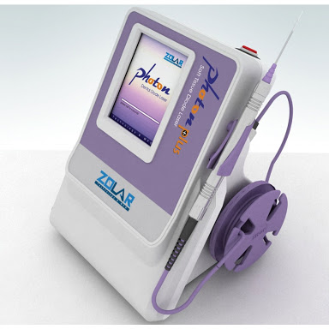
Its use has been spread to different fields:
1:Endodontics(As in case of pulpectomy).
2:Hypersensitivity/Root sensitivity.
3:Bleaching(Photoactivation)[5 Watt+].
4:Soft tissue lesions(Herpes Simplex:TIME:45sec;gets treated within 1 week).
5:Gingival Currettage(0.8 WP;Time:3-4sec).
6:Open flap debridement(1 WP).
7:2nd stage implant surgery(1.2 WC).
8:Frenectomy(1.0 WP).
9:Unerupting tooth(0.9 WC).
10:Crown lenghthening.
11:Periimplantitis(0.8 WC).
12:Carapal Tunnel Syndrome.
13:Nerve regeneration.
14:Cancer therapy.
15:Diabetic foot.

It has been generally noticed that people nowdays change their mobiles after every 2 years(example:apple iphone7 costs Rs.42,999) and the cars like BMW costs about 34.50 lakhs,instead of which they can invest their money in buying zolar photon plus for their clinics which costs around Rs.2,30,000 to Rs.9,84,286.Those dentists using laser treatment for their patients are earning Rs.30,000 in 45sec as compared to those who are still unaware of this device.
If the dentists start using this zolar photon plus then for sure “Your patients will be walking out of your clinic with that white smile they are looking for.”
Written by:Dr.Madhulika Banerjee(Final year BDS,Maharaja Ganaga Singh Dental College & Research Centre,Sriganganagar,Rajasthan).


