Title: Animal and plant protein intake and body mass index and waist circumference in Korean elderly population

Ki-Byeong Park ¹, Hyun Ah Park ^{1,}* Jae-Heon Kang¹, Kyoungwoo Kim¹, Young Gyu Cho¹ and Jinyoung Jang¹
Department of Family Medicine, Seoul Paik Hospital, Inje University College of Medicine, Seoul, Korea

Abstract

Controversy exists on whether animal and plant proteins influence obesity differently. The purpose of this study was to evaluate the association between total, animal, and plant protein intake with the obesity index and renal function in Korean elderly. Study participants included Korean adults aged 60 years or older from the Korean National Health and Nutrition Examination Survey in 2013-2014. Height, weight, and waist circumference (WC) were measured and the body mass index (BMI) was calculated. One-day 24-hour recall data were used to estimate daily total, animal, and plant protein intake. Glomerular filtration rate (GFR) was calculated by using the Modification of Diet in Renal Disease (MDRD) equation. General linear modellings were used to assess the relationships between protein intake, BMI and WC. The mean age was 69.2 ± 0.2 years, 44.2% were male. The total daily protein intake was 1.1 ± 0.02 g/kg/d and 0.9 ± 0.02 g/kg/d for males and females, respectively. Only one third of protein intake was from animal sources. In males, BMI (regression coefficient (95% CI); -1.30 (-1.55, -1.06), p < 0.001; -0.29 (-0.52, -0.05), p = 0.016; -1.30 (-1.8, -1.02), p < 0.001, respectively) and WC (-3.87 (-4.58, -3.16), p < 0.001; -0,90 (-1.58, -0.22), p = 0.010; -3.88 (-4.68, -3.08), p < 0.001, respectively) decreased as daily intake of plant protein (g/kg/d), animal protein (g/kg/d) and total protein (g/kg/d) increased. Similar associations were shown in Korean females. GFR was not associated with protein intake regardless of protein source in both sexes. In Korean adults aged 60 years or older, the protein intake was associated with a favorable obesity index without decrease in renal function. The effect was similar in both males and females, with both animal and plant proteins.

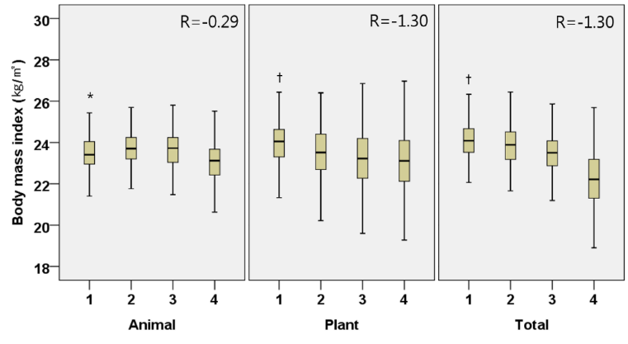

(a)
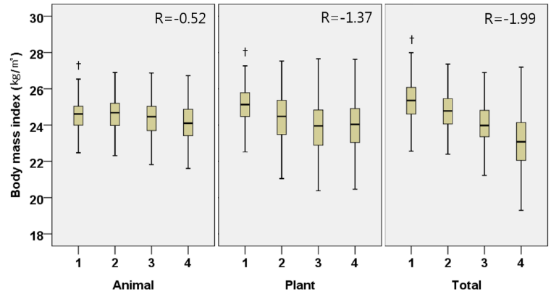

(b)

Figure. Adjusted body mass index (kg/m²) by the quartiles of daily animal, plant, and total protein intake per weight (g/kg/d) in Korean elderly population. (a) Male, (b) Female

Recent publications:
- Park HA (2018) Adequacy of protein intake among Korean elderly. KJFM 39:1-5
- Jang J, Cho YG, Kang JH, Park HA, Kim KW, Hur YI, Park KB (2018) The distribution of weight status according to familial socioeconomic status in Korean adolescents. Korean J Health Promot 18(1):23-31
- Kang BH, Kang JH, Park HA, Cho YK, Sim WY, Byeon GR, Kim KW (2017) The mediating role of parental support in the relationship between life stress and suicidal ideation among middle school student. 38:213-9.

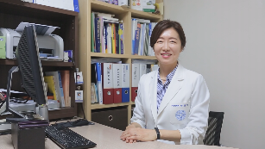
Biography (150 word limit)
HA Park has her expertise in nutrition, obesity, and women’s health. She works for a private hospital affiliated with a medical college and has busy days for research, teaching, and patients care. She is also involved in the Nutritional Consulting Team of her hospital for patients with nutritional risk.
Email: drparkhyunah@gmail.com

Speaker Mobile Number: 82-10-7372-3785
Speaker Facebook Profile URL: none

