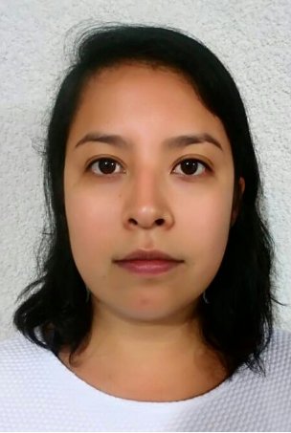
Neck circumference as an indicator of risk for the systemic arterial hypertension and dyslipidemia
(Unidad Medico Familiar No.9, IMSS Aguascalientes, Mexico).

Silos Vega, Citlalli Alejandra*Tutor: Dr. Ramírez Orozco, Ricardo Ernesto**
Bachelor's degree in Human Nutrition*, Autonomous University of Aguascalientes
Nutrition professionals focus on the prevention and detection of cardiovascular diseases related to obesity, through the implementation of non-invasive, easily applicable and inexpensive anthropometric methods as a preventive method such as the determination of the neck circumference (NC). Therefore, a correlation, cross-sectional, and prospective study was conducted for a period of 2 months (October to November 2017) in a Public Health Center in the state of Aguascalientes, Mexico. We analyzed 42 patients (28 female and 14 male), which showed Body Mass Index (BMI) values ​​between 22.4 to 45.9 kg/m². Interestingly, a relationship was found between the increase in NC with the prevalence of diseases (mainly in the development of hypertension and dyslipidemia), with risk factors for cardiovascular diseases, with an increase in triglycerides and serum cholesterol (r2 = 0.661, p <0.023), preferably in females. Reports from the previous investigations have associated NC with cardiovascular diseases and with metabolic risk factors. The mechanism involved in the association between NC and cardiovascular risks is not well defined; however, it is known that subcutaneous fat in the upper area of ​​the body causes an increase in the release of systemic fatty acids associated with cardiovascular risks. In this study, NC was also positively related to weight (r = 0.661, p <0.001), height (r = 0.439, p <0.004), Body Mass Index (r = 0.448, p <0.003), Waist Circumference (r = 0.432, p <0.004) and the Hip Circumference (r = 0.370, p <0.016), which are also used as indicators of overweight and obesity. For the foregoing, we could conclude that the NC should be considered as an important anthropometric measurement and used as a diagnosis of the identification of health risks in patients of the Public Health Centers, due to its low costs and easy reference and interpretation of the health status of the individuals.

Biography
I´m Citlalli Silos, received the bachelor's degree in Human Nutrition at the Universidad Autónoma de Aguascalientes, Mexico. During my programme, I have carried out the academic training Seville, Spain. Later, I have undergone short research stay at the Instituto Nacional de Ciencias Médica y Nutrición Hospital Salvador Zubirán, México City, Mexico. At the end of my semester, I have carried out the professional practices in the Clinic area at the Hospital of the Mexican Institute of Social Security (IMSS). Meanwhile, I did a research this investigation.
Presenting author details
Full name: Citlalli Alejandra Silos Vega
Contact number: 0 52 0 45 44 936 335 31
Twitter account: Citlalli SVega
Category: Poster presentation

