ORAL HYGIENE
Healthy teeth not only enable you to look and feel good, they make it possible to eat and speak properly. Good oral health is important to your overall well-being.
In between regular visits to the dentist, there are simple steps that each of us can take to greatly decrease the risk of developing tooth decay, gum disease and other dental problems. These include:
- Brushing thoroughly twice a day and flossing daily
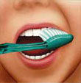 | 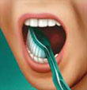 | 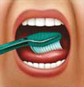
Tilt the brush at a 45° angle against the gumline and sweep or roll the brush away from the gumline. | Gently brush the outside, inside and chewing surface of each tooth using short back-and-forth strokes. | Gently brush your tongue to remove bacteria and freshen breath.

Proper Flossing Technique
 | 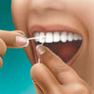 | 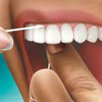
Use about 18" of floss, leaving an inch or two to work with. | Gently follow the curves of your teeth. | Be sure to clean beneath the gumline, but avoid snapping the floss on the gums.

- Eating a balanced diet and limiting snacks between meals
- Using dental products that contain fluoride, including toothpaste
- Rinsing with a fluoride mouthrinse if your dentist tells you to
- Making sure that your children under 12 drink fluoridated water or take a fluoride supplement if they live in a non-fluoridated area.

