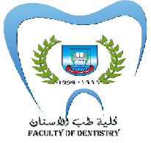
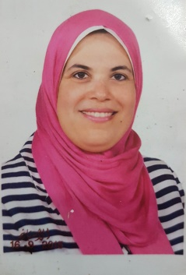 Official Photo University Logo
One Year -Randomized Clinical Trial to Evaluate Packable Bulk fill and Nano Resin Composite in Children and Adolescents
Shaimaa M. Mahfouz* and Asmaa A.Emam**

Shaimaa M. Mahfouz*PhD,Egypt
Asmaa A. Abo Elsoud **PhD, Egypt
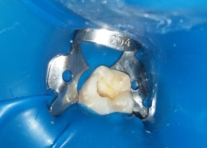
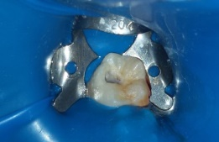
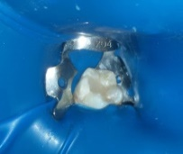
a
c
b

Abstract
Many studies used layering technique for placement of composite restoration. Layering technique in which the material can be placed in increments of 2-mm or less , this method results in adequate light infiltration and improvement of polymerization of composite resin restoration. Bulk- fill resin composites introduced into cavities in one increment that up to 4 –mm, this thickness offers several advantages of saving time and more simple technique of placement the restoration. No clinical study tested the efficiency of packable bulk- fill composite resin with maximum 4 mm depth in class I cavity in children. The Purpose of this study:- to evaluate the one- year clinical performance of the packable bulk fill and nano resin composite in class I restorations in children and a adolescents. Materials & Methods:- (33) pairs of first permanent molars had class I restorations were placed in (33) children, each patient received two class I restorations that were similar as possible . In all cavities, single bond adhesive (Xeno V+ ) was applied. One cavity of each pair was randomly assigned to be restore with packable bulk fill resin composite (Quixfil) in increment up to 4 mm . Anther cavity was restored with Nano hybrid resin composite (Esthet-X flow) placed in 2 mm increments. Finding:- at all evaluation periods of, no statistically significant differences were detected between packable bulk fill composite resin and Nano hybrid composite resin in marginal discoloration, surface roughness and caries detection ,whereas statistically significant differences between both materials in anatomical form and marginal discoloration parameters in favor with packable bulk fill.
Key words: Bulk fill- Nano composite

Figure 1 :-(a) Preoperative carious first permanent molar, b) cavity preparation, c) Bulk fill composite resin restoration
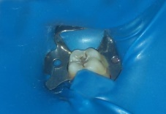
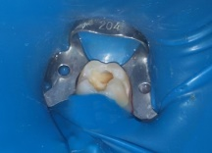
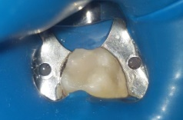
b
c
a

Figure 2 :-(a) Preoperative carious first permanent molar, b) cavity preparation, c) Bulk fill composite resin restoration

Recent Publications

1-ElBaz Gh , Mahfouz Sh (2017). Efficacy of two Different modalities on masking white Spot Lesions in Children with Molar Incisor Hypomineralization.EDJ;63:353-360.

2-Sharaan M, Elsoud A (2017).Calcium Enriched mixture used for permanent molar pulpotomy in teeth diagnosed as irreversible pulpitis:a case series.EDJ;86.

Presenting authors details
Shaimaa Mohamed Mahfouz Mahfouz Omer
*Lecturer of Pediatric and Preventive Dentistry and Dental Public Health , Faculty of Dentistry, Suez Canal University, Egypt.
Asmaa Aly Abo Elsoud
**Lecturer of Pediatric and Preventive Dentistry and Dental Public Health , Faculty of Dentistry, Suez Canal University, Egypt.
Mobile number:- 002012223228727
Email: HKMSSSM@yahoo.com
Track number: https://annualmeeting.conferenceseries.com/dentists/call-for-abstracts.php (For track number follow this link
Category: (E-poster)
Research interest: Bulk fill composite restorations in children

Year of birth: 1977
Linked In/Facebook: Shimaa el Bardisy

