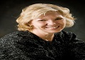
Sharon Decker
Chair texas tech university Health Sciences Center,USA
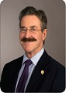
John C Lewin
President And CEO Cardiovascular Research Foundation,USA
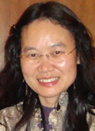
Guang Zeng
Associate Proffessor Texas A&M University-Corpus Christi,USA
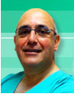
Sindey Chocron
Cardiac Surgeon University Hospital Of Besancon,France
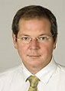
Louis P.Perrault
Doctor,Surgery Department Montreal Heart Institute,USA
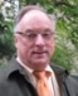
Dr.Thomas Adamski
Director Jewish Home Lifecare,USA

Annika Odell
Head of the Research unit,Cardiology Sahlgrenska University Hospital, Goteborg,Sweden
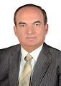

Samer Ellahham
Senior cardiovascular condultant,SKMC,UAE
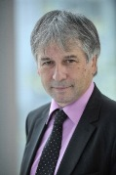
DOMINIQUE LETOURNEAU
President,Director,Associate Professor Creteil university,Frnace
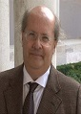
Carlo Pappone
Head,unit of clinical Arrhythmology& Electrophysiology,Clinical arrhythmology & electrophysiology Center, Italy

Andrzej Nowicki
Nicolaus Copernicus University , Poland
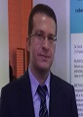

Umit Yuksek
Doctor Odemis State Hospital, Izmir, Turkey
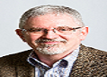

Paul Morrison

Professor Murdoch University, Australia

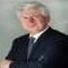

Michael Frass

Professor Medical University of Vienna , Austria

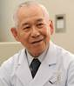

Dr. Takehiko Ohura

Chair & Professor Japanese Association of Homecare for Pressure Ulcers & Wounds , Japan

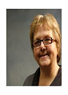

Eileen Savage

Professor and Head University College Cork, Ireland

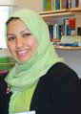

Thurayya Eid

Director King Abdulaziz University, Saudi Arabia

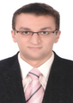

Ayman Khairy M. Hassan

Vice Director Assiut University, Egypt

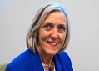

Hilary Whyte

Medical Director University of Toronto, Canada

