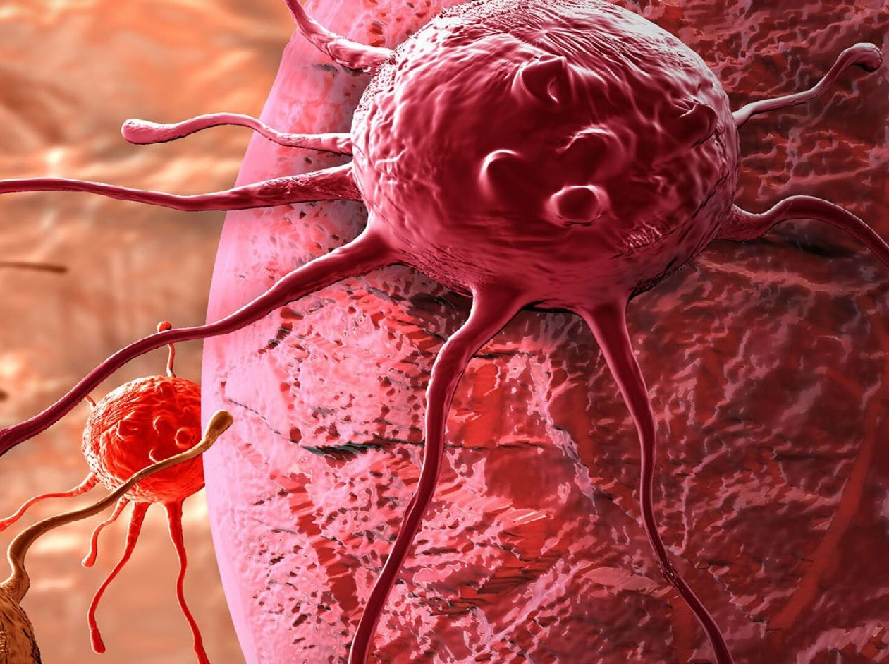







Mail us to know more!
No doubt you have lots of queries... Why not get in touch...! Drop us your query with details and we will call you right away

Program Manager
Suzan Alice
Email: oncology@surgerycongress.com https://oncology.cmesociety.com/

Pulsus Conference
35 Ruddlesway, Windsor, Berkshire, SL4 5SF, UK
https://www.pulsusconference.com/

Theme: “Exploring the possibilities of therapeutic interventions in Oncology & Cancer Research”

Contact
WhatsApp: +44-7418 603803
https://www.pulsusconference.com/contact-us https://www.pulsusconference.com/

2ND ANNUAL CONGRESS ON
ONCOLOGY AND CANCER RESEARCH
Aug 28-30, 2023 | LONDON, UK

https://oncology.cmesociety.com/

Good Will,
INVITATION

ONCOLOGY CONFERENCE 2023

We are delighted to welcome you all to the “2nd Annual Congress on Oncology and Cancer Research” which is scheduled on Aug 28-30, 2023 at London, UK
Oncology Conference 2023 takes a privilege of welcoming all the researchers, brand exhibitors, investigators, doctors, professors, academicians, delegates, as well as students around the world to explore, learn, and share their research knowledge and experience in the field of Oncology.
Oncology Conference 2023 is going to be a great platform to bring together dynamic and motivating keynote speeches on Oncology, as well as lectures on cancer symptoms, early indicators, and oral and video presentations on cancer awareness.
We cordially invite you to the Oncology Conference 2023 to explore the recent breakthrough
in the field of Oncology.
Regards Suzan Alice
Program Manager | Oncology Conference 2023

CONFERENCE HIGHLIGHTS

- Oncology
- Oncologists
- Cancer and its types
- Stages of Cancer
- Oncogenesis
- Cancer Biology
- Cancer Diagnosis and treatment
- Prevention of Cancer
- Oncology Pharmacy
- Chemotherapy
- Cancer Radiation Therapy
- Clinical Trails
- Cancer Drugs and Vaccines
- Surgical Oncology
- Clinical Oncology
- Head and Neck Cancer
- Breast Cancer
- Melanoma and Other Skin Cancer
- Biomedical Advancements in Cancer
- Palliative Care




https://oncology.cmesociety.com/abstract-submission










ABOUT US

Since many years Pulsus has also been very instrumental to provide an invaluable channel for scientists and researchers to exchange ideas and research by creating a forum for discussing the possibilities of future collaborations between universities, institutions, research bodies and organizations from differ- ent countries through international conferences and meetings.
Pulsus Group is an internationally renowned medical peer-review publisher and conferences organizer established in the year 1984 publishes and hosts the work of researchers in a manner that exemplifies the highest standards in research integrity.

With a legacy of 30 years of excellence in Medical Publishing, we are endorsed by various societies like the International Academy of Cardiovascular Sciences, International Society of Addiction Medicine, European Biotechnology Thematic Network Association, World Federation of Paediatrics Intensive and Critical Care Societies, World Association of Medical Sciences, International Society for Ceramics in Medicine, Thalassemia International Federation and World Association of Integrated Medicine to nurture the research and development for the beneficence of society.

https://oncology.cmesociety.com/about-us


MARKET ANALYSIS
Due to the rising number of oncology-related clinical trials and companies investing in cancer therapeutics, the size of the pipeline of therapies currently undergoing clinical testing, the introduction of novel drug substances, and the rising level of global investment in oncology, oncology is regarded as the most innovative area of therapy. The rising use of tobacco and alcohol is contributing to the expansion of the worldwide oncology industry. The GLOBOCAN study from the International Institute for Research on Cancer (IARC) estimates that there were 10.3 million cancer-related deaths and 19.3 million new cases of cancer worldwide in 2020. The IARC predicts a 47% global increase in new cancer cases between 2020 and 2040. Because of this, the global usage of oncology diagnostics and oncology treatments is anticipated to rise, driving the expansion of the global oncology market. In addition, expanding government and non-profit programs to promote cancer prevention is anticipated to support market expansion. For instance, the Global Action Plan for the Prevention and Control of Noncommunicable Diseases of the World Health Organization intends to reduce early death from diabetes, cardiovascular disease, cancer, and other chronic respiratory diseases by about 25% by 2025. Global demand for early cancer diagnosis and treatment has increased due to the rising frequency of numerous chronic diseases.

TARGET AUDIENCE
WHO SHOULD ATTEND

    - Oncologists
    - Pediatric Oncologists
    - Oncology Researchers
    - Directors and Chair Persons
    - Health Care Professionals
    - Oncology Schools and Colleges
    - Medical Students
    - Chemotherapists

    - Medical Institutes
    - Industrial Professionals
    - Pharmacists
    - Pharmaceutical Companies
    - Physical Therapists
    - Training Institutes
    - Business People

WHY TO ATTEND
Oncology Conference 2023 aims to bring together the eminent researchers, medical oncologists, health care professionals to spread and advance the current research in the field of Oncology. This is a great opportunity to take away new insights from recent medical practices, particularly in the fields of Medical Oncology, Radiation Oncology, Chemotherapy, Neuro Oncology, Computational Oncology and Oncological Disorders. The young researchers and aspiring scientists would be able to improve their research ideas by attending this conference.
This conference will provide an extraordinary stage to network with featured subject matter experts, keynote speakers, and other members. Furthermore, as banner and oral introductions, this program will provide an opportunity to introduce research, special strategies, or clinical encounters. We guarantee that all members, including speakers and representatives, will leave with innovative thinking abilities.
https://oncology.cmesociety.com/scientific-program-pdf

WHY SPONSOR OUR EVENT?
Maximum exposure at a premier conference devoted to those involved in the office professional industry. An opportunity to build and reinforce strategic relationships within the office professional industry.
Time to network with industry colleagues and key decision makers.
A cost effective way to reinforce your organization’s brand and build brand awareness amongst a relevant audience.
Access to a broad network of industry partners from state and federal Government departments and the private sector.
Time to present latest innovations and new products or services to a pertinent audience, and showcase your expertise and capabilities.
Increased marketing opportunities including visibility on the conference website and associated marketing materials

DIAMOND SPONSOR
$10000

GOLD SPONSOR
$7500

SILVER SPONSOR
$5000
- Top billing logo recognition (Chamber website, event website, invitation/publicity, event signage)
- Three corporate sponsored workshop slots (audio visual included).
- Two complimentary exhibit booths with priority to purchase exhibition space and choose booth location (Booth size-3X3 sqm).
- Four complimentary registrations.
- One A4 color advertisement in the congress program or book of abstracts (excluding cover pages).
- 50% discount on both Extra Delegate Registrations and Booth

- Logo recognition (Chamber website, event website, invitation/publicity, event signage)
- Two corporate sponsored workshop slot (must honor deadlines, catering and audio visual included).
- One complimentary exhibit booth with priority to purchase exhibition space and choose booth location (Booth size-3X3 sqm).
- Three complimentary congress registrations.
- Logo recognition on congress website front page with link and logo recognition on congress sponsorship page.
- One A4 color advertisement in the congress program or book of abstracts (excluding cover pages).
- 50% discount on both Extra Delegate Registrations and Booth

- Larger name recognition (Chamber website, event website, invitation/publicity, event signage)
- Two complimentary congress registrations.
- One corporate sponsored workshop slot (must honor deadlines, catering and audio visual included).
- One complimentary exhibit booth with priority to purchase exhibition space and choose booth location (Booth size-3X3 sqm).
- One A4 color advertisement in the congress program or book of abstracts (excluding cover pages).
- 50% discount on both Extra Delegate Registrations and Booth

https://oncology.cmesociety.com/registration

BRONZE SPONSOR
$3500

EXHIBITION SPONSOR
$2500
- Larger name recognition (Chamber website, event website, invitation/publicity, event signage)
- One complimentary congress registrations.
- One corporate sponsored workshop slot (must honor deadlines, catering and audio visual included).
- One complimentary exhibit booth with priority to purchase exhibition space and choose booth location (Booth size-3X3 sqm).
- One A4 color advertisement in the congress program or book of abstracts (excluding cover pages).
- 50% discount on both Extra Delegate Registrations and Booth

- Larger name recognition (Chamber website, event website, invitation/publicity, event signage)
- One complimentary congress registrations.
- One corporate sponsored workshop slot (must honor deadlines, catering and audio visual included).
- One complimentary exhibit booth with priority to purchase exhibition space and choose booth location (Booth size-3X3 sqm).
- Half Page A4 color advertisement in the congress program or book of abstracts (excluding cover pages).
- 25% discount on both Extra Delegate Registrations and Booth

EDITORIAL BOARD MEMBERS

Dr. Alireza Heidari
California South University (CSU), USA

Dr. Mahnaz Darvish
NeoPhore Ltd, London, UK

Dr. Liping Wang
University of South Australia, Australia

Dr. Kalyan Saginala
Plains Regional Medical Center, Clovis, New Mexico

Dr.Mayukh Pandit
University College of Holistic Medicine and Technology Ghana

SUPORTING JOURNALS
Selected contributions will be published in following supporting international Journals:
Journal of Molecular Cancer https://www.pulsus.com/journal-molecular-cancer.html Journal of Cancer & Metastasis Research
https://www.pulsus.com/journal-cancer-metastasis-research.html

