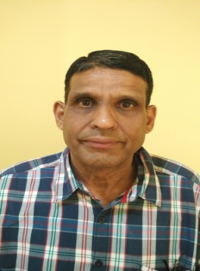
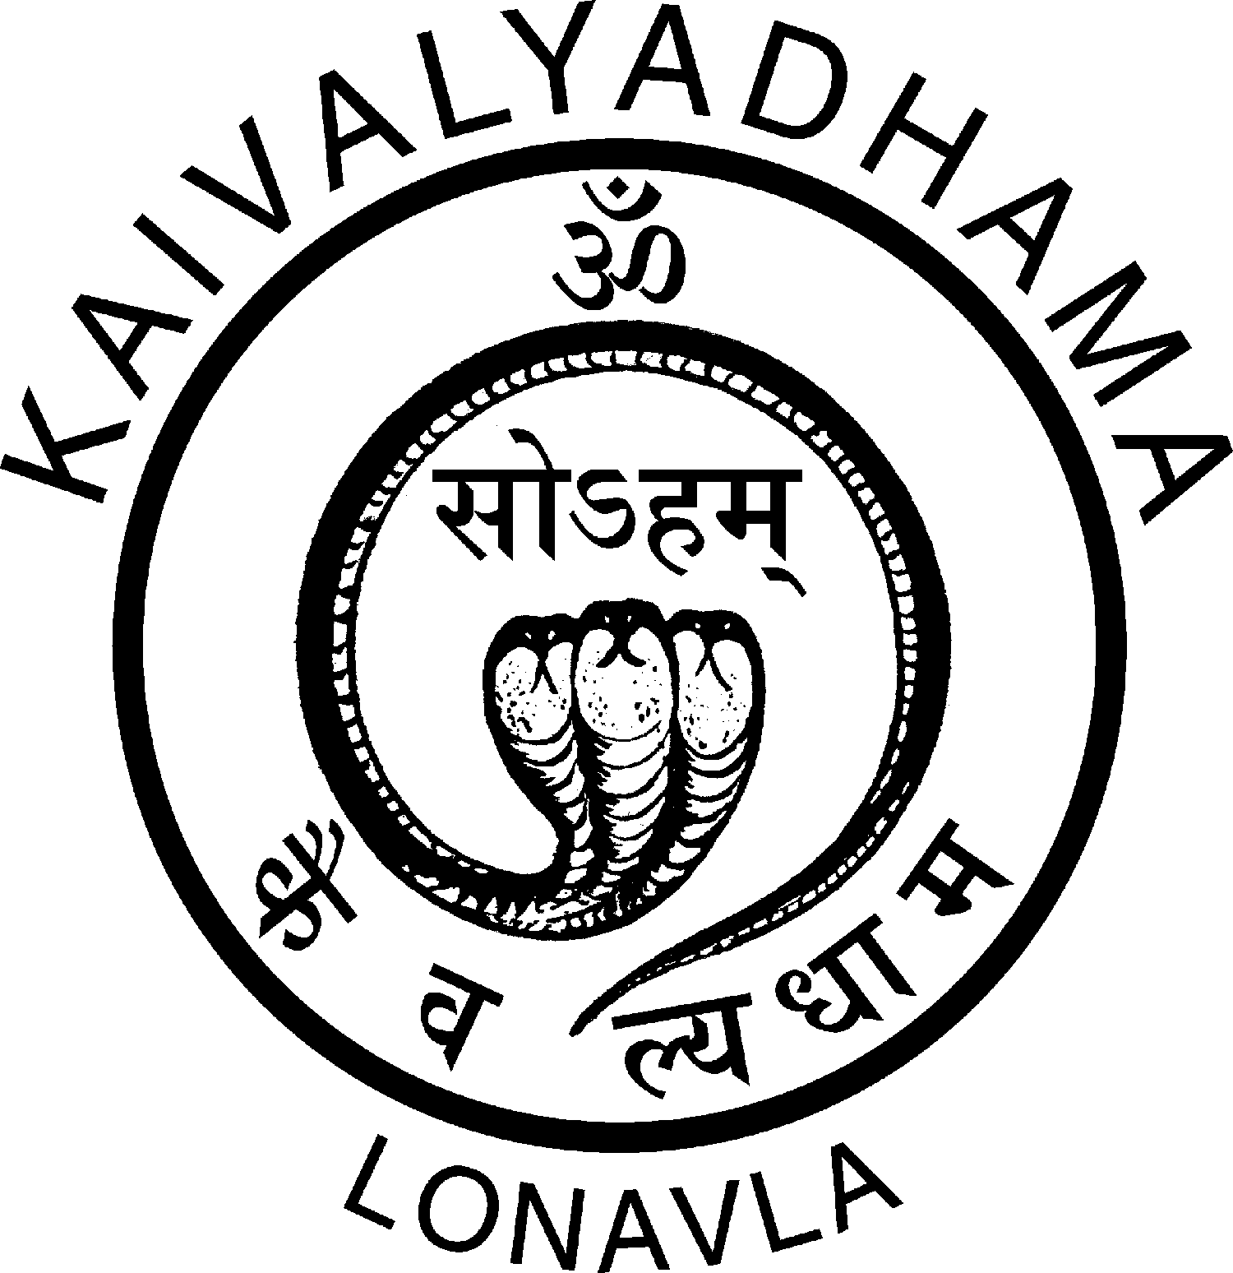

Title: Role of Yogic Science in Physiotherapy
Name: Mr. Dattatraya Devarao Kulkarni

Research Officer, Scientific Research Department, KAIVALYADHAMA – An Institute of Scientific & Philosophico-Literary Research Training and Therapy in Yoga, Grant in aid by Ministry of HRD, Govt of India , Lonavla, INDIA -410403

The physiotherapy as interdisciplinary subject of health restoration having several merits to restore vegetative component of brain-body functions, However, physiotherapy approach lacks internalized mind-body awareness, a component essential to restore auto regulation of Mind-Body co-ordination. The study proposes Patanjali School of Yoga, ancient traditional Indian Science address psycho-somatic aspects of brain behavior (Psyche) function, while Hatha Yoga school of Swatmaram renders experiential aspect of systematic relaxation from somatic (body) to psychic (mind) plane. The cumulative effects both schools of yoga develops psychobiological basis two-way five step Human Information Processing (HIP) Pathway to address somatic (body) and cortical awareness, as virtue of “a priori” information nature of yogic instructions processed on Control and Automatic modes of attention functions. The past scientific yoga research reports on psycho-physiological and neuropsychological front reveals decreased metabolic energy expenditure, psycho-neuro-immunological modulation via Neuro-endocirne & Hypothalamic –Pituitary axis, being monitored and modulated by electro-cortical activity triggered by breath awareness. The yogic HIP effects enhance cell-cell communication through increased signal power, for better affective and cognitive homeostasis. The unique nature of yogic HIP based relaxation response is based on operationally defined two step Post-Detection Closure (PDC) HIP involving “Detection” and “Rejection” stages perceived somatic activity. Further, attains neutral state of attention within perceptual channel assigned to neural space. The study concludes that incorporating yoga training to physiotherapy patients develops whole body monitoring response due breath and body awareness for faster recovery..

Key Words: Patanjali Yoga School, Hatha Yoga School , Physiotherapy, HIP, PDC & Mind-Body Complex

Biography

Mr Dattatraya Devarao Kulkarni has completed his Master of Science in Zoology at the age of 24 years from Bangalore University, Since, 27 years working as Research Officer at Scientific Research Department, KIVALYADHAMA, Lonavla-INDIA. His area of research interest encompasses Signal Detection Theory, Psychophysics, neurophysiology and neuropsychology in the context of yoga practices. He has authored more than 30 research articles in national and international journals and co-authored a book on Scientific Expositions of Pranayama. His current research includes bio-electrical basis of body awareness in yoga practices, exploring theoretical basis of Vedic concepts like Gayatri Mantra, OMkar and Pranadharana as explained from astrophysics, and astrobiology.

