Processing of wound images using interferometry

- M. Hamed
Physics Department, Faculty of Science, Ain shams University 11566 Cairo, Egypt.

Abstract

In this report, the processing of wound images using cascaded multiple beam interference is investigated. The deformation in the surface skin is computed from the fringe shift occurred as compared with the ordinary fringes of multiple beam interference. The profiles at different heights are computed giving two dimensional mapping corresponding to the deformation. The profiles are taken along the two cartesian coordinates corresponding to the whole modulated image . The results are discussed and followed by a concluding remarks. The Mat- Lab code is used in the processing.

References
1- .M. Hamed, Opt. and Photonics J. 6 (2016)75- 86, Image processing of coronavirus using interferometry. http://dx.doi.org/10.4236/opj.2016.65011

- A.M. Hamed, International Journal of Photonics and Optical Technology (IJPOT) 2 (2016) 18- 23, Compromising of resolution and contrast using quadratic aperture in scanning holographic imaging.

- A. M. Hamed and T. A. Al-Saeed, IJPOT 2 (2016) 6- 12, Reconstruction of the corneal layers affected by a periodic noise Application on microscopic interferometry

- A. M. Hamed, S.Y. Elzaiat, T.A. Al-Saeed, and L.K. Hammad, IJPOT 3(2017)1- 9, The point spread function using longitudinal black and white strips inside a circular aperture.

- A. M. Hamed, Optik, 131 (2017) 838- 849, Improvement of point spread function (PSF) using linear- quadratic aperture.
https://doi.org/10.1016/j.ijleo.2016.11.201

- A. M. Hamed, IJPOT 3(2017)1- 5, A modified Michelson interferometer and an application on microscopic imaging.

- A. M. Hamed, IJPOT 3 (2017)21- 27, Processing of the retinal artery image using higher orders of two beam interference.

- A. M. Hamed, IJPOT 4(2018) 13- 19, Design of some heterogeneous apertures and computation of resolution.

- A.M. Hamed, Int. J. Innovative Res. in Eng. and Management (IJIREM), 5 (2018) 189- 195, Sharp fringes using cascaded Multiple beam interferometers. Application on Kidney images. https://doi.org/10.21276/ijirem
- A.M. Hamed, Int. J. Innovative Res. in Eng. and Management (IJIREM), 5 (2018) 173- 181, Recognition of some modulated apertures using the Cascaded Fabry- Perot Interferometer (CFPI). https://doi.org/10.21276/ijirem

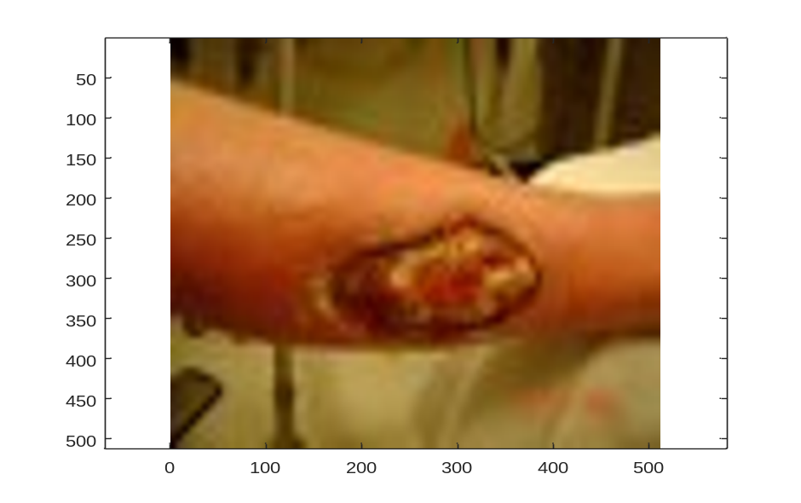

Figure (1): Wounded arm of dimensions 512×512 pixels.

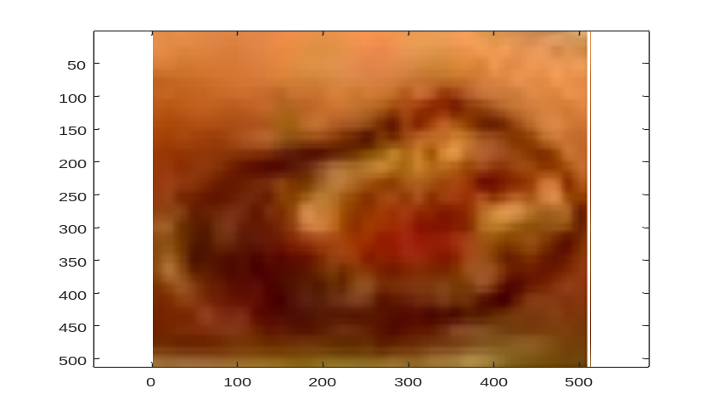

Figure (1- b): The wound image.
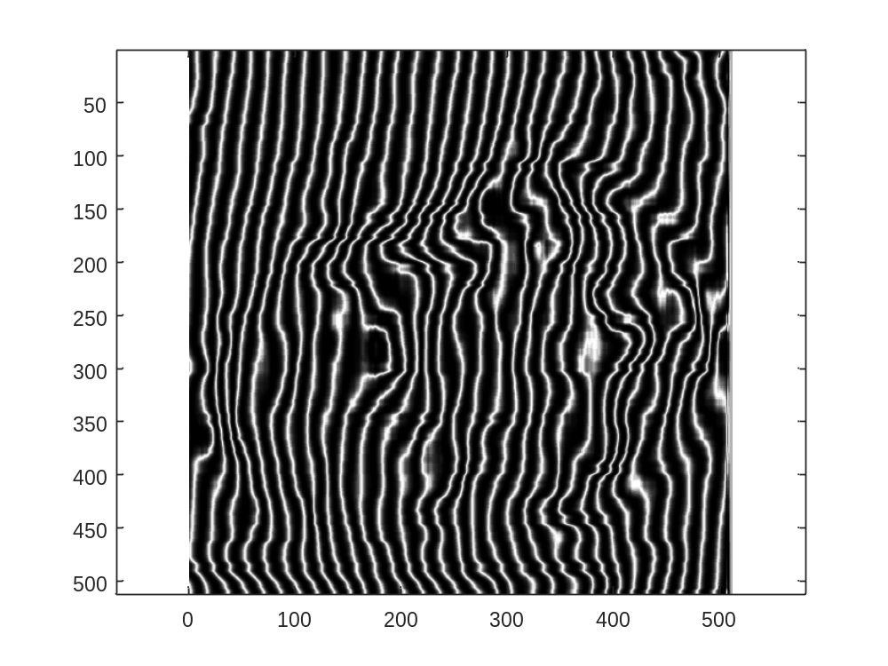
Figure (1- c): The wound shown in the figure (1- b), modulated with the multiple beam interference.

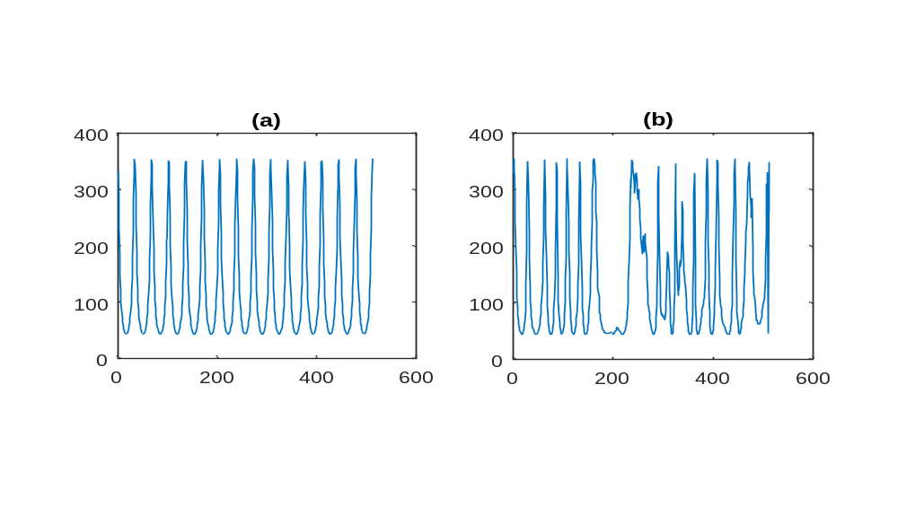
Figure (2- a): Profile along x- direction normal to the fringes. In the left as in (a) is the normal interference fringes while in the right as in (b)is the modulated fringes. The profile is taken at y = 200 pixels.

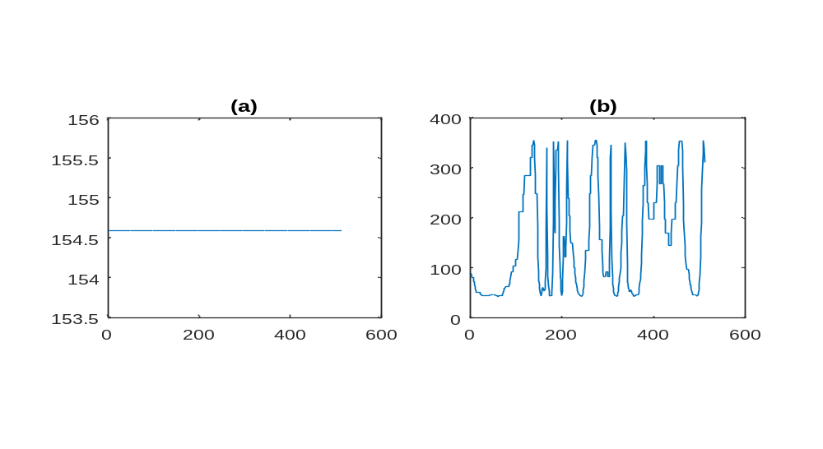
Figure (2- b): Profile along y- direction parallel to the fringes giving constant value as in (a), while in the right as in (b)is the modulated fringes. The profile is taken at x = 200 pixels.

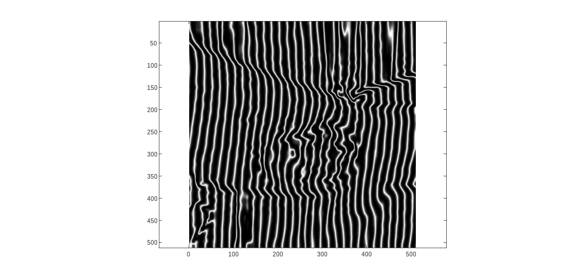

Figure (3- a): Modulated wounded arm with multiple beam interference for N = 1

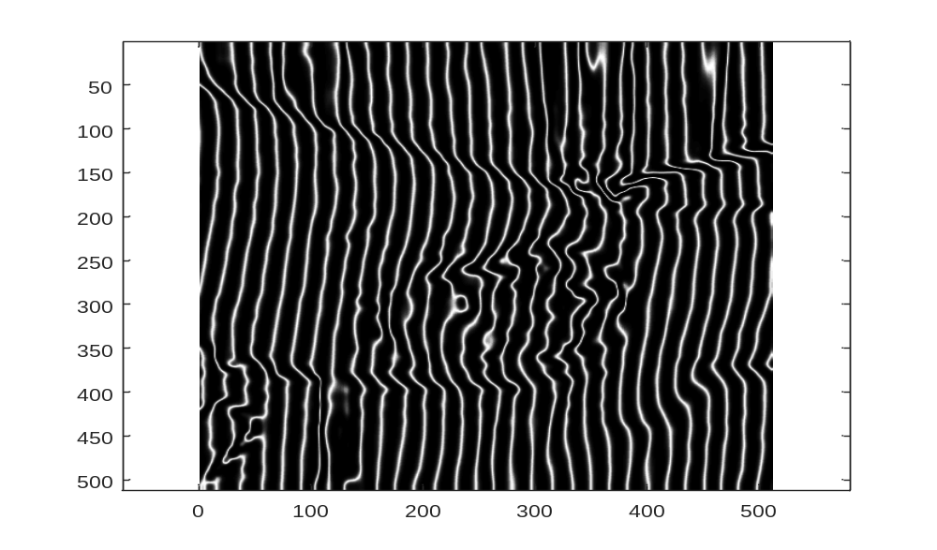
Figure (3- b): Modulated wounded arm with multiple beam interference for N = 2

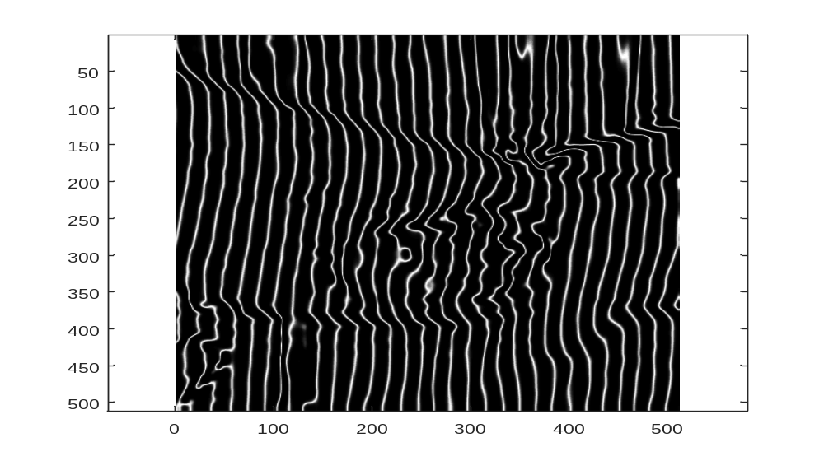
Figure (3- c): Modulated wounded arm with multiple beam interference for N = 3

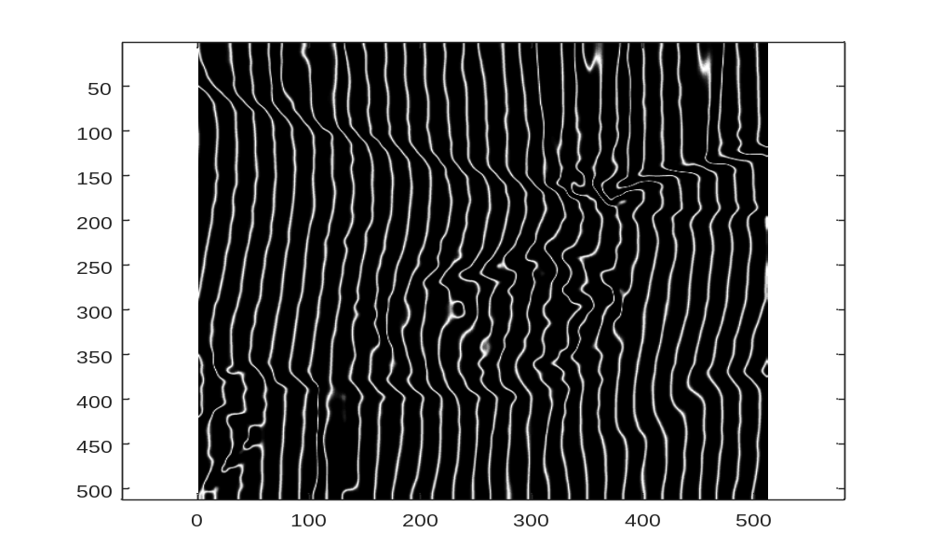
Figure (3- d): Modulated wounded arm with multiple beam interference for N = 4

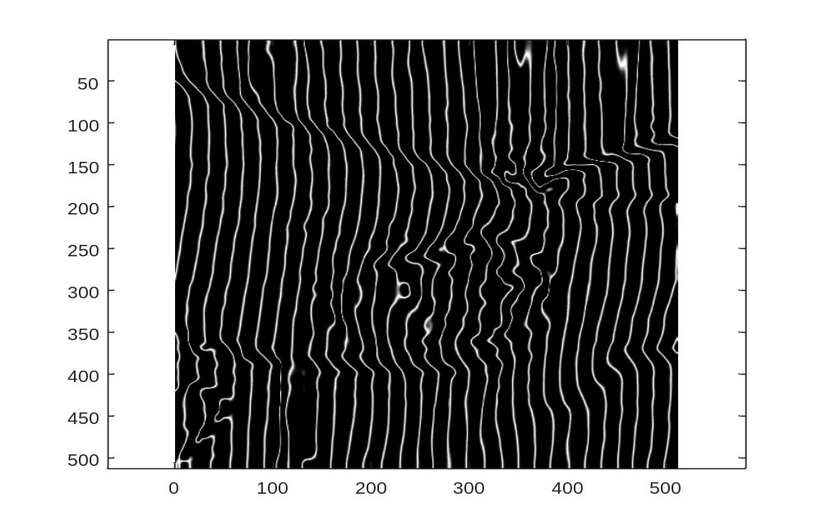
Figure (3- e): Modulated wounded arm with multiple beam interference for N = 5

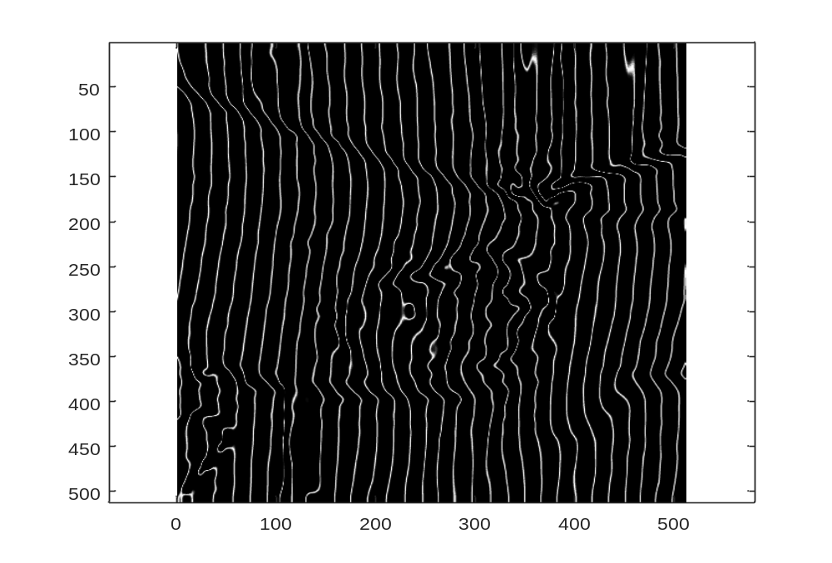
Figure (3- f): Modulated wounded arm with multiple beam interference for N = 10

