Accelerated antibacterial and wound healing activity in full thickness chronic wounds by iodine loaded chitosan encapsulated graphene oxide nanocomposite
Dr PRIYANKA CHHABRA PhD, GALGOTIAS UNIVERSITY, INDIA
Dr.AMIT TYAGI PHD,INMAS,DRDO,INDIA

Abstract (300-word limit)
Nanotechnology has emerged as a novel innovation of the century in different areas of science. The development of different types of nanocarriers offers novel approaches to delivering active drug at the site of injury in a sustained and effective manner which could significantly enhance the wound healing potential of chronic wounds. Given that, the goal of the present study is to develop nanocomposite based on chitosan, graphene oxide, and iodine as an antimicrobial agent for rapid wound healing. The prepared Iodine loaded chitosan encapsulated graphene nanocomposites (I-CH-G) were characterized using different techniques, such as SEM, FTIR, AFM, particle size analysis and zeta potential measurement. The average diameter of I-CH-G nanocomposite was found to be 370±1.2 nm and showed sustained release behavior. The optimized I-CH-G nanocomposite was incorporated into Carbopol gel and evaluated for drug content, pH, in vitro release, texture analysis, and viscosity. In addition to that, they were also evaluated for their antimicrobial activity against Staphylococcus aureus, Pseudomonas aeruginosa and Escherichia coli. Further, these nanoparticles were evaluated in- vivo for wound healing efficacy in Sprague Dawley rats. Histopathological evaluations demonstrated that I-CH-G-NPOs showed significantly enhanced wound contraction, enhanced cell adhesion, epithelial migration, and high hydroxyproline content leading to faster and more efficient collagen synthesis as compared to plain carbopol, plain Iodine and controls. Hence the topical administration of fabricated I-CH-G-Nanocomposites appears to be an interesting and suitable strategy for the treatment of chronic wounds.
Keywords: Nanocomposite, Iodine, chitosan, graphene, antimicrobial activity, Wound healing.

Image

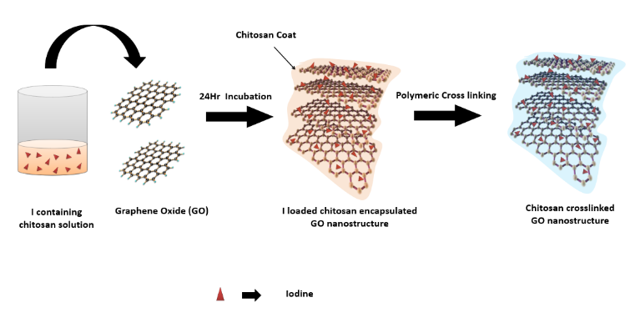
Figure1: Formation of iodine loaded chitosan encapsulated graphene oxide nanocomposite (I-CH-G).

Recent Publications (minimum 5)
- Meenakshi Choudhary, Priyanka Chhabra, Amit Tyagi, Harpal Singh. Scar free healing of full thickness diabetic wounds: A unique combination of silver nanoparticles as antimicrobial agent, calcium alginate nanoparticles as hemostatic agent, fresh blood as nutrient/growth factor supplier and chitosan as base matrix. International journals of Biological Macromolecules. Volume 178, 1 May 2021, Pages 41-52
- Chhabra P, Chauhan G, Kumar A. Augmented healing of full thickness chronic excision wound by rosmarinic acid loaded chitosan encapsulated graphene nanopockets. Drug Development and Industrial Pharmacy. 2020 Jun 2;46(6):878-88.
- Akash Kumar, Priyanka Chhabra. Challenges Faced by a Forensic expert in Internet of Things Forensics: A Review International Journal of All Research Education and Scientific Methods (IJARESM), ISSN: 2455-6211 Volume 8, Issue 10, October-2020,
- Chhabra, P., Tyagi, P., Bhatnagar, A., Mittal, G., & Kumar, A. (2016). Optimization, characterization, and efficacy evaluation of 2% chitosan scaffold for tissue engineering and wound healing. Journal of Pharmacy & Bioallied Sciences, 8(4), 300.
- Priyanka Chhabra, Lalita Mehra, Gaurav mittal, Amit Kumar. A comparative study on the efficacy of chitosan gel formulation and conventional silver sulfadiazine treatment in healing burn wound injury at molecular level. Asian Journal of pharmaceutics. July-Sep 2017.Vol 11 (3) ,489.

Photograph

Biography (150 word limit)
Dr priyanka Chhabra has her expertise in development and evaluation of formulations for enhancing wound healing in improving the health and wellbeing. She had developed different like scaffolds, hydrogels and nanoparticles formulations for accelerating wound healing process in full thickness chronic wounds, burn wounds and diabetic wounds. she is an Assistant professor in School of Basic and applied Science, Galgotias University and serving as a mentor for an undergraduate and graduate student.
Email: pchhabara188@gmail.com

Notes/Comments:

