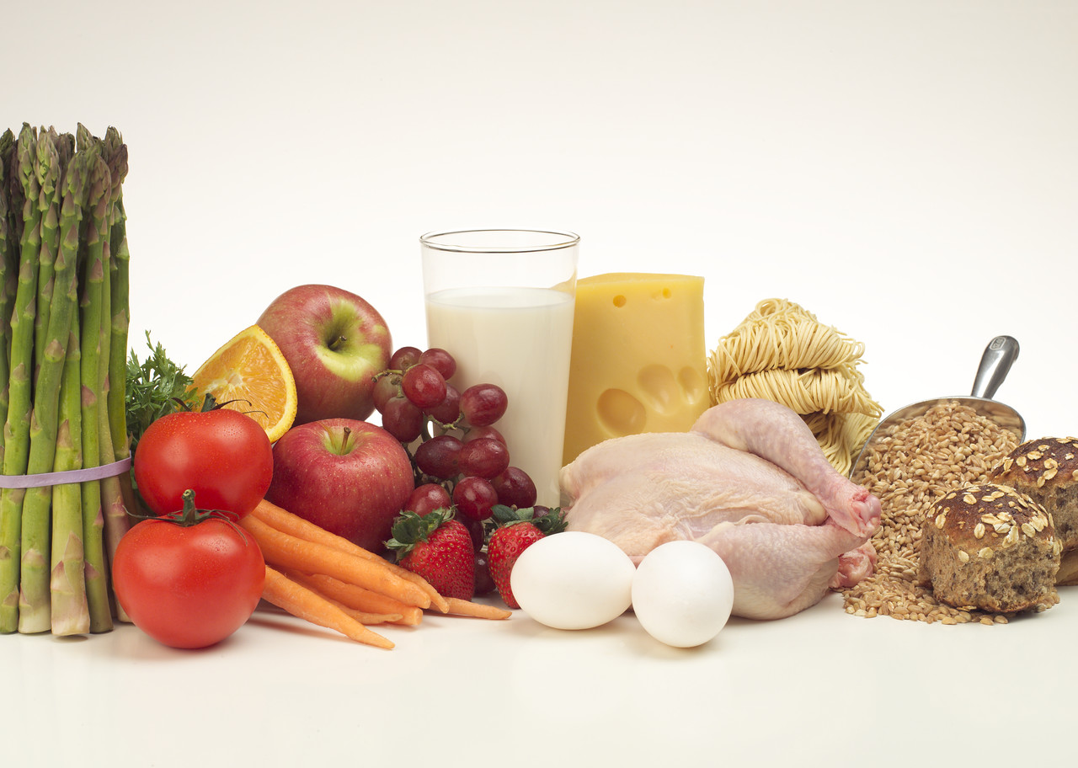
Nutrition and
wound Care

Marie Gabrielle Avril BFA, WCC, LPN

Nutrition plays a key role in both the prevention and treatment of wounds. The goal in preventing pressure ulcers is to screen and identify individuals at risk for ulcer development. A nutritional assessment should be completed both for individuals at high risk for pressure ulcers and those currently with wounds.

Nutritional screening as defined by the American Dietetic Association (ADA), a nutritional screening is the process of identifying characteristics known to be associated with nutritional problems. Its purpose is to pinpoint individuals who are malnourished or at nutritional risk and then determining appropriate intervention.

The screening process should identify risk factors for the development of pressure ulcers as well as identify those individuals who are malnourished or at risk for malnutrition: Significant weight loss: 5 lb. or more in 1 month; 5% in 30 days; 10% in 180 days. Disease states and conditions: diabetes, dementia, malnutrition, chronic obstructive disease (COPD), cancer, renal disease, obesity. Immobility and inactivity: hip fracture, spinal cord injury (SCI), stroke. Chewing and swallowing problems: dysphagia, stroke, Parkinson’s disease, cerebral palsy. Poor and fluid intake. Medication adverse effects.

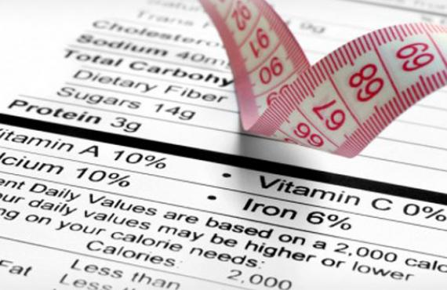

Nutritional assessment is a systematic process of obtaining, verifying, and interpreting data in order to make decisions about the nature and cause of nutrition-related problems. It’s an ongoing process that also includes continued reassessment and analysis of the patient’s needs. The assessment includes the patient’s nutritional status using medical, nutritional, and medication histories; physical examination, and laboratory data.
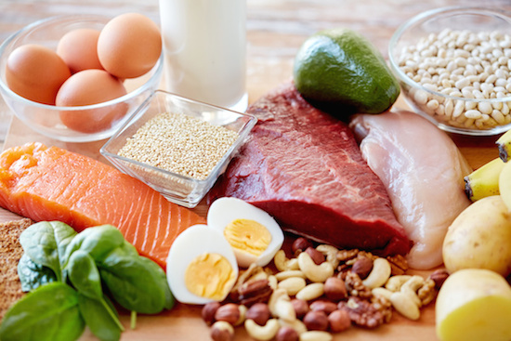
Role of nutrients in healing, there are six major classes of nutrients: carbohydrates, proteins, fats, vitamins, minerals, and water.

Nutrition is an important consideration when treating the patient with pressure ulcers, chronic wounds, or diabetic ulcers because it not only facilitates healing, but also improves or stabilizes the patient’s quality of life.

Marie Gabrielle Avril has a Bachelor degree in graphic design, has an LPN with wound Care Nurse certification, has been doing wound care for the past 12 years.

