Abstract Template
Abstract Title: STROMAL VASCULAR FRACTION AND GROWTH FACTORS CLINICAL APPLICATIONS

Priscilla Ortiz Porras

¹ Priscilla Ortiz Porras (ICM, Costa Rica)

Abstract (not more than 300 words)

Regardless of the specie, when animals have degenerative pathologies, most of their symptoms can be eased with pills, but the disease will keep progressing until the animal either dies; this pills no longer cause the desired effect and an euthanasia has to be performed so the animal doesn’t suffer; or some organ or organs get affected as a side effect of the long term consumption of the pills, mainly pain killers.
The heterologous cell population obtained from the combination of autologous Stromal Vascular Fraction SVF that contains an important population of Medical Signalling Cells MSCs, plus the platelet derived growth factors, has shown to be safe and to be able to induce regeneration in different tissues.
On the last years we have seen that clinical applications in animals with tendons and ligament partial ruptures and osteoarthritis can improve healing and at least enhance the quality of life of the patients treated, these results have been replicated in different species.
Have also treated animals with a dead sentence like a horse with severe central nervous system degeneration due equine protozoal myeloencephalitis, or a dog with aplastic anemia, and see how they survived and have a great quality of life thanks to the treatment.
Even the protocols to know the exact quality and quantity of cells to apply, biomolecules and biomaterials to add in order to have the best tissue regeneration are still unknown, responsible clinical use of this therapies had shown great potential, should therefore be integrated to the treatment options offered to owners, mainly on the pathologies where there is evidence of their success, and as a compassionate use, when the patient still has chance of surviving doesn’t matter if the current books say there is nothing left to do, we have proved there is much left to write.

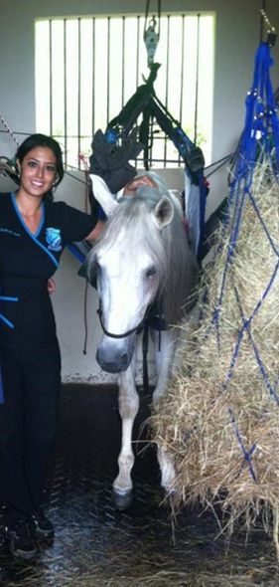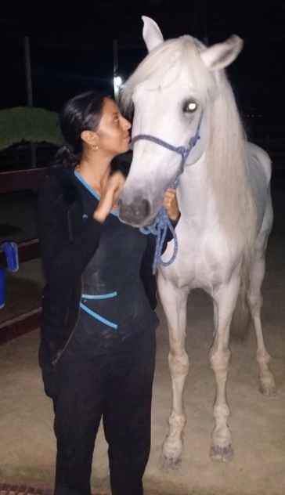

Keywords—cellular therapies, tissue regeneration, biomedicine, Adipose derived MSCs

Professional Biography (100-150 words)

Priscilla Ortiz Porras, DVM
Well-known international speaker regarding cellular therapies and regenerative medicine in world class events like 2016 World Stem Cell Summit in Palm Beach, FL, MSC Conference 2017 from Case Western University, Cleveland, OH, among other international meetings. Organized the First and Second International Congress of Regenerative Medicine in Costa Rica. Graduated in Veterinary Medicine and Surgery at the ESFA University, Véritas, Costa Rica and has regularly attended regenerative medicine events worldwide, including: the World Stem Cell Summit (2012, 2013, 2015 and 2016); and the Harvard MSC Colloquium Road to Translation by Harvard Stem Cell Institute held in Boston in 2016) among other meetings in USA, Chile and other countries. Selected as 2018 YLAI Young Leaders of the Americas Initiative fellow by the US Embassy. Has extensive clinical experience treating over 200 animals with MSCs derived from adipose tissue and growth factors and some successful cases performed first time worldwide.
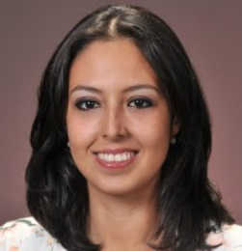

Email Id: drapriscillaortiz@gmail.com

