Abstract Template
Abstract Title: Wounds that would have put dogs down, how did we save them?
Priscilla Ortiz Porras

¹ Priscilla Ortiz Porras (ICM, Costa Rica)

Abstract (not more than 300 words)

These cases are two examples of severe wounds in canine patients treated with growth factors..
The first one is a dog that was hit by a car, the accident left it without an impressive amount of tissue on his head, making us believe at the beginning he had lost his eye and even part of his sculp.
When we did X rays, they showed there were no fractures, because of its anatomy, it only lost skin and most of the temporalis muscle. To treat the wound we used, non-steroidal anti-inflammatories, antibiotics until there was no infection, and gel-growth factors once a month for three months (closing time of the wound), collagen, plurionic gel once a day to keep it hydrated and even one session of laser therapy, the wound healed regenerating most of the muscular tissue and skin, even hair was growing in most of the wounded area.
The second case is a dog that was bitten by a very venomous snake, Bothrops asper, which made her lose half of her face skin in two days, it was dramatic and painful, but the owner wanted to do everything in his hands to save it, so we helped them with growth factors and collagen every three weeks, and also applied pure honey every day, it regenerated the tissue, when it was closed it went home six weeks after, after 12 months most of his hair grew and it was having a great life.
Overall these affordable therapies not only activate wound healing and induce tissue regeneration, but also significantly accelerate recovery and should therefore be integrated at first-line treatments in cases of severe tissue injuries.
Case 1

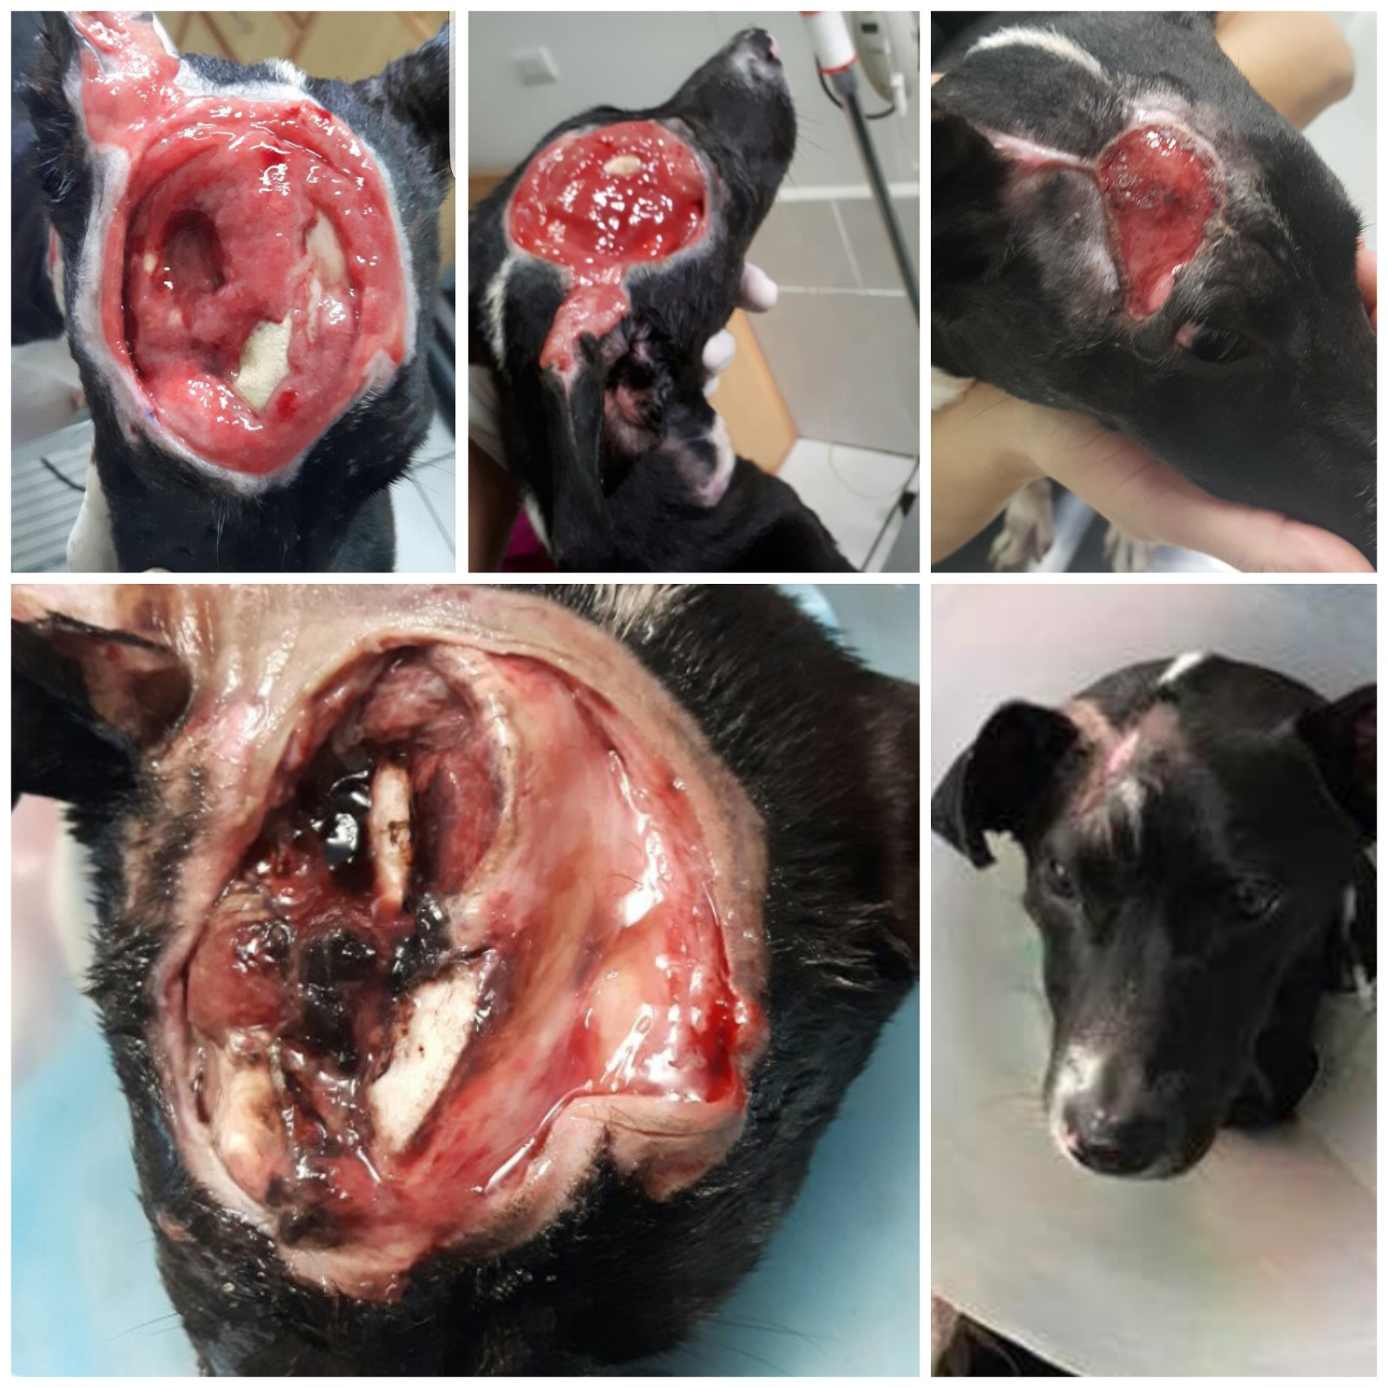
Case 2

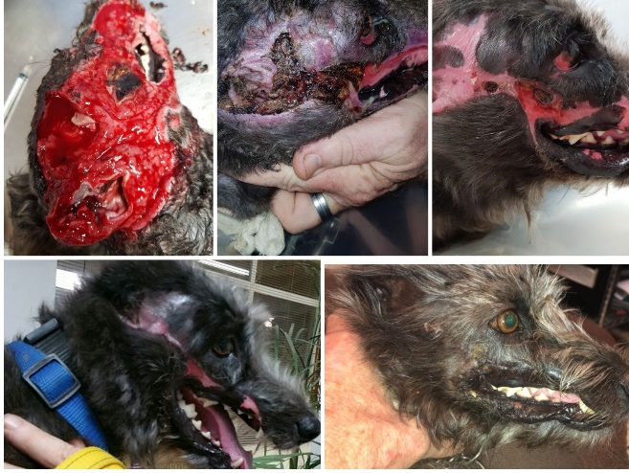

Keywords—face wounds, deep wounds, extensive wounds, dog wounds, tissue regeneration

Professional Biography (100-150 words)

Priscilla Ortiz Porras, DVM
Well-known international speaker regarding cellular therapies and regenerative medicine in world class events like 2016 World Stem Cell Summit in Palm Beach, FL, MSC Conference 2017 from Case Western University, Cleveland, OH, among other international meetings. Organized the First and Second International Congress of Regenerative Medicine in Costa Rica. Graduated in Veterinary Medicine and Surgery at the ESFA University, Véritas, Costa Rica and has regularly attended regenerative medicine events worldwide, including: the World Stem Cell Summit (2012, 2013, 2015 and 2016); and the Harvard MSC Colloquium Road to Translation by Harvard Stem Cell Institute held in Boston in 2016) among other meetings in USA, Chile and other countries. Has extensive clinical experience treating over 200 animals with MSCs derived from adipose tissue and growth factors and some successful cases performed first time worldwide.
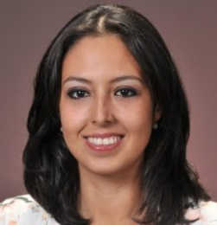
Paste your Photograph here

Email Id: drapriscillaortiz@gmail.com

Any Comments: I have other cases in dogs, cats riding bulls and horses treated with adipose derived MSCs I could present, and also please do not use or publish the images attached without Dr Ortiz permission

