Survey Of Bacterial Diseases of Ajmer Rajasthan India.
Dr Rashmi Sharma
Ajmer
Rajasthan
India.
sharmarashmigca@gmail.com

Abstract

Rajasthan is western state of India. Ajmer is located in the center of Rajasthan (INDIA)
between 25 ⁰ 38 “ and 26 ⁰ 58 “ north 75 ⁰ 22” east longitude covering a geographical area of
about 8481sq km hemmed in all sides by Aravalli hills . About 7 miles from the city is
Pushkar lake created by the touch of lord Brahma. The Dargah of khawaja Moinuddin chisti
is holiest shrine next to Mecca in the world. Rajasthan has hot dry summer and cold bracing
winter. The winter extends from November to February and summer extends from March to
June followed by rainy season till mid September. The temperature varies from 2 º C in
winter and 49 ⁰ C in summer. The normal annual rainfall is 527.3mm. Bacterial diseases
spread during March and September. The Bacterial diseases of Ajmer are Typhoid (
Salmonella typhi ) ,Diarrhea (Enterobacteriaceae), Abscesses ( Bacteroides), Food poisoning
(Staphylocci ), Streptococci, Pneumonia (Pneumococci ), UIT (Enterococci). Bacterial diseases
are contagious and can result in serious life threatening complications Blood poisoning
(Bacteremia ), kidney failure, toxic shock syndrome . Bacterial infection occur due to
unhygienic ‘conditions and improper sanitation. Maximum number of cases of Salmonella
typhi were recorded in Rajasthan. The observation were based survey carried out in
Rajasthan. Proper hygienic conditions, prior treatment and precautions can prevent
death and outbreak of disease.

Introduction
Virus is infectious particle that replicates inside the body of living organisms.
Virus can infect all microorganisms, bacteria and archaea.
Ajmer is located in the center of Rajasthan (INDIA) between 25 ⁰ 38 “ and 26 ⁰ 58 “
north 75 ⁰ 22” east longitude covering a geographical area of about 8481sq km
hemmed in all sides by Aravalli hills . About 7 miles from the city is Pushkar lake
created by the touch of lord Brahma. The Dargah of khawaja Moinuddin chisti is
holiest shrine next to Mecca in the world. Ajmer has hot dry summer and cold bracing
winter. The winter extends from November to February and summer extends from
March to June followed by rainy season till mid September. The temperature varies
from 2 º c in winter and 49 ⁰ c in summer. The normal annual rainfall is 527.3mm. Viral
diseases spread during March and September. The Bacterial diseases of Ajmer are
Typhoid ( Salmonella typhi ) ,Diarrhea (Enterobacteriaceae), Abscesses ( Bacteroides), Food
poisoning (Staphylocci ), Streptococci, Pneumonia (Pneumococci ), UIT (Enterococci).

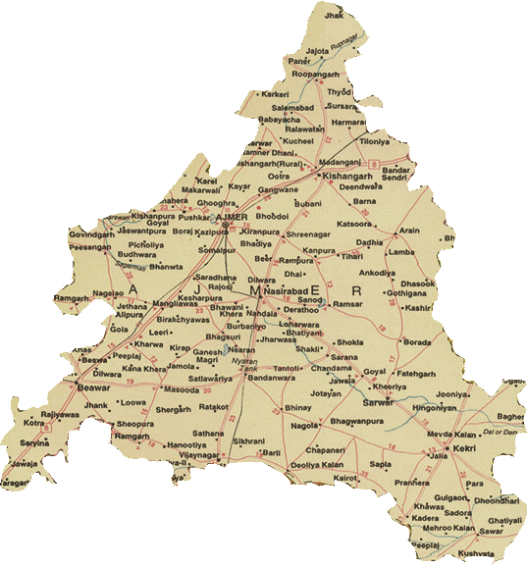

Image 2: Map of Ajmer

Materials and Methods.

House to house survey was done and data were also taken from local hospitals.

Observations and Results
During survey these viral diseases were observed.
Table – 1.

Bacterial disease | Bacteria Causative
Typhoid | Salmonella typhii
Diarrhea | Enterobacteriaceae
Abscesses | Bacteroides
Food poisoning | Staphylocci
Pneumonia | Pneumococci
UIT | Enterococci

Conclusion
Location of Rajasthan is being Western in India. And that of Ajmer is Central in
Rajasthan. Temperature is 2 ⁰ C in winters and 49 ⁰ C in summers. Average annual rainfall
is 300 mm .( Below average ).
The Bacterial diseases of Ajmer are Typhoid ( Salmonella typhi ) ,Diarrhea
(Enterobacteriaceae), Abscesses ( Bacteroides), Food poisoning (Staphylocci ), Streptococci,
Pneumonia (Pneumococci ), UIT (Enterococci).
For all Bacterial diseases precautions should be taken such as avoiding contact, using
safe needles, washing hands, proper sanitation and safe sex .

Summary

Ajmer is located in the center of Rajasthan , Temperature varies from 2- 49 ⁰ C .
Most of the people are vegetarian. Rainfall is below normal. Proper sanitation is required
for lower Bacterial diseases. Limited Bacterial diseases are there in Rajasthan.

Acknowledgement

I am thankful to Principal GCA for giving permission to do the studies . I am also
thankful to my team Garima, Grace, Vandana, Garima, Sampat and Sushil.

References

1. Verma R., Sharma P. , Garg R.K. , Atam V., et.al., Neurological complications of dengue
fever, Experience from a tertiary center of North India. An Indian Acad . Neurol. 2011.
Oct-Dec. 14 (4); 272-8.
2. Urthy J.M. Neurological complications of dengue infection. Neurol India. 2010; 58(4): 581-4.
3. Yuki N. Watanabe H., Nagajima T. , Spath P.J. IVIG Blocks compliment deposition
mediated by anti GM1 antibodies in multifocal motor neuropathy J. Neurol Neurosurg
Psychiatry 2011: 82(1) : 87-91.
4. Choudhary V., Swash M. Multifocal motor neuropathy : is conduction block essential?
Neurology . 2006 Aug . 67 (4) 558-9.

Table 1: Viral Diseases of Rajasthan India.
Type | Family |  |  | Transmission |  |  | Disease |  | Treatment |  | Prevention
Adenovirus | Adenoviridae |  |  | Droplet contact |  |  | Pneumonia |  | Avoid contact |  | Vaccine Avoid contact
 |  |  |  |  |  |  |  |  | Immunoglobulins |  | Avoid contaminated food water.
Hepatitis A | Picornaviridae |  |  | oral fecal route |  |  | Acute hepatitis
Hepatitis B | Hepadnaviridae |  |  | Body fluids |  |  | Acute hepatitis |  | Immunoglobulins |  | Avoid contaminated food water.
Hepatitis C | Flviviridae |  |  | Blood |  |  | Acute hepatitis |  | Ribavirin |  | Avoiding shared needles.
Herpes simplex virus | Herpesvridae |  |  | Direct contact , Saliva. |  |  | Gingivostomatitis, Tonsils |  |  |  | Avoiding close contact.
HIV | Retroviridae |  |  | Blood , Breast milk. |  |  | AIDS |  | Reverse transcriptase inhibitors. |  | Avoiding shared needles.
Influenza  Virus | Orthomyxoviridae |  |  | Droplet contact |  |  | Influenza |  | Amantadine |  | Hand washing covering mouth.
Measles | Paramyxoviridae |  |  | Droplet contact |  |  | Measles |  |  |  | Avoiding contact
Mumps | Paramyxoviridae |  |  |  | Droplet contact |  | Mumps |  |  |  | Avoiding contact
Parainfluenza | Paramyxoviridae |  |  |  | Droplet contact |  | Pneumonia |  |  |  | Covering mouth when sneezing.
Polio virus | Picornaviridae |  |  |  | Oral fecal |  | Poliomyelitis |  |  |  | Avoiding contaminate food and water.
Rabies | Rhabdoviridae |  |  |  | Animal bite |  | Rabies |  |  |  | Avoiding Rabid animal

