TREATMENT OF EMERGING SKIN DISEASES USING A NEW LOTION PROFESSOR(ORONSFRANKLO)® PROFESSORORONSAYE FE DEPARTMENT OF MEDICAL LABORATORY SCIENCE, COLLEGE OF MEDICAL SCIENCES, UNIVERSITY OF BENIN CITY, NIGERIA
Tel: +2347085424003
Email:sayfrankon@yahoo.com

Background: The emergence of new diseases of previously unknown aetiology is a common health challenge in developing countries. These diseases have defiled all known medications. They affect upper region of the body, particularly the face, neck and the jaw. Methods; One hundred subjects compressing 30 children,50 adults and20 elderly subjects who were discovered having bumps as it is called ’ on the face, scalp and neck were randomly recruited into the study Their consent was obtained verbally. And wee assured strict confidentiality: The subjects were given the lotion orondfranklo(R)which was applied to the affected areas only, twice daily, preferably morning and evening. The lotion is currently being investigated for its toxiccity in the Department o Pharmacology and toxicology Universiyty of Benin Benin City Nigeria The lotion is exclusively for external use. This lotion has been successfully, tried for treating both superficial fungal and bacterial infections. In Benin City Nigeria.
Results: the most dramatic effect of the lotion is the fact that during its application, successful clinical response was achieved within three days. e’.
Conclusion: This study presents ,the novel effect f this lotion in treating skin infections

.

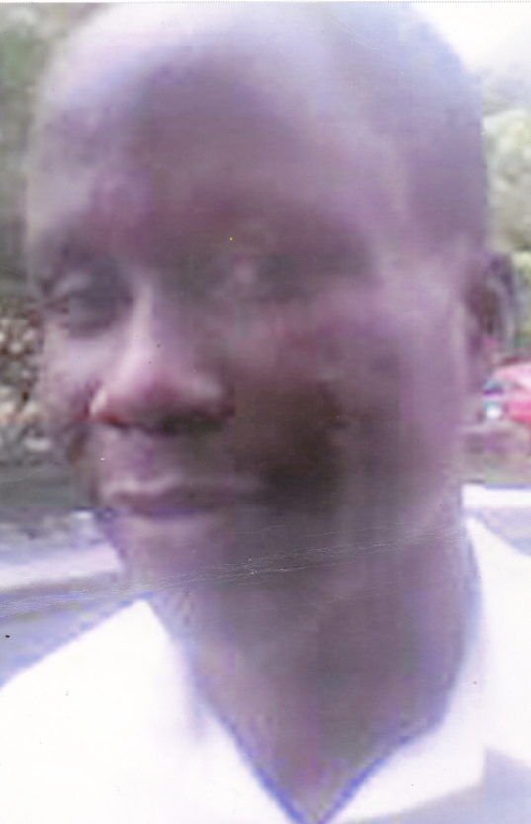
plate 1: Before Treatment


plate 2: After treatment
RECENT PUBLICATIONS
strainsWHO *2014) First global report of antibiotic resistance ,reveals serious world wide threat to public health. WHO month;y report, 2014
Smith J T (1984)The mode of action of the fluoroqauinolones and possible mechanism of resistance.J A CSuppll.D
Cowan S T and Steel K J (19745)Manual for the identification of the medical bacteria.2EDITIONCambridge University press. London pp. 15-21.
Gurrant T L (82) Nausea,vomiting and non inflammatory diarrheoa Princioles and practice of infectious diseases3rd Edition Church Hill Living stone New York. 837-851
Hancock DD and Riley L W(1995)Ecology of E coli 0157 in cattle and impact management and [ractice in 85-91 C O Brien A D Edition E coli 0157 and other shiga producing E. Clol strains.America society of microbiology Washington DC 85-91pp.
Gross R J and Holmes DD (1990) Enterotoxin testing n of Escherichia coli causing epidermic infantile enteritis inthe UK i LANCET1;112-118.
Oronsaye F E (2013)Prevention of HIV/AIDS from sociocultural perspective.Pan African Journal (in Press).
Oronsaye F E and Iyoha O. (2012) Environmental health risks posed by liquid/ solid waste and coew droplets in Nigerria. JJOurnal of biological science and bioconservation 4;39-41.
~Oronsaye F E and Yussuf E O (2005) Health risks posed by vegetables sold in markets in Benin city Nigerias. International Journal of food science technology. 2 91
0; 60-62.
Idu M, SE Omonigho, nIgeleke C I9, Oronsaye F E and Orhue E B(2008) Microbial load contamination of medicinal plants sold in markets in Benin city Nigeria. India Journal of traditional knowledge 7;669-672.
.Oronsaye F E ,Yussuf E O and Esiekpe E(2015) Treatment of sturborn fungal infection of the skin using a new lotion African Journal series (press)

BIOGRAPHY

