Occult Hepatitis C Virus Infection in Patients with Malignant Lymphoproliferative Disorders
Hisham Abdelaziz, Mahmoud Mohamed kamel
Department of Clinical Pathology, National Cancer Institute, University of Cairo, Egypt

Abstract
Introduction: Egypt has the highest prevalence of HCV in the world, estimated nationally at 14.7%. Occult hepatitis C virus infection (OCI), defined as the presence of HCV RNA in liver and in peripheral blood mononuclear cells (PBMCs) in the absence of detectable viral RNA in serum. The association between OCI and malignant LPDs remain to be further investigated. Methods: This study was conducted on 32 newly diagnosed patients with LPDs obtained from National Cancer Institute, Cairo University and 27 Healthy control. Both patients and controls were subjected to: Detection of HBsAg, HIV, EBV, CMV antibodies by ELISA, Detection of HCV-RNA by PCR, Conventional and Immuno-electron microscopy. Results: Patients were divided into 3 groups; Group 1: positive OCI LPD patients, Group 2: positive HCV LPD patients, Group 3: negative OCI/negative HCV LPD Patients. LPD patients showed a significantly higher percentage of positive OCI (12 patients, 37.5%) and positive HCV (11 patients, 34.38%) compared to the control group (0%) (p <0.001). Nine (28.13%) of LPD patients showed neither OCI nor HCV infection compared to 27 (100%) of controls (p <0.001). Positive OCI group also showed a significantly higher percentage of positive HCV PCR in PBMCs and significantly higher copy number of HCV in PBMCs compared to the negative OCI/negative HCV LPD group. Ultrastructural examination of PBMCs revealed the presence of intracytoplasmic vacuoles enclosing viral like particles, which were more in positive HCV patients than those seen in positive OCI patients. Conclusion: The existence of OCI among Egyptian LPD patients. Therefore, the possibility of OCI should be considered in patients with LPDs which can lead to relapse or cause overt infection even after treatment. Also, may help in the choice of treatment modalities (immunotherapy, chemotherapy and antiviral therapy).
 Biography
Dr. Hisham Abdelaziz, Assist. Professor of clinical pathology/hematology in National Cancer Institute, Cairo University, Egypt. He graduated from Kasr Alaini Medical School on 1996 and got his M.D. on 2018. He published many articles in Hematology, immunology and microbiology. He has a great talented experience in teaching hematology in addition to managerial studies, Total Quality Management, Assurance and safety measures.
Email: hishamaziz2002@yahoo.com

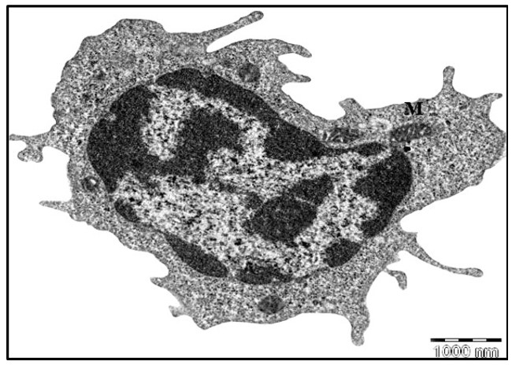
Figure (1): TEM micrograph of a lymphocyte isolated from a patient with OCI (Original magnification x11000)
Recent Publications:
- Abdelaziz H, Mahmoud K (2014): P selectin and T cell profiles provide verification to understand the pathogenesis of liver cirrhosis in HCV and Schistosoma mansoni infections. Microbial Pathogenesis, 73:19–24.
- Abdelaziz H (2014): HCV Signal-to-Cutoff Ratio in Predicting Hepatitis C Viremia. The 25th Regional Congress of the ISBT, Amsterdam, May 30 – June 5, 2014. Vox Sanguinis 2014 International Society of Blood transfusion 107: 57-248 p.140
- Abdelaziz H (2014): Routine Use of Mini-Pool Nucleic Acid Testing (MP-NAT) Multiplex Assay for Sero-Negative Blood Donors 2013. JESHR. 7(2):1-5.
- Abdelaziz H (2013): Diagnosis of Neonatal Sepsis using different sepsis markers. 4th International Conference Biomarkers & Clinical Research, Philadelphia, USA.
- Abdelaziz H (2013): The Predisposing Role of NAD (P)H: quinine Oxidoreductase Gene Polymorphisms in the Development of Pediatric ALL. JESHR, 9(2): 1-6.

