REPORT CASES: Selective IgM Deficiency: An Underestimated Primary Immunodeficiency and Vitamin D associated Beta-Glucana injectable in impact on immune functions: implications for preventive strategy of infection disease.

MD. FABRÍCIO PRADO MONTEIRO INST. ALLERGY AND IMMUNOLOGY WEST BAHIA, BARREIRAS-BAHIA-BRAZIL

Abstract
IgM is the first immunoglobulin to be expressed on the surface of B cells and the first immunoglobulin isotype secreted during an initial immune response to an exogenous antigen. Mature naïve B cells in response to antigens undergo clonal expansion and differentiation into Ig-secreting cells. A subset of activated IgM+ B cells undergo a process of heavy chain isotype switching resulting in the production of antibodies of different isotypes such as IgG, IgA, and IgE, upon engagement of CD40 with CD40L and interaction with cytokines, and somatic hyper mutation in V region results in the selection of high affinity antibody producing B cells (1,2).
In contrast to secreted IgG, IgM comes in two flavors, pre-immune or without exposure to exogenous antigen also known as “natural IgM” that is spontaneously produced, and the second type is exogenous antigen-induced or “immune” IgM antibodies. In addition to providing early defense against microbes, natural IgM plays an important role in immune homeostasis, and provide protection from consequences of infections and inflammation (1,3).
Beyond its well-known effects on calcium homeostasis and bone mineralization, vit.D has become recognized as a pluripotent immunoregulator of biological functions with a particular role in immune tolerance and antimicrobial immunity. The expression of the vit.D receptor (VDR) in many immune cells have led to recognition of the associations between the vit.D metabolism and infections, allergic and cronic auto immune disorders (4,5,6).
Immunostimulating subcutaneous therapy as proposed, according to protocol and subcutaneous and muscular administration bimonthly of glucan and glucoronidase (ITA BG ®) associated with VIT.D 600.000 UI (HERVA’S PINEDA PHARMACIAS ®) , providing an increase of antigenic recognition because of an efficient activation of antigen presenting cells through up-regulation of their receivers. (7,8).
Thus the activation and degranulation of inflammatory products that cause various clinical manifestations are minimized and regulated, with the consequent clinical improvement and no adverse effects.

Image
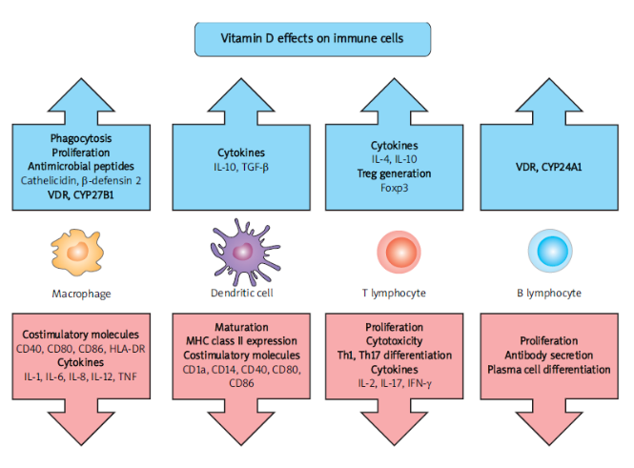
Recent Publications
- Sudhir Gupta; Ankmalika Gupta. Selective IgM Deficiency—An Underestimated Primary Immunodeficiency. Front Immunol. 2017; 8: 1056.
- Valdivieso JM, Fernandez E. Vit.D receptor polymorphisms and diseases. Clin.Chem Acta 2006; 371: 1-12.
- Goutham Dronavalli, MD et al., Selective IgM deficiency, www.uptodate.com, September 15, 2008.
- Holick MF. Vit.D deficiency. N Engl. J Med 2007; 357: 266-81.
- Holick MF. Vitamin D status: measurement, interpretation, and clinical application. Ann Epidemiol. 2009; 19: 73-8.
- Hewison M. Vit.D and the immune system: new perspectives on an old theme. Endocrinol MetabClinNorth Am 2010; 39:365 –79.
- Monteiro FP; Recurrent Vulvo-Vaginites and Immune System (RVVC). J Clin Rev Case Rep. 2018; Vol.3/Issue.3/ ISSN 2573.
- Fabrício Prado Monteiro, J Allergy Ther 2017, 8: 3(Suppl) DOI:10.4172/2155-6121-C1-005.

 Fabrício Prado Monteiro has his expertise and passion in evaluating and improving the health and immunology. He is a Medical Director at Institute of Allergy and Immunology of West Bahia, Brazil & Specialist in Allergology & Immunology (since 2006, by ASBAI). He is a Specialist in Pediatrics (since 2004, by SBP), has masters (UCES/ARG) in Administration and Economics (Management) in Health (public and private). He has built work model after years of experience in research, evaluation, teaching and attention in pediatrics and clinical allergy and immunology, both in hospital and education instructions. Email: fabriciopmonteiro@gmail.com / dottfprado@outlook.it / www.fabriciopradomonteiro.com.br
Notes/Comments: The beta Glucuronidase / beta-Glucana are an agent stimulant of the immune system and has a desensitizing action under normal pH. This substance has an important role as immune response modifier that stimulates the expression of adhesion molecules by antigen-presenting cells in contact with lymphocytes and vice versa, in the intra-cellular space and acts on the balance shift TH2/TH1. Method with proven security, without cases of deaths to this date and large scale in Brazil since the early of the 90ʼs was considered.

