Role of Sabin vaccine in poliomyelitis eradication: A brief review of achievements and risks
Omar A.Nafi
Mutah University, Karak.P.O Box (7), Jordan - 61710
Abstract
Eradication of poliomyelitis has been a major medical achievement made possible by great efforts on the part of the World Health Organization (WHO) and all countries involved. The main tool which made the eradication possible was the oral polio vaccine (OPV), or the Sabin vaccine. The OPV has been administered over 10 billion times to 3 billion children and has prevented over 13 million cases of polio. With a 99% reduction in polio incidence, and the more recent appearance of OPV-related complications, especially the vaccine-derived poliovirus (VDPV) and vaccine-associated polio paralysis (VAPP),it is important to reconsider the role of these vaccines in polio eradication. There are currently more cases due to VDPV than due to the wild polio virus(WPV).Considering that OPV is the only source of VDPV, the WHO has established a phased plan to withdraw OPV from use and to switch to an inactivated polio vaccine (IPV) by 2020. Therefore, the estimated 126 countries that still use this vaccine in their national immunization programmes need to make adequate plans for securing a sufficient supply of affordable IPV. However, there is some concern that vaccinators and caregivers might refuse to give children >2 injectable vaccines in a single visit, resulting in lower immunization coverage. This review discusses the benefits of Sabin vaccine over the years and its medical implications in the future.

Keywords: oral polio vaccine (OPV), vaccine-associated polio paralysis (VAPP), vaccine-derived poliovirus (VDPVs), wild polio virus (WPV)
Poliomyelitis eradication

Recent publication ;
1-Cochi SL, LinkinsRW. The final phase of polio eradication: new vaccines and complex choices. J Infect Dis. 2012;205:169–171.
2-Guo J, Bolivar-Wagers S, Srinivas N, Holubar M, Maldonado Y. Immunodeficiency-related vaccine-derived poliovirus (iVDPV) cases: a systematic review and implications for polio eradication. Vaccine. 2015;33:1235–1242.
3-Blankenhorn A, Cernuschi T, ZaffranMJ.Exceptional financial support for introduction of inactivated polio vaccine in middle income countries.J Infect Dis.2017;216:S9–S14.
4-Shendale S,Farrell M,Hampton LM,Harris JB, Kachra T, Kurji F, Patel M, Ramirez Gonzalez A, Zipursky S4.. Financial support to eligible countries for the switch from trivalent to bivalent oral polio vaccine—lessons learned.J Infect Dis. 2017;216:S52–S56.
5-Lopalco PL. Wild and vaccine-derived poliovirus circulation, and implications for polio eradication. Epidemiol Infect. 2017;145:413–419.

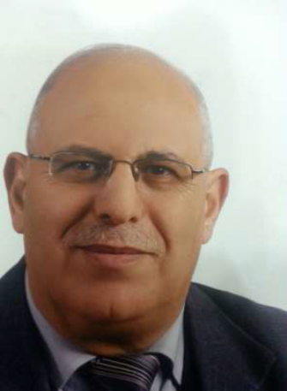
OMAR ALI NAFI MRCP Pediatric neurologist , Associated professor of pediatrics, Dean faculty of medicine , Mutah university . karak . Jordan. Member NITAG, Member polio eradication committee in Jordan, Member in measles and rubella eradication committee, Interested in childhood developmental disorders, attention deficit hyperactive disorder. Epilepsy. Cerebral palsy. Childhood immunization
Onafi2000@yahoo.com.

